VistA Scheduling Enhancements (VSE)

VS GUI  
User Guide



May 2016

Department of Veterans Affairs

Office of Information and Technology (OI&T)

Revision History

|  |  |  |  |
| --- | --- | --- | --- |
| Date | Revision | Description | Author |
| 5/2/16 | 1.0 | Initial Baseline | D. Reed |
|  |  |  |  |
|  |  |  |  |
|  |  |  |  |
|  |  |  |  |
|  |  |  |  |
|  |  |  |  |
|  |  |  |  |
|  |  |  |  |
|  |  |  |  |
|  |  |  |  |
|  |  |  |  |
|  |  |  |  |
|  |  |  |  |
|  |  |  |  |

Table of Contents

1 Introduction 1

1.1 Purpose 1

1.2 Overview 1

1.3 Project References 1

1.3.1 Information 1

1.3.2 Coordination 1

1.3.3 Help Desk 1

1.4 Organization of the User Guide 2

1.5 Acronyms and Abbreviations 2

2 System Summary 4

2.1 User Access Levels 6

3 Getting Started 7

3.1 Logging On 7

3.2 Logging Off 7

3.3 VS GUI Tabs 8

3.3.1 Tasks Tab 8

3.3.2 System Tab Action Areas 9

3.3.3 Reports Tab Action Areas 10

3.4 Searching 10

3.4.1 Search for patient: 10

3.5 Filtering 11

3.5.1 Filtering Lists 11

3.5.2 Paging Through Records 12

3.5.3 Filtering by Facility or Clinic 13

3.5.4 Filtering by Time Period 13

3.6 Sorting 14

3.6.1 Sorting by Column 14

3.7 Printing and Exporting a Request Grid 15

3.7.1 Printing a Request Grid 15

3.7.2 Exporting a Grid 16

3.8 Viewing 17

3.8.1 Viewing Requests by Request Type 17

3.8.2 Viewing Requests by Patient 18

3.8.3 Changing the Schedule View 19

4 Ribbon Bar 20

4.1 Patients Demographics 20

4.1.1 Finding a Patient 20

4.1.2 Viewing Patient Demographics in the Ribbon Bar 20

4.1.3 Patient Eligibility Information 22

4.1.4 Updating Patient Demographics 22

4.1.5 Marking for Bad Address 23

4.2 Actions 25

4.2.1 New Request 25

4.3 Arrangement 26

4.3.1 View Mode 26

4.4 Pending Appointment Window 26

4.5 Special Needs/Preferences 28

4.5.1 Adding/Removing Special Needs/Preferences from Requests 28

4.6 Mobile Requests 30

4.7 Tools 30

4.7.1 Print 30

4.7.2 Export 30

4.7.3 Refresh 30

4.7.4 Query 31

5 Request Management 33

5.1 Request Management Procedures. 33

5.1.1 Viewing a Patient’s Existing Requests 33

5.1.2 Adding Appointment Request 34

5.1.3 Viewing/Editing Appointment Request 36

5.1.4 Disposition or Removing an Appointment Request 38

5.1.5 Transfer to EWL Request for a Patient 39

5.1.6 Disposition or Removing a Patient from the EWL 40

5.1.7 Adding Recall Request 41

5.1.8 Disposition or Remove Recall Request 42

5.2 Contacting a Patient 44

5.2.1 Call Attempt 1 44

5.2.2 Call Attempt 2 45

5.2.3 Call Attempt 3 46

5.2.4 Letter Sent to Patient 47

6 Appointment Management 49

6.1 Adding Appointments 49

6.1.1 Add Appointment for Appointment Request 49

6.1.2 Add Appointment for EWL Request 55

6.1.3 Add Appointment for Recall Request 60

6.1.4 Add Appointment for Consult Request 65

6.2 Disposition Appointments 71

6.2.1 Edit Appointment Information 71

6.2.2 View Appointment Information 72

6.2.3 Canceling an Appointment 74

6.2.4 Mark as No Show Appointment 77

6.2.5 Undo No-Show Appointment 79

6.2.6 Checking In a Patient 80

6.2.7 Undo a Patient Check In 82

6.2.8 Check Out a Patient 84

6.2.9 Undo a Patient Check In 85

6.2.10 Rescheduling an Appointment 86

6.3 Multiple Appointment Requests and Appointments 88

6.3.1 Multiple Appointment Request 88

6.3.1.1 Note regarding Parent and Child Appointment Requests 90

6.3.2 Adding Multiple Appointments from Find Appointment Dialog 91

6.4 Overbooking Appointments 95

6.4.1 Overbooking Appointments with SDMOB Security Key 96

6.4.2 Overbooking Appointments with SDOB Security Key 101

6.5 Variable Length Appointment 106

6.5.1 Identifying a Variable Length Clinic 106

6.5.2 Add a Variable Length Appointment 108

6.6 Compensation and Pension Appointments 111

6.6.1 Adding Compensation & Pension APPT Request. 111

6.6.2 Add Compensation & Pension appointment for pending 2507 Request NOT previously linked to appointment. 111

6.6.3 Add Compensation & Pension appointment for pending 2507 request already linked to appointment NOT due to cancellation. 112

6.6.4 Add Compensation & Pension appointment for pending 2507 Request due to Clinic Cancellation 114

6.6.5 Add Compensation & Pension appointment for pending 2507 Request due to Veteran Cancellation/No Show. 118

6.6.6 Disposition Appointment linked to pending 2507 Request. 121

6.7 Veteran Appointment Request Scheduling 123

6.7.1 Scheduling a Mobile Request 123

7 Clinics 125

7.1 Task Tab 125

7.1.1 Viewing Clinic Schedule Availability 125

7.1.2 Viewing Clinic’s Availability Cancellation 128

7.1.3 Viewing clinic’s length of appointment and maximum overbook 129

7.1.4 Viewing clinic’s variable length indicator 129

7.1.5 Viewing clinic’s special instructions 130

7.1.6 Viewing clinic’s available slots 131

7.1.7 Time Slot Viewer 131

7.1.8 Viewing Provider Availability 135

7.1.9 Viewing Clinic Group Availability 138

7.2 System Tab 140

7.2.1 Viewing Clinic Availability Information 140

7.2.2 Adding and Removing Privileged Users 141

7.2.2.1 Add Privileged User 141

7.2.2.2 Remove Privileged User 142

7.2.3 Creating Clinic Groups 143

7.2.4 Removing Resource(s) from a Clinic Group 146

8 Reports 147

8.1 Audit Activity Report 147

8.1.1 Generating an Audit Activity Report for Individual Scheduler 147

8.1.2 Generating Audit Activity Report for All Schedulers 148

8.1.3 Working with Audit Activity Report data 149

8.1.3.1 Sorting by column header 149

8.1.3.2 Filtering by column data 151

8.1.4 Export Audit Activity Report for Individual or All Schedulers 151

8.2 Clinics Report 152

8.2.1 Clinic Activity Report—Individual Clinic 152

8.2.2 Working with Clinic Activity Report 152

8.2.2.1 Sorting by Column Headers 152

8.2.2.2 Filtering by column data 154

8.2.3 Exporting a Clinic Report 155

8.2.4 Resource Management Reporting 157

9 VistA Scheduling 508 Compliance 160

9.1 Tasks Tab 160

9.1.1 Ribbon Bar 160

9.1.2 Request Type Dialog 161

9.1.3 Appointment Request Dialog 161

9.1.4 Query Dialog 162

9.2 Systems Tab 165

9.2.1 Systems Tab Ribbon Bar 165

9.2.2 Scheduling Management Dialog 165

9.2.2.1 Clinics and Users Tab 165

9.2.2.2 Clinic Groups Tab 166

9.2.3 Availability Selection Dialog 167

9.3 Reports Tab 167

9.3.1 Reports Tab Ribbon Bar 167

9.3.2 Audit Activity Dialog 168

9.3.3 Clinic Activity Dialog 168

9.3.4 Management Reports Dialog 169

10 Troubleshooting 170

10.1 Changing User ID and Password 170

10.2 Special Instructions for Error Correction 170

Table of Figures

Figure 1: User Login 7

Figure 2: VS GUI Tabs 8

Figure 3: Task Tab 9

Figure 4: System Tab 9

Figure 5: Reports Tab 10

Figure 6: Patient Search 11

Figure 7: Filtering Lists 12

Figure 8: Paging Through Records 12

Figure 9: Filtering by Facility/Clinic 13

Figure 10: Filtering by Time Period 14

Figure 11: Sorting by Column 14

Figure 12: Printing a Schedule 15

Figure 13: Exporting a Grid 16

Figure 14: Request Type column 17

Figure 15: Select Patient 18

Figure 16: Request Type 18

Figure 17: Patient Pending Requests and Booked Appointments 18

Figure 18: View Mode 19

Figure 19: Changing View of a Specific Schedule 19

Figure 20: Search Patient 20

Figure 21 Patient Demographics in the Ribbon Bar 21

Figure 22 Patient Inquiry Detail 21

Figure 23 Patient's Eligibility Information 22

Figure 24 Request Type - APPT 23

Figure 25 Appointment Request Dialog—Patient Information Section 23

Figure 26 Select Patient3. 24

Figure 27 Request Type - APPT4. 24

Figure 28 Appointment Request Dialog—Bad Address Selection 25

Figure 29: Actions Pane 26

Figure 30: Request Type – APPT 26

Figure 31: Pending Appointment Window—Past Appointment Date 27

Figure 32: Pending Appointment Window—Current less than 3 days in future 27

Figure 33: Pending Appointment Window—Future Appointment Dates 28

Figure 34: Request Type - APPT 28

Figure 35: Appointment Request—Special Needs/Preferences Section 29

Figure 36: Ribbon Bar—Special Needs/Preferences 30

Figure 37: Refresh Button in Tools Pane 30

Figure 38: Request Query 31

Figure 39: Query Rule Validation 32

Figure 40: Request Query Rule Confirmation 32

Figure 41: Request Type - PATIENT 33

Figure 42: Request Grid and Pending Appointments 33

Figure 43: Request Type - APPT 34

Figure 44: Actions Pane—New Req. Selection 34

Figure 45: Appointment Request Dialog—Request Information Section 35

Figure 46: Special Needs/Preferences section from Appointment Request dialog. 35

Figure 47: Appointment Request dialog. 36

Figure 48: View Request (read-only) 37

Figure 49: Edit Request (Request Information Only) 38

Figure 50: APPT/Veteran Disposition Options 39

Figure 51: EWL Request Dialog. 40

Figure 52: Request Type - RECALL 41

Figure 53: Recall Appointment Request Dialog 42

Figure 54: EWL Disposition Options 43

Figure 55: Recall Comment 43

Figure 56: Contact Options—Call Attempt 1 44

Figure 57: Patient Contact Dialog 45

Figure 58: Contact Options—Call Attempt 2 45

Figure 59: Patient Contact Dialog 46

Figure 60: Contact Options—Call Attempt 3 47

Figure 61: Patient Contact Dialog 47

Figure 62: Contact Options—Letter Sent to Patient 48

Figure 63: Patient Contact Dialog 48

Figure 64: Request Type - PATIENT 49

Figure 65: Select APPT Request—Clinic Schedule Grid display 50

Figure 66: Select Time Slot 50

Figure 67: Right-Click options - Add Appointment 51

Figure 68: New Appointment dialog - Appointments Tab 52

Figure 69: New Appointment dialog - Contact Information Tab 52

Figure 70: Print Letter? Dialog 53

Figure 71: Closing Request Dialog 53

Figure 72: Clinic Schedule Grid –Past Appointment Date Display 54

Figure 73: Clinic Schedule Grid—Current or less than 3 days in future Appointment in Clinic Schedule Display 54

Figure 74: Clinic Schedule Grid--Future Appointment Date in Clinic Schedule Display 55

Figure 75: Request Type - PATIENT 55

Figure 76: Select EWL Request 56

Figure 77: Select time slot 56

Figure 78: Right click options - Add Appointment 57

Figure 79: New Appointment Dialog –Appointments Tab 57

Figure 80: New Appointment dialog - Contact Information Tab 58

Figure 81: Print Letter? Dialog 58

Figure 82: Closing Request Dialog 58

Figure 83: Past appointment date in Clinic Schedule Grid—EWL Appointment Past Date Display 59

Figure 84: Clinic Schedule Grid--EWL Appointment Current Date 59

Figure 85: Future appointment date in Clinic Schedule Grid—EWL Appointment Future Date Display 60

Figure 86: Request Type - PATIENT 60

Figure 87: Select Recall Request 61

Figure 88: Select time slot 61

Figure 89: Right click options - Add Appointment 61

Figure 90: New Appointment dialog - Appointments Tab 62

Figure 91: New Appointment dialog - Contact Information Tab 63

Figure 92: Print Letter? Dialog 63

Figure 93: Closing Request Dialog 63

Figure 94: Past appointment date in Clinic Schedule display—Past Date Appointment 64

Figure 95: Clinic Schedule Display –Current Date Appointment 65

Figure 96: Future appointment date in Clinic Schedule display--Future Date Appointment 65

Figure 97: Request Type - PATIENT 66

Figure 98: Select Consult Request 66

Figure 99: Clinic Schedules 67

Figure 100: Select time slot 67

Figure 101: Right Click options - Add Appointment 67

Figure 102: New Appointment dialog - Appointments Tab 68

Figure 103: New Appointment dialog - Contact Information Tab 68

Figure 104: Print Letter? Dialog 69

Figure 105: Clinic Schedule Display --Consult Past Appointment Date 70

Figure 106: Consult with current date or less than 3 days in future in Clinic Schedule display 70

Figure 107: Consult future appointment date in Clinic Schedule display 70

Figure 108: Appointment Right Click Options -- Edit Appointment 71

Figure 109: Edit Appointment Dialog 72

Figure 110: Hover box displaying appointment details 73

Figure 111: Appointment Right Click Options--View Appointment 73

Figure 112: View Appointment Dialog 74

Figure 113: Appointment Right Click Options--Cancel Appointment 75

Figure 114: Cancel Appointment Dialog 76

Figure 115: Pending Appointment Window –Appointment Status Cancelled by Clinic 76

Figure 116: Pending Appointment Window –Appointment Status Cancelled by Patient 77

Figure 117: APPT Request returns to Request Management Grid and Time Slot Count Increases 77

Figure 118: Appointment Right Click Options—Mark as No Show 78

Figure 119: Mark as No Show Dialog 78

Figure 120: Clinic Schedule Display—No Show Pink 79

Figure 121: Pending Appointment Window –Appointment Status No-Show 79

Figure 122: Appointment Right Click Options—Undo NoShow 80

Figure 123: Appointment Clinic Schedule Display--Undo NoShow as white 80

Figure 124: Pending Appointment Window Undo NoShow--Appointment Status No Action Taken 80

Figure 125: Appointment Right Click Options—Check In Patient 81

Figure 126: Appointment Check In Dialog 81

Figure 127: Clinic Schedule Display—Check In Green 82

Figure 128: Pending Appointment Window—Appointment Status ACT REQ/CHECKED IN 82

Figure 129: Appointment Right Click Options—Undo Check In Patient 83

Figure 130: Clinic Schedule Display --Undo Check In Patient White 83

Figure 131: Pending Appointment Window--Appointment Status No Action Taken 83

Figure 132: Appointment Right Click Options—Check Out Patient 84

Figure 133: Appointment Check Out Dialog 85

Figure 134: Clinic Schedule Display--Check Out Patient Orange 85

Figure 135: Pending Appointment Window—Appointment Status ACT REQ/CHECKED OUT 85

Figure 136: Appointment Right Click Options--Undo Check Out Patient 86

Figure 137: Clinic Schedule Display--Undo Check Out Patient Green 86

Figure 138: Pending Appointment Window--Appointment Status ACT REQ/CHECKED IN 86

Figure 139: Move Appointment? Dialog 87

Figure 140: Cancel Appointment Dialog 88

Figure 141: Pending Appointment Window—Appointment Status Canceled and Future 88

Figure 142: Multiple Appointments Required Disabled for Past CID/Preferred Dates 89

Figure 143: MRTC Interval/Appt. # Dialog 90

Figure 144: MRTC Requests displayed in Request Management Grid 91

Figure 145: Find Appointment Dialog 93

Figure 146: Find Appointment Dialog + MRTC Booking Status Dialog 94

Figure 147: Future Clinic Inactivation Date 95

Figure 148: Request Type – PATIENT 96

Figure 149: Clinic Schedule Display –APPT Request Future CID/Preferred Date 97

Figure 150: Max Overbook Limit 97

Figure 151: Appointment Right Click options --Add Appointment 98

Figure 152: Overbook Confirmation Dialog 98

Figure 153: New Appointment Dialog – Appointments 99

Figure 154: New Appointment Dialog -- Contact Information 99

Figure 155: Print Letter? Dialog 100

Figure 156: Closing Request Dialog 100

Figure 157: Clinic Schedule Display --Overbook Appointment 101

Figure 158: Request Type – PATIENT 101

Figure 159: Clinic Schedule Display -- APPT Request Future CID/Preferred Date 102

Figure 160: Overbook After Hours Time Slot 102

Figure 161: Appointment Right Click Options – Add Appointment 103

Figure 162: Overbook Confirmation Dialog 103

Figure 163: New Appointment Dialog – Appointments Tab 104

Figure 164: New Appointment Dialog – Contact Information Tab 104

Figure 165: Print Letter? Dialog 105

Figure 166: Closing Request Dialog 105

Figure 167: Clinic Schedule Display--Overbook Appointment After Hours 106

Figure 168: Clinic Schedules – Clinic Search 107

Figure 169: Clinic Schedule Grid 107

Figure 170: Variable Length Indicator 108

Figure 171: Clinic Schedule Display – Left Click Open Time Slot 108

Figure 172: Clinic Schedule Display -- Multiple Time Slot Selected 109

Figure 173: Right Click Options – Add Appointment Variable Length 109

Figure 174: New Appointment Dialog -- Variable Length Appointment Duration 110

Figure 175: Clinic Schedule Display -- Appointment Length Extended 111

Figure 176: AMIE C&P EXAM TRACKING Record Updated. 112

Figure 177: C&P Appointment for Patient with No Pending 2507 Request 112

Figure 178: Comp & Pension Requests Dialog 113

Figure 179: Comp & Pension Request Due to Cancellation Dialog 114

Figure 180: AMIE C&P EXAM TRACKING Record Updated 114

Figure 181: Comp & Pension Requests Dialog 115

Figure 182: Comp & Pension Request Due to Cancellation Dialog 116

Figure 183: Comp & Pension Request Appointment Links Dialog 116

Figure 184: C&P Appt Links Due to Veteran Cancellation or No Show 117

Figure 185: Comp & Pension Due to Cancellation Dialog 117

Figure 186: C&P Appointment Link Adjustment Dialog 117

Figure 187: Comp & Pension Request Dialog 119

Figure 188: Comp & Pension Request Due to Cancellation Dialog 119

Figure 189: Comp & Pension Request Appointment Links Dialog 120

Figure 190: Comp & Pension Canceled Appointment Links Dialog Warning 120

Figure 191: C&P Appt Links Due to Veteran Cancellation or No Show 121

Figure 192: AMIE C&P EXAM TRACKING Record Updated 121

Figure 193: C&P Cancel Appointment Associated 2507 Request Updated 122

Figure 194: C&P Cancel Appointment NOT linked to Pending 2507 Request 122

Figure 195: Mobile Requests 123

Figure 196: Mobile Request List 123

Figure 197: Mobile Request Selected 124

Figure 198: Veteran APPT Request 124

Figure 199: Message to Veteran Dialog 125

Figure 200 Mobile Request Removed from Grid 125

Figure 201: Clinic Schedules Search 126

Figure 202: Clinic Schedules Display Available vs Unavailable 126

Figure 203: Clinic Schedules Display Hours of Operation 127

Figure 204: Clinic Schedules Display -- Holiday Bookable 127

Figure 205: Holiday Unbookable 128

Figure 206: Clinic Schedule Display – No Availability Defined 128

Figure 207: Clinic Schedule Display – Cancel Availability 129

Figure 208: Appointment Length and Max Overbook Allowed 129

Figure 209: Variable Length Indicator 130

Figure 210: Special Instruction Indicator 130

Figure 211: Time Slot Count 131

Figure 212: Overbook Time Slot Count 131

Figure 213: Minimized Time Slot Viewer 131

Figure 214: Expanded Time Slot Viewer 132

Figure 215: Time Slot Viewer Displays Slot Details 132

Figure 216: Time Slot Viewer Right Click Options — Add Appointment 133

Figure 217: Time Slot Viewer Right Click – Edit, View, Cancel 133

Figure 218: Time Slot Viewer – Check In Patient 134

Figure 219: Time Slot Viewer -- Check Out Patient 134

Figure 220: Time Slot Viewer – Mark as No Show 135

Figure 221: Provider Schedules 136

Figure 222: Provider Schedules Selection List 137

Figure 223: Provider Schedule Display 137

Figure 224: Provider Schedules Booked Appointments 138

Figure 225: Fixed View Size 138

Figure 226: Clinic Groups 139

Figure 227: Clinic Groups Search Result List 139

Figure 228: Clinic Groups Schedule Display 140

Figure 229: Provider Schedules –Fixed View Size 140

Figure 230: Clinic Availability Search 141

Figure 231: Clinic Availability 141

Figure 232: Clinics and Users 142

Figure 233: Add Privileged User 142

Figure 234: Remove Privileged User 143

Figure 235: Create New Clinic Group 144

Figure 236: Find Resource 145

Figure 237: Add Resource to Clinic Group 146

Figure 238: Remove Resource from Clinic Group 147

Figure 239: Reports Tab Selections 147

Figure 240: Audit Activity Report—Individual Scheduler 148

Figure 241: Audit Activity Report –All Schedulers 149

Figure 242: Audit Activity Sort –Ascending 150

Figure 243: Audit Activity Sort –Descending 150

Figure 244: Audit Activity Report –Filtered 151

Figure 245: Audit Activity Report --Multiple Filters 151

Figure 246: Clinic Activity Report –Sorted Ascending Order 153

Figure 247: Clinic Activity Report –Sorted Descending Order 154

Figure 248: Clinic Activity Report—Filtered 155

Figure 249: Clinic Activity Report –Multiple Filters 155

Figure 250: Clinic Activity 156

Figure 251: Save As 156

Figure 252: Resource Management Report Selection Dialog 157

Figure 253: Report Console 158

Figure 254: Generated Resource Management Report 159

# Introduction

Department of Veterans Affairs (VA) Veterans Health Information System and Technology Architecture (VistA) Scheduling (VS) Graphical User Interface (GUI) module is the Windows GUI version of the Patient Information Management System (PIMS) Scheduling module. It provides appointment management functions included in PIMS Scheduling, but with the added convenience and usability of a GUI.

## Purpose

VS GUI is a software module that allows Schedulers to make appointments quickly by viewing multiple appointment request types and multiple clinics in one screen. A Scheduler can easily view patient requests for service, find the next available open appointment, view the provider’s availability in multiple clinics, and track a patient’s appointment process.

## Overview

For help understanding the screen layout or how to log on or off, see Section 3: Getting Started for more specific instructions.

If VS GUI was previously installed at the site and it has to be upgraded to the current version, patients can be scheduled as described in Section 6: Appointment Management, or view and print schedules.

## Project References

For references for VistA Scheduling Enhancement (VSE) Enhancement (Enh) 1, Enh 2, Enh 3, New Service Request (NSR) #002, Veteran Appointment Request (VAR), and Optional Task #3 (OT3), refer to the following Requirements Specification Documents (RSD):

* VSE_Enh1_Enh2_RSD.doc
* VSE_Enh3_RSD.doc

### Information

The points of contact (POCs) for VS GUI are the same as those for the VistA Scheduling module.

### Coordination

Coordination between the project and its specific support functions (e.g., installation coordination, security, etc.) for VS GUI are the same as those for VistA.

### Help Desk

The National Service Desk (NSD) supports VS GUI.

## Organization of the User Guide

The user guide is comprised of seven sections. They are:

* 1 – Introduction. Discusses general and project information. Also included is a list of acronyms and abbreviations.
* 2 – System Summary. Contains system configuration, data flows, and user access level information.
* 3 – Getting Started. Contains procedures for logging on and off of the system, information on VS GUI tab displays, basic searching, sorting, filtering, and viewing of information. Also, printing and exporting schedules.
* 4 – Manage Patient Demographics. Includes procedures to find patients, view and update demographic information, and add new patient requests. Managing appointment procedures are also contained in the section.
* 5 – Clinics. Viewing and appointments with clinics and administrator actions with clinics are located in this section.
* 6 – Reports. An overview of viewing and printing reports, as well as procedures to generate Audit and Clinic reports is contained in this section. A list of warnings is also included.
* 7 – Troubleshooting.

## Acronyms and Abbreviations

The table below defines terms used in this document.

Table : Acronyms and Abbreviations

| Term | Description |
| --- | --- |
| ACAP | Access and Clinic Administrative Program |
| Access Block | A color-coded representation of the amount of time allotted for a specific Access Type (or appointment). |
| Access Types | The variety of different appointment types available in the Legacy VistA Scheduling package. Each type of appointment, such as routine physical, dental, walk-in, or other specific appointment type is an Access Type. |
| Access Groups | Categories of Access Types. Assigning Access Types to Access Groups makes it easier to schedule and search for certain types of appointments. |
| API | Application Program Interface |
| Appointment | A scheduled meeting with a provider or at a clinic; an appointment can include several encounters with other providers or clinics for tests, procedures, etc. |
| Clinic | A medical center location where patients receive care by a doctor or authorized provider. |
| Provider | A doctor or other authorized provider in the medical center who provides patient care. |
| Enh | Enhancement |
| EWL | Electronic Wait List |
| GUI | Graphical User Interface |
| MUMPS | Massachusetts General Hospital Utility Multi-Programming System |
| NSR | New Service Request |
| PACT | Patient-Aligned Care Teams |
| PIMS | Patient Information Management System |
| POC | Point of Contact |
| PWS | Performance Work Statement |
| OT3 | Optional Task #3 |
| OT4 | Optional Task #4 |
| Slot | Number of appointments per defined appointment length that have been previously set up in VistA Scheduling. For example, If Slots = 4 and your clinic (resource) appointment length is 30 minutes, then there are four available appointments for every 30 minutes. |
| T4 | Transformation Twenty-One Total Technology |
| TAC | Technology Acquisition Center |
| TCP/IP | Transmission Control Protocol/Internet Protocol |
| VA | Department of Veterans Affairs |
| VAR | Veteran Appointment Request |
| VistA | Veterans Health Information Systems and Technology Architecture |
| VSE | VistA Scheduling Enhancements |

# System Summary

**Enhancement 1:** VHA requires an aggregated (combined) view of clinic profile scheduling grids to allow the user to view the resource’s availability collectively and decrease the time it takes to match an available resource with the patient’s request and improve the appointment scheduling process. Enhancement 1 provides an aggregated view of clinic profile scheduling grids for VistA Scheduling to include:

* A standard tool for viewing and scheduling aggregated resources in order to improve performance for appointment scheduling
* Improved visibility into resources across clinic profiles
* Exposes previously underutilized resources
* Improves business processes and efficiency

**Enhancement 2:** This enhancement consolidates information from multiple appointment request sources so all patient requests are available collectively to be queried, filtered, and sorted to improve the appointment scheduling process. The single queue of request lists for appointment requests provides immediate, incremental relief to the field, including:

* Promotes a standard tool for consolidating, viewing, sorting and prioritizing appointment requests in order to improve performance for appointment scheduling
* Improves the business’ ability to accurately prioritize patient appointment needs regardless of method of request and work list
* Improves business processes and efficiency by streamlining the process and removing duplication
* Eliminates waste in a Scheduler’s workload processes related to appointment requests

**New Service Request (NSR) #002:**

* The aggregated request list functionality built into the VS GUI must be separated from the wait list file structure in VistA.
* Assigning of schedulers to clinics must be done on an exclusionary instead of the current inclusionary basis.
* The current capability to link multiple appointments to a single appointment request must be replaced by a one-to-one linkage (one appointment request per appointment).
* The aggregated request list functionality built into the VS GUI will only display Wait Lists associated with Clinics whose clinic profiles allow such display.
* In multiple return to clinic scenarios (multi-book appointments), VS GUI calculation of subsequent Desired Dates based on initial Appointment Booking Date rather than initial Desired Date.

**Veteran Appointment Request (VAR)** **Interface:** Provides an interface between the VS GUI and the VAR appointment request database, including:

* Link an appointment requested in VAR and processed in VistA such that the state of the appointment in VistA (e.g. cancelled, checked out) can be displayed in the VS GUI application
* View appointment requests within VS GUI
* Communicate or message the Veteran from within VS GUI up to a limit of four times
* Close out requests from VS GUI

**Optional Task #3 (OT3):** Three enhancements to the VS GUI have been identified by VHA to support the Scheduling workflow and policy:

* Appointments generated from Consults in CPRS shall use the Consult **Earliest Appropriate Date** to populate the **DESIRED/RECALL DATE** and **ENTERED/RR NO DATE** fields in the VS GUI when a value is present other than **Today’s** date (as set as default by CPRS) and is not equal to the Appointment Entered Date.
* Remove functionality in Legacy VistA Scheduling and VS GUI that provided the ability to hide appointment requests associated with Wait Lists associated with Clinics
* Veteran Disabilities will be displayed in the VS GUI to aid in determining eligibility for specific clinics

**Optional Task #4 (OT4) Functionality** consists of additional enhancements identified by VHA to support the Scheduling workflow and policy:

* The VSE GUI shall follow the same rules as in VistA for Overbooking and Master Overbooking Security keys.
* The VSE GUI shall display number of available appointment slots in the calendar view for the clinic within each appointment time slot to allow booking of several appointments.
* The VSE GUI shall have a consistent color visual indication for the following:
* Hours of operation.
* Non-workable hours during that specific day (after hours bookable using a key).
* No appointment can ever be booked.
* Clinic inactive.
* Holiday but bookable.
* Holiday but NOT bookable.
* No availability created for the clinic.
* The VSE GUI shall allow entering variable length appointments only for clinics with variable appointment lengths defined in the VistA Clinic Setup Parameters.
* The VSE GUI shall display a visual indicator for clinics that allow variable appointment lengths.
* The VSE GUI shall display special clinic instructions on the screen e.g. “only make new appointments on Tuesday and Thursday”.
* The VSE GUI shall NOT shall display Occasion of Service Clinics (OOS) - (field 50.01 = yes is the OOS indicator) including drop down lists.
* The VSE GUI shall display message "No availability was created for the clinic" when a grid does not exist for the clinic (example: VCL and admin clinics) similar to current VistA Scheduling processing.
* The VSE GUI shall allow for entering 'CID/Preferred Date' and/or appointment date within the appointment requests using past dates.
* Multi-book Enhancement GUI.
* For inpatients, the VSE GUI shall display ward location in patient demographic area for each patient.
* Comp & Pension Appointments need to be linked to the 2507 Request as it currently does in VistA.
* Multi-Appointment Booking Wait Time.
* Scheduling ‘Desired Date’ Change.
* Recall Reminder Parameters.
* Recall Reminder Print Failures.
* Modification to VistA Recall Reminders.

**Enhancement 3:** Enhancement 3 provides a consolidated view of resource management metrics related to scheduling supply and demand, for appropriate organizational components (e.g., clinic, facility levels). The tool is referred to as Resource Management Reporting. The enhancement provides aggregate views of Legacy VistA Scheduling data and does not directly contain Personally Identifiable Information (PII) data.

## User Access Levels

The VS GUI module uses two access levels:

* **Scheduler** – Has access to:
* **VS GUI** – Make appointments quickly by viewing multiple clinics in one screen. The user can easily find the next available open appointment, view the provider’s availability in multiple clinics, and track a patient’s appointment process.
* **Find Appointments** – Specify the dates to select for the next available appointment in a clinic or a list of clinics.
* **Resource Schedules** – Display Clinic Schedules.
* **Appointment Schedule** – Display the Appointment Schedules for a clinic and be able to view a providers schedule for the day, week or month in 10, 15, 20, 30, 60 minute time slots.
* **Request Management Queue** – Shows a list of patients waiting for an appointment.
* **Ribbon Bar** – Organizes the VS GUI into a series of tabs at the top of the module. Tabs being Tasks, System, Reports.
* **Mobile Requests** – Shows number of pending mobile requests and provides access to the Mobile Request List for scheduling.
* **Administrator** – Has access to:
* All Scheduler functions.
* **System** – Allows an administrator to add/delete privileged users from a prohibited clinic and set up clinic groups.
* **Reports** – Allows for viewing and exporting reports.

# Getting Started

This section provides a general walkthrough of the system from initiation through exit. The logical arrangement of the information shall enable the functional personnel to understand the sequence and flow of the system.

## Logging On

VistA User Access and Verify codes are required in order to log on to the VS GUI. If User Access and Verify codes are needed, contact your supervisor or site administrator.

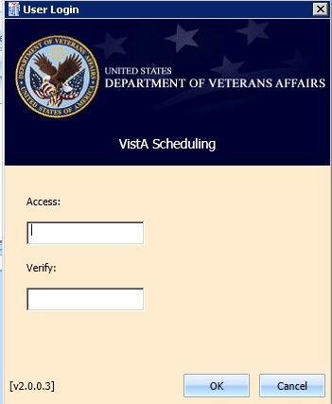

Figure : User Login

## Logging Off

To log off when you are finished scheduling appointments, click the Close button (**X**) in the upper right corner of the VS GUI.

## VS GUI Tabs

The VS GUI provides the following tabs:

* **Tasks:** Allows Scheduler to search for patient requests, view clinic resources, and make appointments
* **System:** Allows an administrator to add/delete privileged users from a prohibited clinic and set up clinic groups.
* **Reports:** Allows for various reports to be generated by all users

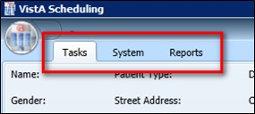

Figure : VS GUI Tabs

### Tasks Tab

The **Tasks** tab display includes the following sections:

* **Select Patient:** Search for and view information about a selected patient
* **Actions:** Allows Scheduler to initiate new APPT, Recall, or Patient requests
* **Arrangement:** Time Scale (30-Minute) and View Mode (Day, Week, or Month for the clinic schedule grids of the screen.
* **Pending Appointments**: Date, clinic, and status of any pending appointments for the selected patient
* **Special Needs/Preferences:** Identified special needs and/or preferences for the selected patient
* **Mobile Requests:** Shows number of pending mobile requests and provides access to the Mobile Request List for scheduling. If the mobile request service is not available, **UNAV** is displayed in place of the request number.
* **Tools:** Options to print, export, refresh, and perform queries.
* **Request Grid:** View a list of patients waiting for an appointment
* **Resources:** Calendar to choose a desired appointment date and to search for and access **Clinic Schedules**, **Provider Schedules**, and **Clinic Groups**
* **Schedules:** View multiple clinic schedules in one screen

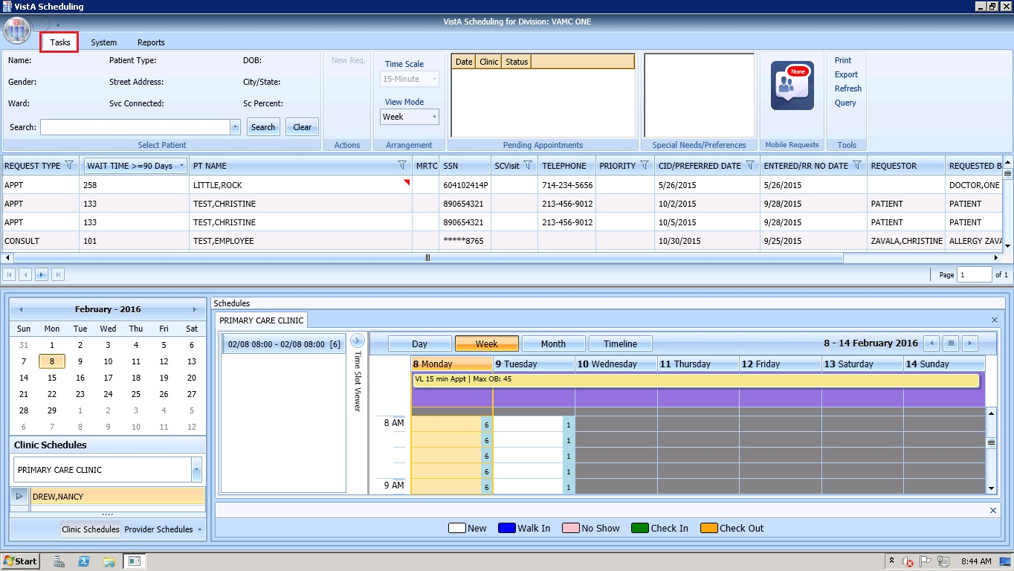

Figure : Task Tab

### System Tab Action Areas

The System tab display includes the following sections:

* **Resource Management:** **Scheduling Management** allows for management of privileged users within Prohibited and Clinic Groups
* **Resource Schedules:** **Availability** allows for search of resource by name
* **Selected Clinic:** View Primary Provider, Overbook Limit, Inactive Date, and ReactiveDate for a selected clinic

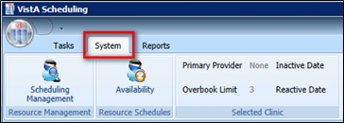

Figure : System Tab

### Reports Tab Action Areas

The **Reports** tab display allows for viewing and exporting of **Audit Activity**, **Clinics Activity**, and **Management Reports**.

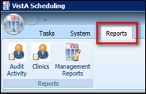

Figure : Reports Tab

## Searching

The search feature enables a Scheduler to:

* View and search clinic profiles to view appointments resources by clinic or by clinic groups
* View and search patient requests by request type
* Sort the request queue by any column in ascending or descending order
* Sort results and save the search into various outputs, such as Microsoft Excel or Adobe PDF
* Generate an audit report of search and sort results
* Print various screens and open lists

### Search for patient:

1. Log into VS GUI.
2. In Search field, the following options are available for searching for a patient:

* Last name, First name
* Full Social Security Number (SSN)
* First initial last name + last four SSN (ex. T0170)
* Last four of SSN (0170)
* Last name only (3 character minimum)

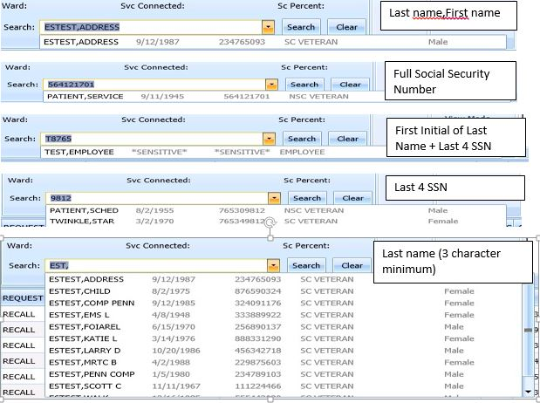

Figure : Patient Search

## Filtering

Filtering can be accomplished in a number of areas of the VS GUI. Items that can be filtered by:

* Lists
* Time Period
* Facility

The following sections describe basic filtering.

### Filtering Lists

You can filter any column on the request grid to narrow the type of information that you want to see. In the request grid, click any column that shows a filter icon, and then select a filter option.

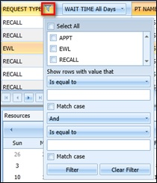

Figure : Filtering Lists

### Paging Through Records

Filtered results are retrieved from the database and displayed in 25 row increments. To view additional records, use the arrow key to page through the records.

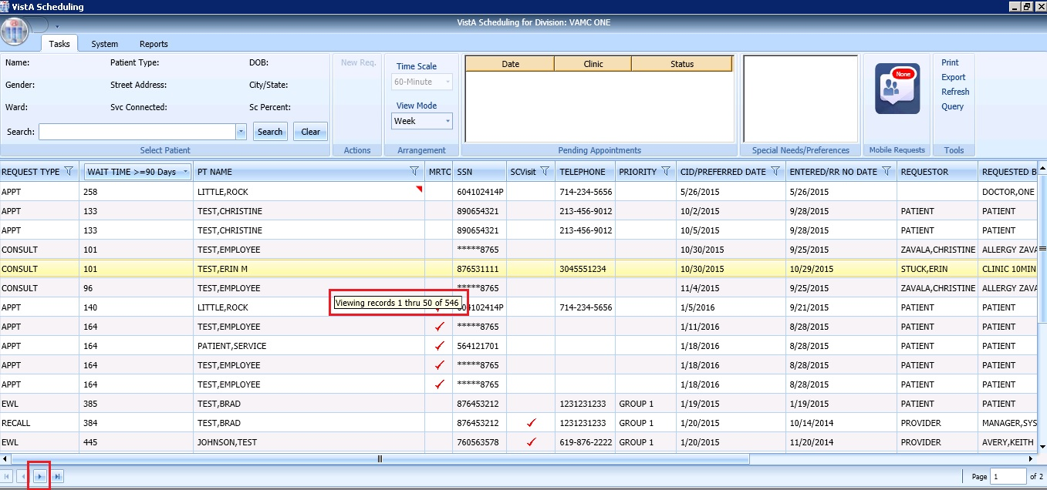

Figure : Paging Through Records

### Filtering by Facility or Clinic

To filter by facility or clinic, in the Clinic Schedules pane, type in the name of the desired clinic (6 character minimum) and then choose the desired clinic to view by clicking the clinic name from the drop down menu.

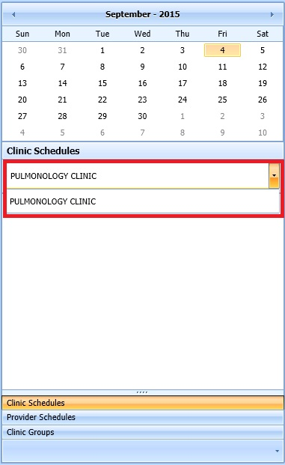

Figure : Filtering by Facility/Clinic

### Filtering by Time Period

To filter by time period, in the Resources pane, search for and select a desired clinic and then use the calendar to select a month and day for viewing appointments.

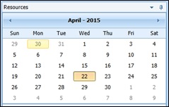

Figure : Filtering by Time Period

## Sorting

You can sort the consolidated list of requests in the request grid in different ways to isolate the information that you need to see.

### Sorting by Column

You can sort the consolidated list of requests in ascending or descending order. The default sort is by Priority group, Service Connected priority, and then by Preferred Appointment date, and then by Date entered (Request date). Perform the following procedure to sort by column.

1. Log on to VS GUI as a Scheduler.
2. Click any of the column headers to change the sort order.

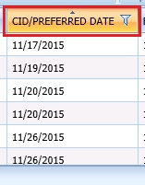

Figure : Sorting by Column

1. Click on the column header to return to the default sort order.

## Printing and Exporting a Request Grid

### Printing a Request Grid

The VS GUI also allows for printing of a request grid. Use the following procedure to print a request grid. **Note:** Only requests downloaded on Request Management Grid will print.

1. On the ribbon bar, in the Tools section, select the **Print** option.

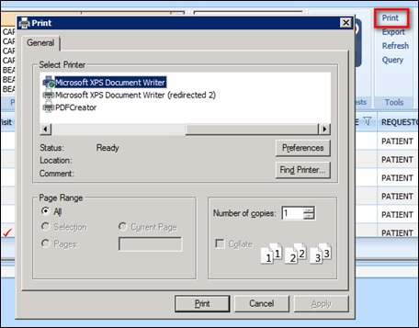

Figure : Printing a Schedule

1. Select the desired printer, and then click **Print**.

### Exporting a Grid

The VS GUI also allows for exporting of a request grid in Microsoft Excel format. Use the following procedure to export a schedule.

1. On the ribbon bar, in the Tools section, select the **Export** option.

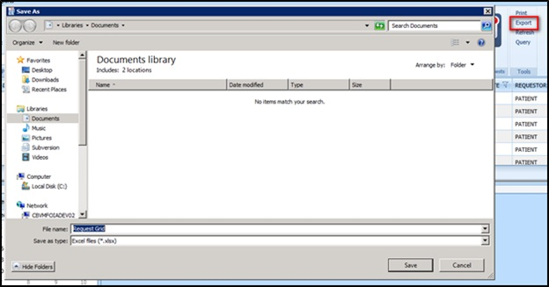

Figure : Exporting a Grid

1. In the **Save As** dialog box, type a file name, select a file type, browse to the location where you want to save the information, and then click **Save**.
2. Open the file and review the contents. All data in the request grid is saved as desired. **Note:** Only data that was displayed on screen will be exported to the file.

## Viewing

### Viewing Requests by Request Type

A Scheduler can view requests for Veteran Appointments (APPT) requests—Consults, Recall reminders, or Electronic Wait List (EWL) reminders. The default view is for requests that are 90 days or older, however, you can change the view. Use the following procedure to view requests by request type. Requests will display 25 at a time. Additional requests can be viewed by paging to next page.

1. Log on to VS GUI as a Scheduler.
2. View the request grid. Consult, APPT, EWL, and Recall requests appear that have a wait time of 90 days or more. The preferred date for the patient request type is shown in the **CID/Preferred Date** column.

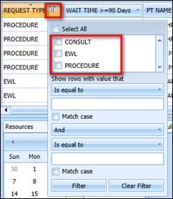

Figure : Request Type column

1. Click the **Request Type** column to filter specific requests. Only request types that are in the current request grid display in the filter tool.
2. Select **EWL** to view the Electronic Wait List requests.
3. Select **APPT** to view appointment requests.
4. Select **Recall** to view recall requests.
5. Select **Procedure** to view procedure requests.
6. Select **Consult** to view consultation requests.

### Viewing Requests by Patient

Use the following procedure to view requests by patient.

1. Log on to VS GUI as a Scheduler.
2. In the **Tasks** tab display, type the patient’s last name, first name in the **Search** text box, click Search button, and then select the requested patient name.

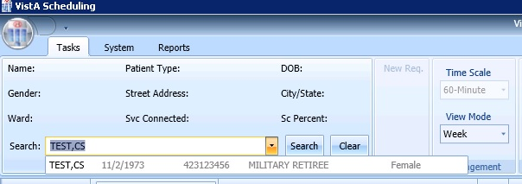

Figure : Select Patient

1. From the **Request Type** dialog box, select **PATIENT**.

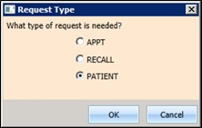

Figure : Request Type

The patient’s pending requests are displayed in the Request Management Grid 25 at a time and booked appointments are displayed in the Pending Appointments Window in the Ribbon Bar of the **Task** tab.

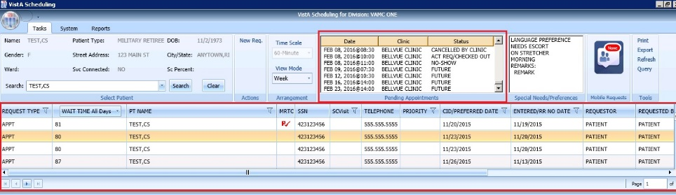

Figure : Patient Pending Requests and Booked Appointments

### Changing the Schedule View

The default schedule view for displaying clinic schedule grids is by week, but the view can be changed to day or month view for ease of scheduling. Use the following procedure to change the schedule view. Use the following steps to change the schedule view.

1. Log on to VS GUI as a Scheduler.
2. Search and select a Clinic to open.
3. In the Arrangement section, click on the **View Mode** pull-down menu and select:

* Day
* Week
* Month

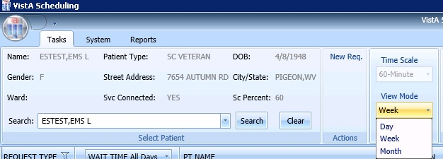

Figure : View Mode

1. A view for a specific schedule can be changed at the top of the Schedules section by clicking on the button that reflects the desired view. The available views from the schedule include:

* Day
* Week
* Month
* Timeline

The Timeline view is displayed.

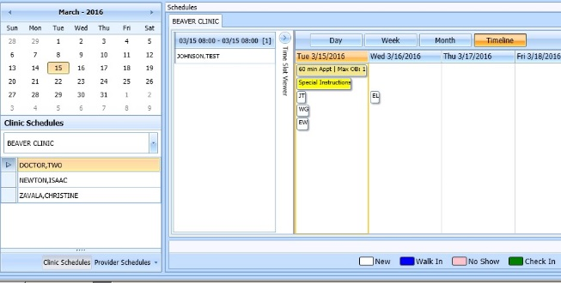

Figure : Changing View of a Specific Schedule

# Ribbon Bar

The following section outlines the sections available in the Ribbon Bar of Schedule Manager.

## Patients Demographics

### Finding a Patient

1. Log on to VS GUI as a Scheduler.
2. In the **Tasks** tab display, type the patient’s last name, first name in the **Search** text box, click Search button.
3. Select the requested patient name from drop down list.

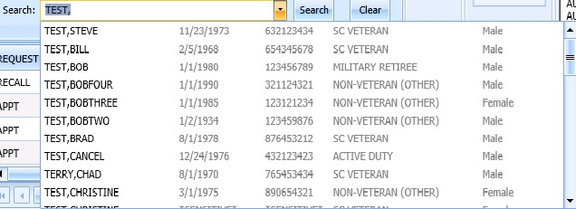

Figure : Search Patient

### Viewing Patient Demographics in the Ribbon Bar

You can view basic patient demographic information in the ribbon bar. The ribbon bar provides a limited amount of patient information, but you can display more patient detail. Use the following steps to view patient demographics in the ribbon bar.

1. Log on to VS GUI as a Scheduler.
2. In the **Tasks** tab display, type the patient’s last name, first name in the **Search** text box, and then click Search Button. Select the requested patient name from drop down list
3. In **Request Type** dialog select **Patient**.
4. View the patient demographics in the ribbon bar. The following patient demographics are available:
   * **Patient Name:** Last name, First name
   * **Patient Type:** VA patient type
   * **DOB:** Date of birth in mm/dd/yyyy format
   * **Gender:** Male (M) or female (F)
   * **Street Address:** Patient’s street address
   * **City/State:** Patient’s address city and state
   * **Ward:** For inpatients current ward location will display
   * **Svc Connected:** Is the patient service connected (Yes or No)
   * **SC Percent:** Percent of service connected disability

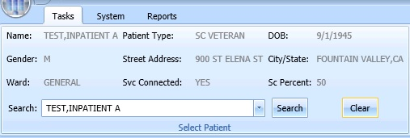

Figure Patient Demographics in the Ribbon Bar

1. Click anywhere in the Select Patient section of the screen to view the Patient Inquiry Detail screen. This allows for viewing of additional patient information.

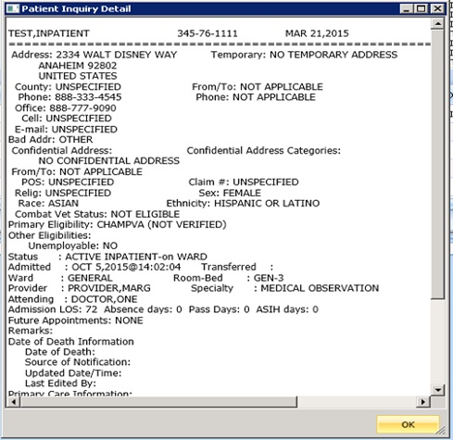

Figure Patient Inquiry Detail

### Patient Eligibility Information

When adding a new Consult, Recall, or APPT request, a **Patient’s Eligibility Information** window displays along with the **New Appointment** dialog. The user can move the **Patient’s Eligibility Information** window around the screen, for convenience.

The window includes:

* SC Percent
* Current Disabilities
* Primary and Secondary Eligibility Codes

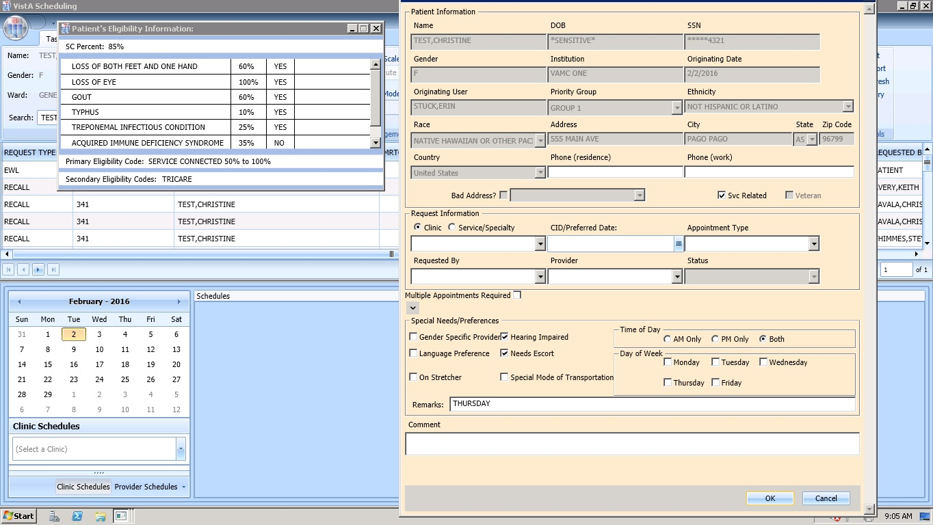

Figure Patient's Eligibility Information

When the **New Appointment** dialog is closed, the **Patient Eligibility Information** window closes automatically.

### Updating Patient Demographics

Patient demographic information, such as ethnicity, race, address, state, ZIP code, country, or phone numbers that were not defined during registration, can be updated while placing an APPT request. Perform the following procedure to update patient demographic data. Use the following procedure to update patient demographics.

1. Log on to VS GUI as a Scheduler.
2. In the **Tasks** tab display, type the patient’s last name, first name in the **Search** text box, click Search button. Then select the requested patient name from drop down list.
3. In the **Request Type** dialog box, select **APPT**, and click **OK**.

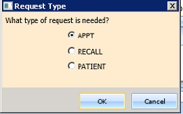

Figure Request Type - APPT

1. In the **Appointment Request** dialog box, undefined patient demographic information will be displayed in empty drop down boxes and text field, in the Patient Information section. Information defined during registration will appear dimmed and is not editable.

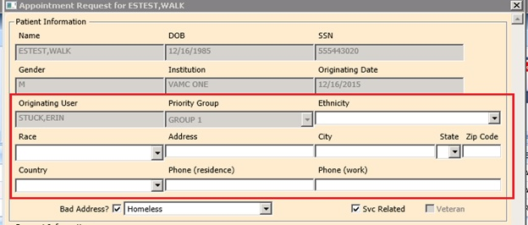

Figure Appointment Request Dialog—Patient Information Section

1. Complete **Appointment Request** per instructions from Section 4.2.2. Click **OK**. Once request is completed the updated patient demographics will be displayed in Ribbon Bar.
2. Click **Clear** to go back to the all patients view.

### Marking for Bad Address

A patient address may be incorrect (e.g., mail has been returned as undeliverable, or if the patient is homeless). If you learn that a patient address is incorrect, you must indicate that information on the patient record so notices will no longer be sent. The bad address can be indicated while updating the patient’s address information when placing an APPT request.

If a patient address is missing because it was not defined during patient registration, then the Bad Address check box is checked by default.

1. Log on to VS GUI as a Scheduler.
2. In the **Tasks** tab display, type the patient’s last name, first name in the **Search** text box, click Search button, and then select the requested patient name from drop down list.



Figure Select Patient3.

In the **Request Type** dialog box, select **APPT**, and click **OK**.



Figure Request Type - APPT4.

In the Appointment Request dialog box, confirm the patient’s address information, and then check the Bad Address check box.

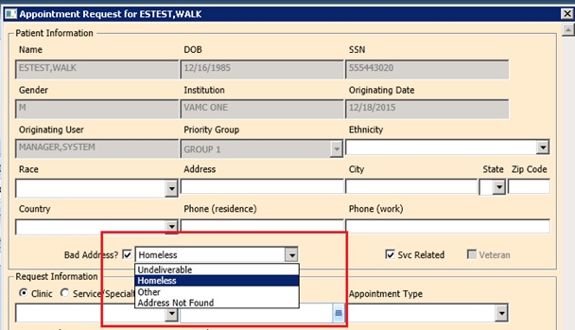

Figure Appointment Request Dialog—Bad Address Selection

1. Choose the reason for the bad address:
   1. Undeliverable
   2. Homeless
   3. Other
   4. Address not found
2. Define the Request Information and Special Needs/Preferences.
3. Click **OK**.

## Actions

### New Request

After searching for and accessing a patient demographics and pending appointments, the Action pane allows you to create a new request for the patient, for example creating a recall request as a follow-up to an appointment request or creating a new appointment request after looking at only patient information.

To start a new request for an already selected patient, use the following steps:

1. Patient demographics and pending appointments will appear in the Ribbon bar. In Actions pane, select New Request.

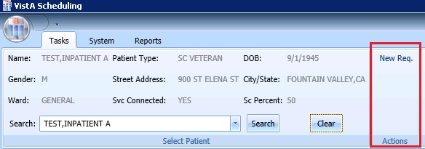

Figure : Actions Pane

1. The Request Type dialog box will re-appear, allowing you to create a new request.



Figure : Request Type – APPT

## Arrangement

### View Mode

Refer to section 3.8.3**: Changing the Schedule View** for changing the arrangement of the default calendar view.

## Pending Appointment Window

The Pending Appointment Window will display a patient’s already booked appointments. The appointment view will default to the current date. The Scheduler can utilize the scroll bar to the right to scroll up to view appointments 365 days in the past. Or, the Scheduler can utilize the scroll bar to scroll down to view appointments 365 days in the future. Selecting an appointment from the Pending Appointment Window in the Ribbon Bar will open the Clinic Schedule Grid.

The clinic schedule will default to the appointment date for past dates. The clinic schedule will default to current (today’s date) for appointments dated “today” or less than three days in the future. The clinic schedule will default to -/+3 days of the appointment date for future dates.

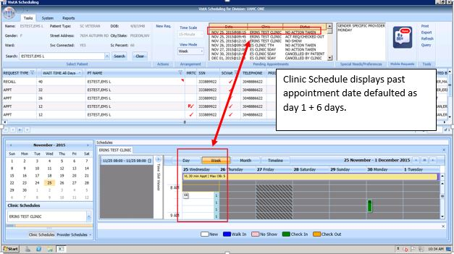

Figure : Pending Appointment Window—Past Appointment Date

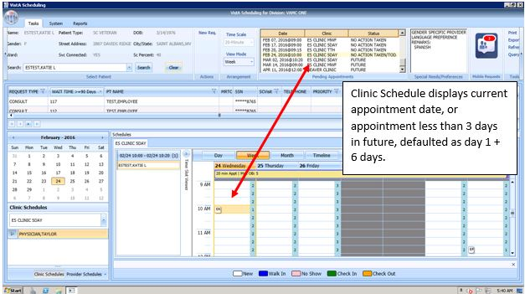

Figure : Pending Appointment Window—Current less than 3 days in future

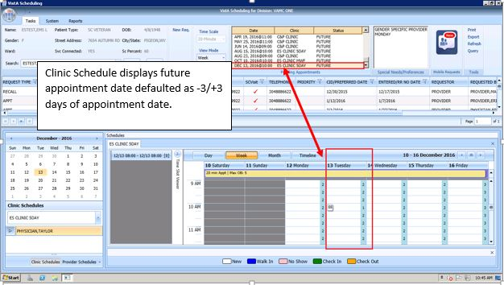

Figure : Pending Appointment Window—Future Appointment Dates

## Special Needs/Preferences

### Adding/Removing Special Needs/Preferences from Requests

Patients visiting the VA may require additional assistance when they arrive for their visit. Some of these special needs/preferences including issues with hearing, how they are arriving at the VA, Day of the Week or Time of the Day etc.

To add Special Needs/Preferences to an appointment request, perform the following:

1. Log on to VS GUI
2. In the Tasks tab display, type the patient’s last name, first name in the Search text box, click Search button, and then select the requested patient name from drop down list.

.

1. Select **APPT** from the Request Type dialog box



Figure : Request Type - APPT

1. Select the patient’s special needs from the Special Needs/Preferences section of the Appointment Request dialog box.
2. Add additional information regarding patient’s Special Needs/Preferences selections in the Remarks field.

**Note:** Remarks entered without accompanying Special/Needs Preferences selections will not display in Ribbon Bar.

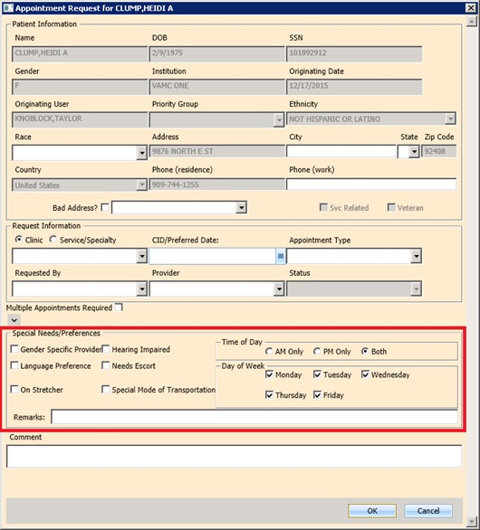

Figure : Appointment Request—Special Needs/Preferences Section

1. Click OK. Special Needs/Preferences entered during APPT Request entry will display in Ribbon Bar.

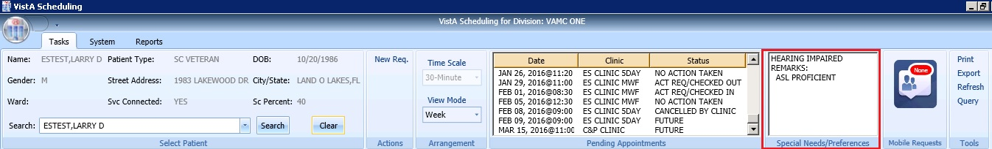

Figure : Ribbon Bar—Special Needs/Preferences

## Mobile Requests

Mobile Requests are requests for appointments submitted by Veterans. If there are pending appointment requests that need processed a number will display inside a red bubble in the Mobile Requests pane. If there are no pending requests the word None will display in the red bubble. For detailed instructions on processing Mobile Requests see section 6.7 Veteran Appointment Request Scheduling.

## Tools

### Print

Refer to Section 3.7.1**: Printing a Request Grid** for details on for using the Print functionality of the Tools Pane

### Export

Refer to Section 3.7.2**: Exporting a Grid** for details on exporting the request grid

### Refresh

After checking a patients pending appointments or checking availability for a clinic, you may want to reset the GUI back to the default view from when you first logon to the GUI, clearing all text entered in any fields.

To refresh the GUI, in the Tools pane, click Refresh. The GUI will reset to its default logon view.

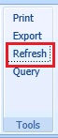

Figure : Refresh Button in Tools Pane

### Query

In order to sift through patient data and only view data of a specific type, the Query tool can be utilized to show only data matching specific criteria. Once the query has been performed, only records matching the query criteria will appear in the request grid.

To perform a query, use the following footsteps:

1. Log on to VS GUI.
2. Select **Query** from the **Tools** pane. The **Request Query** window will display.

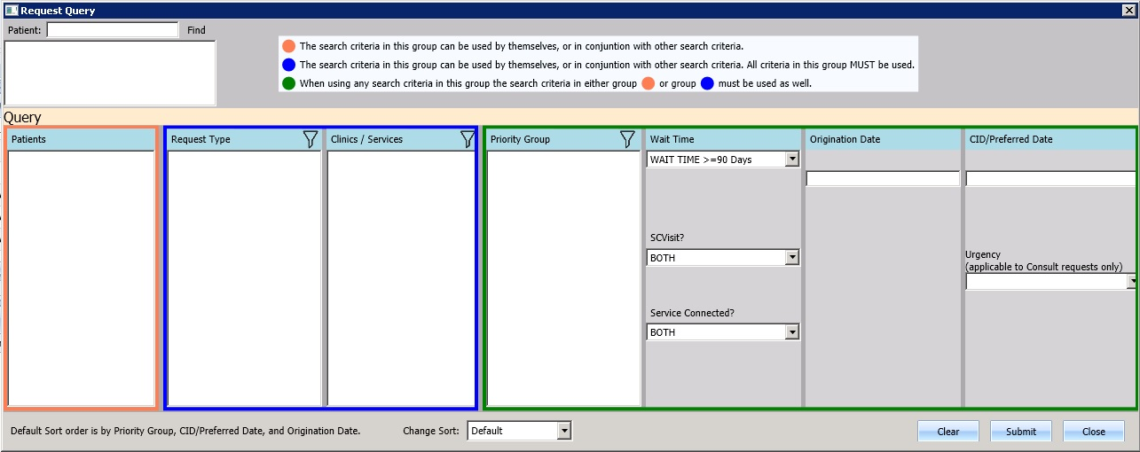

Figure : Request Query

The following business rules are in place to allow for more refined search results:

* Patients are in Group A and can be used independently or in conjunction with other search criteria.
* Request Type + Clinic/Services are in Group B. This group can be used independently or in conjunction with other search criteria.
* Priority, Wait Time, SCVisit, Service Connected, Origination Date, CID/Preferred Date and Urgency are in Group C. This group must be combined with other search criteria from either Group A, Group B, or Group A and B to satisfy the Query Tool business rules.

1. Click **Submit**. If the search criteria rules are not satisfied a **Query Rule Validation** dialog box displays.

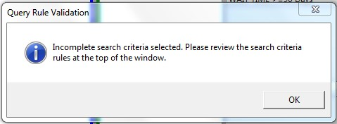

Figure : Query Rule Validation

Once all search criteria has been selected and the results have been returned a **Request Query Confirmation** dialog displays indicating how many records were found that satisfied the search criteria.

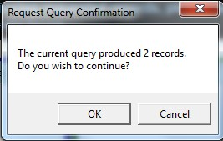

Figure : Request Query Rule Confirmation

1. Click **OK** to display the Query results in the **Request Management Grid**.
2. Click **Clear** to remove search criteria and start a new search.

# Request Management

## Request Management Procedures.

### Viewing a Patient’s Existing Requests

1. Log on to VS GUI as a Scheduler.
2. From the **Tasks** tab display, in the **Search** text box enter the patient’s last name and first name.
3. Click **Search**.
4. Select the requested patient name from drop down list.
5. In the **Request Type** dialog box, select **Patient**, and then click **OK**.



Figure : Request Type - PATIENT

1. In the Request Management grid, view the existing requests for the selected patient. Patient’s booked appointments will display in Pending Appointment Window in the Ribbon Bar defaulted to current date. Schedulers can scroll up or down to view appointments dated -/+365 days of current date.

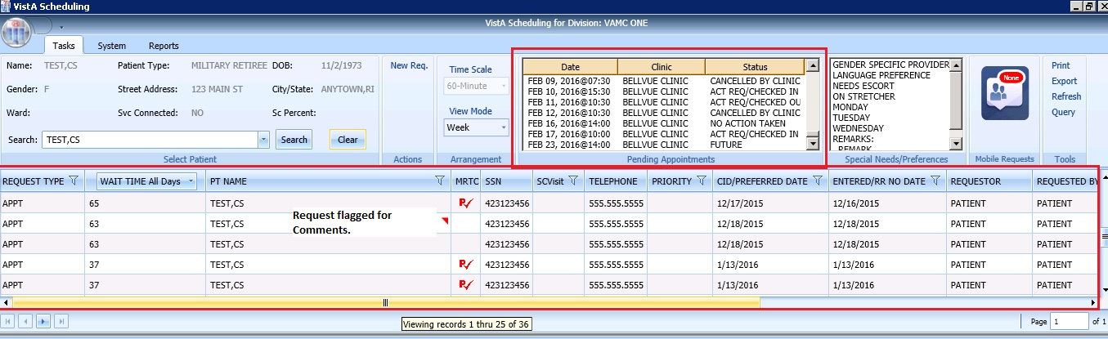

Figure : Request Grid and Pending Appointments

### Adding Appointment Request

1. To submit an appointment request, from **Tasks** tab search for the patient name and select **APPT** in the **Request Type** dialog.



Figure : Request Type - APPT

**Note:** If the patient has already been selected, the **Request Type** dialog can be accessed by clicking **New Req.** in the Actions Pane of the Ribbon Bar.

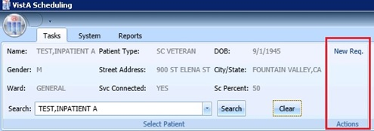

Figure : Actions Pane—New Req. Selection

1. In the Appointment Request dialog confirm Patient Information details.
2. In the **Appointment Request** dialog box, complete the **Request Information** section.
3. Select **Clinic** or **Service/Specialty** radio button. For Clinic enter clinic name (minimum of six characters required). For Service/Specialty enter service or specialty (minimum of six characters required).

* Enter **CID/Preferred Date** for the preferred appointment/recall date. Can enter date directly or select date from Calendar control option. CID/Preferred Date can be past, current, or future.
* Select **Appointment Type** if not defaulted by patient eligibility and clinic selection then choose from drop down list.
* In **Request By**, select either Provider or Patient.
* If **Provider** selected then enter provider name and select from list. (Note: If, Patient was selected in Request By field, then Provider field is dimmed and not editable.)
* **Status** is automatically populated.

1. Established – The patient has been seen at that clinic in the past 24 months
2. New – The patient has not been seen at that clinic in the past 24 months

* See Section 4.3.2 for additional instructions regarding **Multiple Appointment Required** check box options.

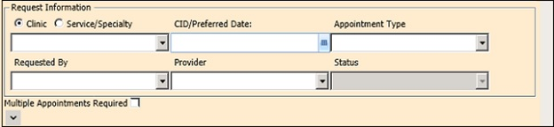

Figure : Appointment Request Dialog—Request Information Section

1. In the **Appointment Request** dialog box, complete the **Special Needs/Preference** section. **Remark**s field is available to add clarifying information regarding selections made. **Selected Special Needs/Preferences** and **Remarks** will display in Ribbon Bar.
2. Text can be added in **Comment** field up to 80 characters to add information regarding Appointment Request. Text will display in Request Management Grid under Comment column.
3. *APPT Requests with Comments are flagged with a red arrow in the Request Management Grid.*
4. Click **OK**. Updated demographics display in ribbon bar. The APPT Request appears on Request Management grid. Clinic Schedule Grid opens for clinic specified in request.

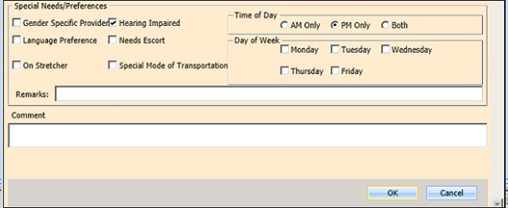

Figure : Special Needs/Preferences section from Appointment Request dialog.

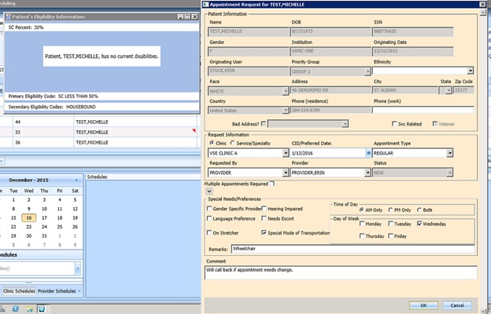

Figure : Appointment Request dialog.

### Viewing/Editing Appointment Request

If a request (APPT, EWL, Veteran) needs to be reviewed or modified before being booked, you can View/Edit the request in the Request Grid using the following steps:

1. Log on to VS GUI as a Scheduler.
2. From the **Tasks** tab display, in the **Search** text box enter the patient’s last name and first name.
3. Click **Search**.
4. Select the requested patient name from drop down list.
5. In **Request Type** dialog, select **Patient**.
6. In the **Request Management** grid, right-click on the applicable **APPT** request.
7. Select APPT/VETERAN Disposition option.
8. The following options appear for selection:

* View Request
* Edit Request
* Transfer to EWL –see section 4.2.4 Transferring to EWL for instructions.
* Death
* Removed/Non-VA Care
* Removed/Scheduled-Assigned
* Removed/VA Contract Care
* Removed/No longer Necessary
* Entered in Error

1. Select **View Request**. The **Appointment Request** dialog box will appear with everything greyed out as the dialog box is Read-Only

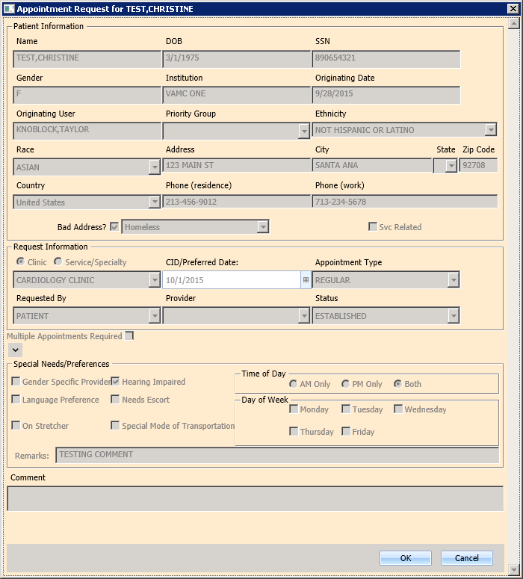

Figure : View Request (read-only)

1. Click OK. You’ll be returned to the request grid.
2. Right-Click on the applicable **APPT** request.
3. Select APPT/VETERAN Disposition option.
4. The following options appear for selection:

* View Request
* Edit Request
* Transfer to EWL –see section 5.1.5Transferring to EWL for instructions.
* Death
* Removed/Non-VA Care
* Removed/Scheduled-Assigned
* Removed/VA Contract Care
* Removed/No longer Necessary
* Entered in Error

1. Select **Edit Request.** The Appointment Request and Patient’s Eligibility Information dialog will display.

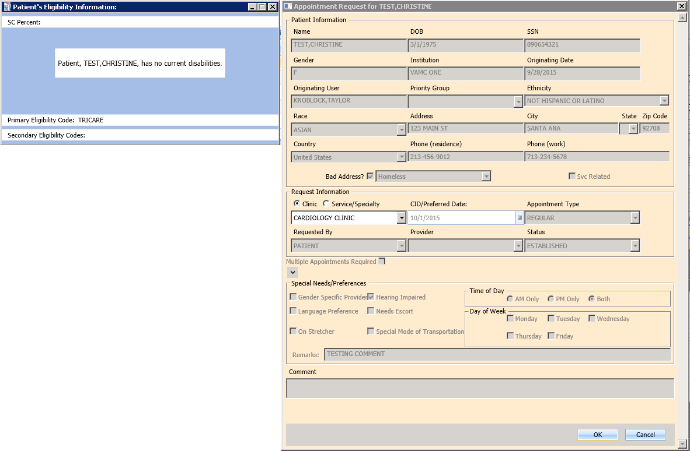

Figure : Edit Request (Request Information Only)

1. The only editable fields are the **Clinic** and **Service/Specialty** radio buttons and text field, and the **CID/Preferred Date** field.
2. Click OK. The request returns to the **Request Grid** with the altered information listed.
3. *If you change the request for a Clinic to a Service/Specialty request, the* ***Appointment Type*** *field becomes editable. Also, changes to the* ***APPT Request*** *are tracked by the system in the SDEC APPT REQUEST file.*

### Disposition or Removing an Appointment Request

If an APPT request is found to no longer be needed Scheduler can remove from Request Grid following the below steps.

1. Log on to VS GUI as a Scheduler.
2. From the **Tasks** tab display, in the **Search** text box enter the patient’s last name and first name.
3. Click **Search**.
4. Select the requested patient name from drop down list.
5. In **Request Type** dialog, select **Patient**.
6. In the **Request Management** grid, right-click on the applicable **APPT** request.
7. Select APPT/VETERAN Disposition option.
8. The following options appear for selection:

* Transfer to EWL –see section 4.2.4 Transferring to EWL for instructions.
* Death
* Removed/Non-VA Care
* Removed/Scheduled-Assigned
* Removed/VA Contract Care
* Removed/No longer Necessary
* Entered in Error

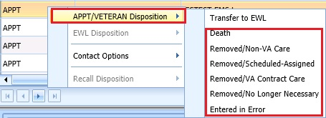

Right-Click in APPT Request.

Figure : APPT/Veteran Disposition Options

1. Select the applicable APPT Disposition option. APPT Request is removed from Request Management Grid.

### Transfer to EWL Request for a Patient

If an appointment cannot be scheduled because of limitations, the patient is put on an Electronic Wait List for future scheduling. Use the following procedures to transfer an APPT Request to an EWL Request.

1. Log on to VS GUI as a Scheduler.
2. From the **Tasks** tab display, in the **Search** text box enter the patient’s last name and first name.
3. Click **Search**.
4. Select the requested patient name from drop down list.
5. In the **Request Type** dialog box, select **Patient**, and then click **OK**.
6. In the **Request Management** grid, view the open APPT Requests for the patient.
7. Select **APPT** request that needs transferred to **EWL**.
8. Right click the APPT request and select **APPT/VETERAN Disposition**.
9. In APPT/VETERAN Disposition options, select **TRANSFER TO EWL**. The **EWL Request** dialog box displays.
10. *The Transfer to EWL option will not be available for MRTC appointments and for users that do not have the SDWL MENU Security Key.*
11. Confirm **Clinic** defaulted in dialog. If not, search and select appropriate Wait List Clinic.
12. *Clinic will not default if not designated as Wait List Clinics in SD Wait List Parameter (File 409.32).*
13. **CID/Preferred** date is not editable.
14. **Appointment Type** is defaulted from APPT Request. If a patient is a Veteran and the Service Related box is checked the type will default to Service Connected. This will put the EWL request in a higher priority than other EWL requests.
15. **Requested By, Provider**, **Status**, and **Special Needs/Preferences** are populated by original APPT request and are not editable.
16. Enter **Comments**, as appropriate.
17. Click **OK**. The request grid shows requests of the selected patient. The newly added request is selected. The calendar defaults to the desired date and shows the clinic schedules.

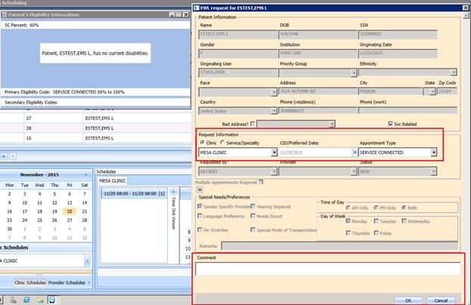

Figure : EWL Request Dialog.

### Disposition or Removing a Patient from the EWL

If a patient is on the EWL for an appointment or a consult, and information is received that the patient no longer needs the appointment, EWL request can be removed and will no longer appear in the Request Management Grid.

To disposition or remove the EWL Request follow the below steps:

1. Log on to VS GUI as a Scheduler.
2. From the **Tasks** tab display, in the **Search** text box enter the patient’s last name and first name.
3. Click **Search**.
4. Select the requested patient name from drop down list. The patient must have an existing EWL request.
5. In the request grid, right-click on the desired EWL request and select EWL Disposition.
6. The following EWL Disposition options are available for selection:

* Death
* Removed/Non-VA Care
* Removed/Scheduled-Assigned
* Removed/VA Contract Care
* Removed/No longer Necessary
* Entered in Error
* Transferred

The EWL Request will be removed from Request Grid and the next APPT Request will be moved up and highlighted.

### Adding Recall Request

Use the following procedure to add a new Recall request for a patient.

1. Log on to VS GUI as a Scheduler.
2. From the **Tasks** tab display, in the **Search** text box enter the patient’s last name and first name.
3. Click **Search**.
4. Select the requested patient name from drop down list.
5. In the **Request Type** dialog box, select **RECALL**, and then click **OK**.

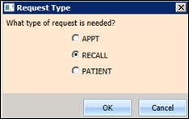

Figure : Request Type - RECALL

1. In the **Appointment Request** dialog box, view the **Special Needs/Preferences** window and add or edit preferences as appropriate.
2. Enter a **Recall Date**. Enter the date the provider requested.
3. Enter a **Recall Date** (per patient). Enter the date the patient prefers.
4. Enter a Recall Appt Type.
   * Follow up
   * Consultation
   * Routine
   * Evaluation
5. Check **Fasting** if patient needs to be fasting for the appointment.
6. Enter the Length of the Appointment.
7. Select **Clinic**. **Note:** Clinic will not appear for selection if Recall Reminders Letter is not defined for the clinic.
8. Select Recall Provider.
9. Enter a **Comment**.
10. Click **OK**. The request grid shows requests of the selected patient. The newly added request is selected. The calendar defaults to the desired date and the selected clinic and defaults, and shows the clinic schedules.
11. View the **Special Needs/Preferences** window in the ribbon bar to confirm it is updated.

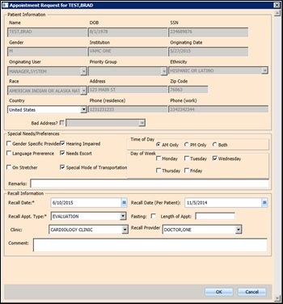

Figure : Recall Appointment Request Dialog

### Disposition or Remove Recall Request

Perform the following procedure to cancel or delete a Recall request.

1. Log on to VS GUI as a Scheduler.
2. From the **Tasks** tab display, in the **Search** text box enter the patient’s last name and first name.
3. Click **Search**.
4. Select the requested patient name from drop down list.
5. In the request grid, right-click the **Recall** request and select **EWL Disposition**. The following dispositions are available for selection:

* Death
* Removed/Non-VA Care
* Removed/Scheduled-Assigned
* Removed/VA Contract Care
* Removed/No Longer Necessary
* Entered in Error
* Transferred

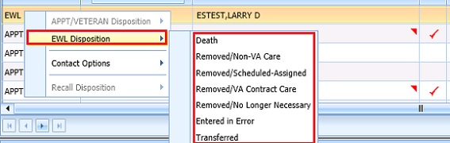

Figure : EWL Disposition Options

1. From the **Recall Comment** dialog box, enter the comments as necessary.
2. Click **OK**. The patient is removed from the request grid.

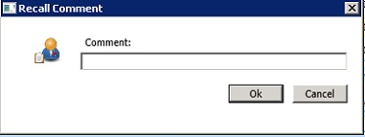

Figure : Recall Comment

## Contacting a Patient

A patient may need to be contacted by phone to schedule an appointment. Contact efforts can be added to the patient record for APPT and EWL requests. They are not viewable in the VS GUI but are storedin the **SDEC APPT REQUEST file. Note:** Once a Contact Option has been processed for a patient it is dimmed in the option and no longer selectable.

### Call Attempt 1

Use the following procedure to document **Call Attempt 1** information. Once documented it is not available for selection in the future.

1. Log on to VS GUI as a Scheduler.
2. From the **Tasks** tab display, in the **Search** text box enter the patient’s last name and first name.
3. Click **Search**.
4. Select the requested patient name from drop down list.
5. In the request grid, right-click APPT or EWL request type, and then select **Contact Options**. The following **Contact Options** are available for selection:

* Call Attempt 1
* Letter Sent to Patient

1. Select Call Attempt 1.

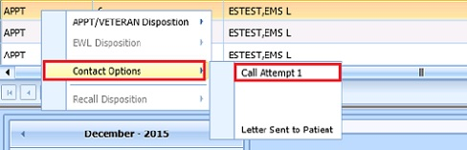

Figure : Contact Options—Call Attempt 1

1. The **Patient Contact** dialog displays, accept the default contact date/time or change as appropriate.

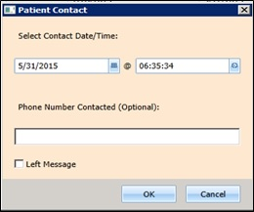

Figure : Patient Contact Dialog

1. Enter phone number that was contacted, if desired.
2. If a message was left, check the **Left Message** checkbox.
3. Click **OK** to close the dialog box.

### Call Attempt 2

Call Attempt 2 option is not available until after Call Attempt 1 has been completed. Once documented it is not available for selection in the future.

Use the following procedure to document Call Attempt 2 information:

1. Log on to VS GUI as a Scheduler.
2. From the **Tasks** tab display, in the **Search** text box enter the patient’s last name and first name.
3. Click **Search**.
4. Select the requested patient name from drop down list.
5. In the request grid, right-click APPT or EWL request type, and then select **Contact Options**.
6. The following **Contact Options** are available for selection:

* Call Attempt 2
* Letter Sent to Patient

1. Select **Call Attempt 2**.

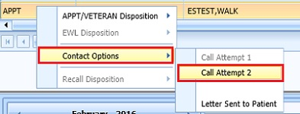

Figure : Contact Options—Call Attempt 2

1. The **Patient Contact** dialog displays, accept the default contact date/time or change as appropriate.



Figure : Patient Contact Dialog

1. Enter phone number that was contacted.
2. If a message was left, check the **Left Message** checkbox.
3. Click **OK** to close the dialog.

### Call Attempt 3

Call Attempt 3 option is not available until after Call Attempt 1 and Call Attempt 2 has been completed.

Use the following procedure to document Call Attempt 3 information:

1. Log on to VS GUI as a Scheduler.
2. From the **Tasks** tab display, in the **Search** text box enter the patient’s last name and first name.
3. Click **Search**.
4. Select the requested patient name from drop down list.
5. In the request grid, right-click APPT or EWL request type, and then select **Contact Options**.
6. The following Contact Options are available for selection:

* Call Attempt 3
* Letter Sent to Patient

1. Select **Call Attempt 3**.

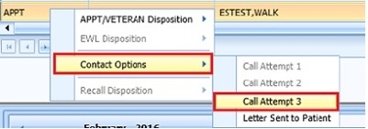

Figure : Contact Options—Call Attempt 3

1. The **Patient Contact** dialog displays, accept the default contact date/time or change as appropriate.



Figure : Patient Contact Dialog

1. Enter phone number that was contacted.
2. If a message was left, check the **Left Message** checkbox.
3. Click **OK** to close the dialog.

### Letter Sent to Patient

Letter Sent to Patient is an alternative option for contacting a patient and is available regardless of the previous Call Attempt Selections. Once documented it is not available for selection in the future.

Use the following procedures to document Letter Sent to Patient:

1. Use Log on to VS GUI as a Scheduler.
2. From the **Tasks** tab display, in the **Search** text box enter the patient’s last name and first name.
3. Click **Search**.
4. Select the requested patient name from drop down list.
5. In the request grid, right-click APPT or EWL request type, and then select **Contact Options**.
6. Select **Letter Sent to Patient**.

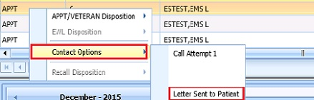

Figure : Contact Options—Letter Sent to Patient

1. The **Patient Contact** dialog displays, accept the default contact date/time or change as appropriate.



Figure : Patient Contact Dialog

1. Click OK to store Letter Sent to Patient information and close dialog.

# Appointment Management

## Adding Appointments

### Add Appointment for Appointment Request

1. Log into VS GUI as a Scheduler.
2. In the Tasks tab display, type the patient’s last name, first name in the Search text box, click Search button, and then select the requested patient name from drop down list.
3. In the **Request Type** dialog box, select **APPT** to create new request or select Patient for existing request, and then click **OK**.

**Note: See Section 0for steps on adding new APPT Request.**



Figure : Request Type - PATIENT

1. In **Request Management** grid select **APPT** request. The Clinic Schedule Grid will display the clinic schedule based upon CID/Preferred date of request. For past dates, the clinic schedule will open defaulted to CID/Preferred date. For current date (or CID/Preferred date less than 3 days in future), the clinic schedule will display defaulted to current date. For future dates, the clinic schedule will display -/+3 days of CID/Preferred date.

**Note:** For newly created APPT request the system will automatically highlight APPT request and Clinic Schedule will display.

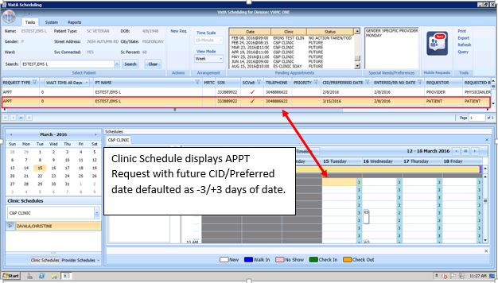

Figure : Select APPT Request—Clinic Schedule Grid display

1. In Clinic Schedule Grid, select available time slot. Time Slot details will display in Time Slot Viewer.

**Note: See Section 7.1.7 Time Slot Viewer for detailed information on Time Slot Viewer functionality.**

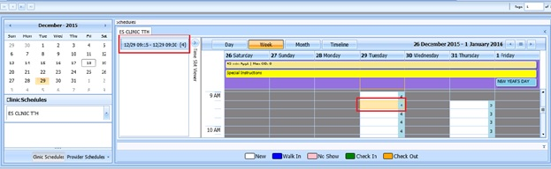

Figure : Select Time Slot

1. Right Click in time slot. Add Appointment option will display. Create Walk In Appointment option is only available for selection on current date. It will not be available for past or future CID/Preferred dates.

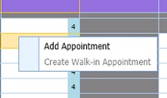

Figure : Right-Click options - Add Appointment

1. Select Add Appointment.
2. New Appointment dialog displays as well as Patient Eligibility dialog. New Appointment dialog has two tabs:

* **Appointments Tab**:
* **Patient Information** Section displays Name, DOB, SSN, Svc Connected, Sc Percent, GAF (read only), and Svc Related check box.
* **Appointment Information** section displays Start Time, Appt Type, Duration, Clinic and Notes. Notes is the only editable field. Information can be added pertinent to appointment.
* **Appointment conflicts** section will display any appointments already schedule that conflict with appointment being added.
* **Contact Information Tab** - displays the patient's address and home and work phone numbers (read only).

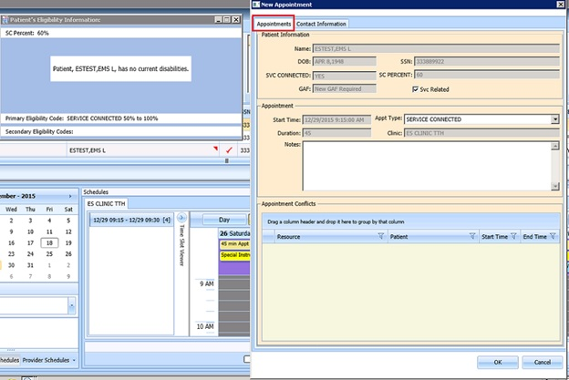

Figure : New Appointment dialog - Appointments Tab

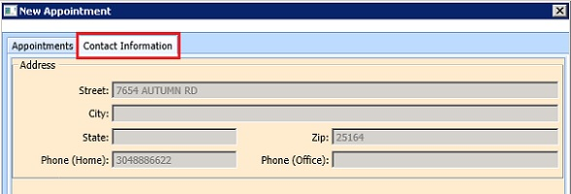

Figure : New Appointment dialog - Contact Information Tab

1. Add any applicable Notes to appointment. Click OK.
2. Print Letter? Dialog displays. Click OK to send Letter to patient. Click Cancel to not send letter.

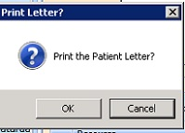

Figure : Print Letter? Dialog

1. Closing Request dialog displays. Click OK.

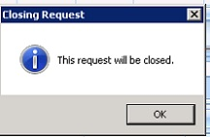

Figure : Closing Request Dialog

1. APPT Request is removed from Patient Request Management Grid. Next request for patient is moved up and highlighted.
2. Clinic Schedule closes.
3. New appointment displays in Pending Appointment Window in Ribbon Bar.
4. Select appointment from the Pending Appointment window to view the appointment in the Clinic Schedule Grid. The clinic schedule will open. For past dates, the clinic schedule will open defaulted to appointment date. For current date (or appointment date less than 3 days in future), the clinic schedule will display defaulted to current date. For future dates, the clinic schedule will display -/+3 days of appointment date.



Figure : Clinic Schedule Grid –Past Appointment Date Display



Figure : Clinic Schedule Grid—Current or less than 3 days in future Appointment in Clinic Schedule Display



Figure : Clinic Schedule Grid--Future Appointment Date in Clinic Schedule Display

### Add Appointment for EWL Request

1. Log into VS GUI as a Scheduler.
2. In the Tasks tab display, type the patient’s last name, first name in the Search text box, click Search button, and then select the requested patient name from drop down list.
3. In the **Request Type** dialog box, select **APPT** to create new request or select Patient for existing request, and then click **OK**.

**Note:** See Section 5.1.5 for steps on transfer APPT request to new EWL Request.



Figure : Request Type - PATIENT

1. In **Request Management** grid select **EWL** request. The Clinic Schedule Grid will display the clinic schedule based upon CID/Preferred date of request. For past dates, the clinic schedule will open defaulted to CID/Preferred date. For current date (or CID/Preferred date less than 3 days in future), the clinic schedule will display defaulted to current date. For future dates, the clinic schedule will display -/+3 days of CID/Preferred date.

**Note:** For newly created Recall request the system will automatically highlight APPT request and Clinic Schedule will display.

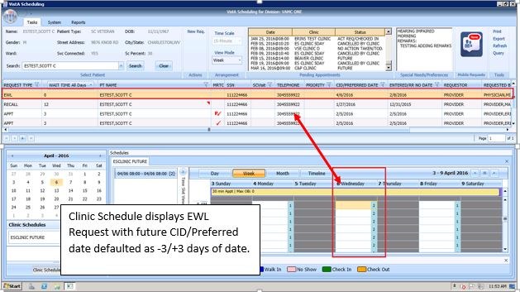

Figure : Select EWL Request

1. In Clinic Schedule Grid, select available time slot. Time Slot details will display in Time Slot Viewer.

**Note:** See Section 7.1.7 Time Slot Viewer for detailed information on Time Slot Viewer functionality.

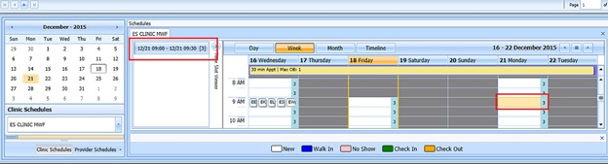

Figure : Select time slot

1. Right Click in time slot. Add Appointment option will display. Create Walk In Appointment option is only available for selection on current date. It will not be available for past or future CID/Preferred dates.



Figure : Right click options - Add Appointment

1. Select Add Appointment.
2. New Appointment dialog displays as well as Patient Eligibility dialog. New Appointment dialog has two tabs:

* **Appointments Tab-**
* **Patient Information** section displays Name, DOB, SSN, Svc Connected, Sc Percent, GAF (read only), and Svc Related check box.
* **Appointment Information** section displays Start Time, Appt Type, Duration, Clinic and Notes. Notes is the only editable field. Information can be added pertinent to appointment.
* **Appointment conflicts** section will display any appointments already schedule that conflict with appointment being added.
* **Contact Information** **Tab** - displays the patient's address and home and work phone numbers (read only).

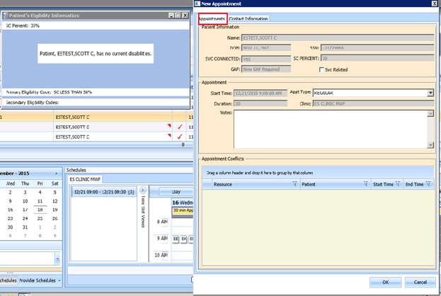

Figure : New Appointment Dialog –Appointments Tab

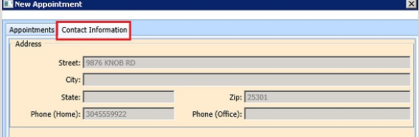

Figure : New Appointment dialog - Contact Information Tab

1. Add any applicable Notes to appointment. Click OK.
2. Print Letter? Dialog displays. Click OK to send Letter to patient. Click Cancel to not send letter.



Figure : Print Letter? Dialog

1. Closing Request dialog displays. Click OK.



Figure : Closing Request Dialog

1. EWL Request is removed from Patient Request Management Grid. Next request for patient is moved up and highlighted.
2. Clinic Schedule closes.
3. New appointment displays in Pending Appointment Window in Ribbon Bar.
4. Select appointment from the Pending Appointment window to view the appointment in the Clinic Schedule Grid. The clinic schedule will open. For past dates, the clinic schedule will open defaulted to appointment date. For current date (or appointment date less than 3 days in future), the clinic schedule will display defaulted to current date. For future dates, the clinic schedule will display -/+3 days of appointment date.



Figure : Past appointment date in Clinic Schedule Grid—EWL Appointment Past Date Display

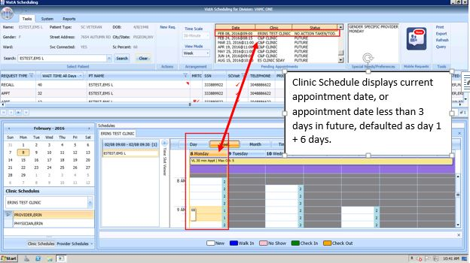

Figure : Clinic Schedule Grid--EWL Appointment Current Date



Figure : Future appointment date in Clinic Schedule Grid—EWL Appointment Future Date Display

### Add Appointment for Recall Request

1. Log into VS GUI as a Scheduler.
2. In the Tasks tab display, type the patient’s last name, first name in the Search text box, click Search button, and then select the requested patient name from drop down list.
3. In the **Request Type** dialog box, select **Recall** to create new request or select Patient for existing request, and then click **OK**.

**Note: See Section 5.1.7for steps on adding new Recall Request.**



Figure : Request Type - PATIENT

1. In **Request Management** grid select **Recall** request. The Clinic Schedule Grid will display the clinic schedule based upon CID/Preferred date of request. For past dates, the clinic schedule will open defaulted to the CID/Preferred date. For current date (or CID/Preferred date less than 3 days in future), the clinic schedule will display defaulted to current date. For future dates, the clinic schedule will display -/+3 days of CID/Preferred date.

**Note:** For newly created Recall request the system will automatically highlight RECALL request in Request Management Grid and Clinic Schedule will display.

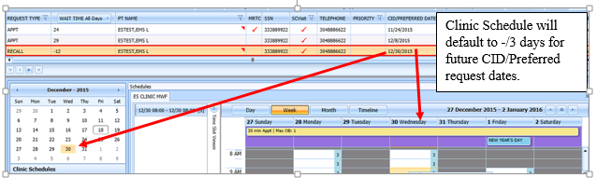

Figure : Select Recall Request

1. In Clinic Schedule Grid, select available time slot. Time Slot details will display in Time Slot Viewer.

**Note:** See Section 7.1.7 Time Slot Viewer for detailed information on Time Slot Viewer functionality.

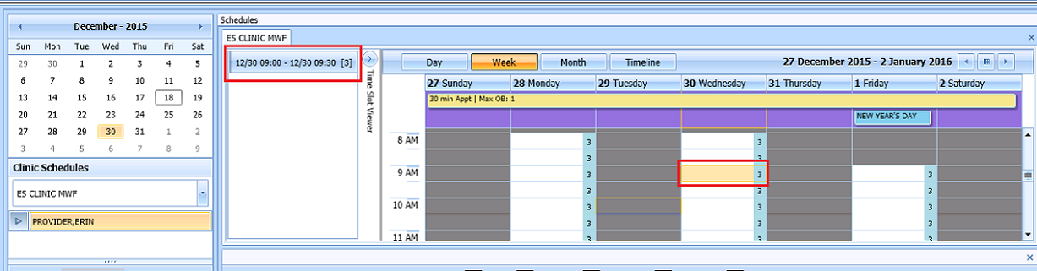

Figure : Select time slot

1. Right Click in time slot. Add Appointment option will display. Create Walk In Appointment option is only available for selection on current date. It will not be available for past or future CID/Preferred dates.

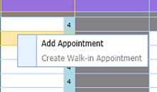

Figure : Right click options - Add Appointment

1. Select Add Appointment.
2. New Appointment dialog displays as well as Patient Eligibility dialog. New Appointment dialog has two tabs:

* **Appointments Tab-**
* **Patient Information Section displays Name, DOB, SSN, Svc Connected, Sc Percent, GAF (read only), and Svc Related check box.**
* **Appointment Information** section displays Start Time, Appt Type, Duration, Clinic and Notes. Notes is the only editable field. Information can be added pertinent to appointment.
* **Appointment conflicts** section will display any appointments already schedule that conflict with appointment being added.
* **Contact Information Tab** - displays the patient's address and home and work phone numbers (read only).

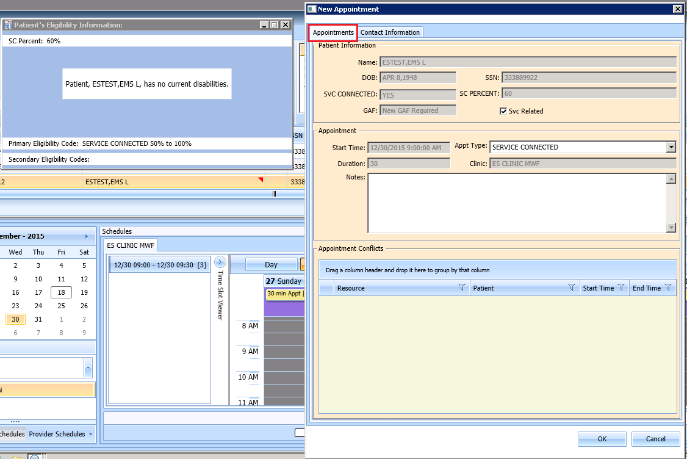

Figure : New Appointment dialog - Appointments Tab

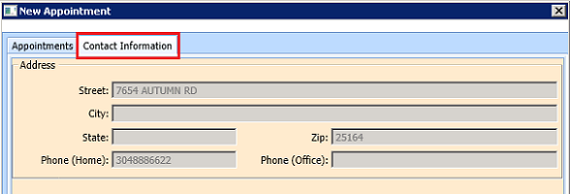

Figure : New Appointment dialog - Contact Information Tab

1. Add any applicable Notes to appointment. Click OK.
2. Print Letter? Dialog displays. Click OK to send Letter to patient. Click Cancel to not send letter.

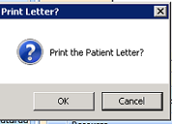

Figure : Print Letter? Dialog

1. Closing Request dialog displays. Click OK.

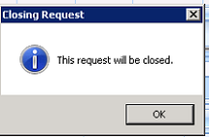

Figure : Closing Request Dialog

**NOTE:** The Recall request is not immediately removed from the request grid. The request will be removed when the task "CLEAN UP CLINIC RECALL ENTRIES" has been ran and when the appointment is made within the CLEAN UP DAY SETTING in ENTER/EDIT CLINIC RECALL SITE PARAMS menu option.

1. Clinic Schedule closes.
2. New appointment displays in Pending Appointment Window in Ribbon Bar.
3. Select appointment from the Pending Appointment window to view it in Clinic Schedule Grid. The clinic schedule will open. For past dates, the clinic schedule will display the defaulted to appointment date. For current date (or appointment date less than 3 days in future), the clinic schedule will display appointment date as day 1 + 6 days to current date. For future dates, the clinic schedule will display -/+3 days of appointment date.



Figure : Past appointment date in Clinic Schedule display—Past Date Appointment



Figure : Clinic Schedule Display –Current Date Appointment



Figure : Future appointment date in Clinic Schedule display--Future Date Appointment

### Add Appointment for Consult Request

1. Log into VS GUI as a Scheduler.
2. In the Tasks tab display, type the patient’s last name, first name in the Search text box, click Search button, and then select the requested patient name from drop down list.
3. In the **Request Type** dialog box, select Patient for existing **Consult** and then click **OK**.

**Note:** Consult requests are added from CPRS.

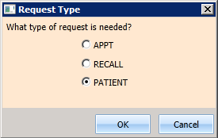

Figure : Request Type - PATIENT

1. In **Request Management** grid select **Consult** request.

**Note: Clinic Schedule will NOT display when selecting Consult request.**

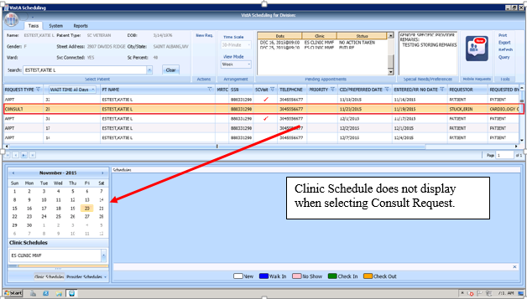

Figure : Select Consult Request

1. From Clinic Schedules, enter clinic name (6 character minimum).

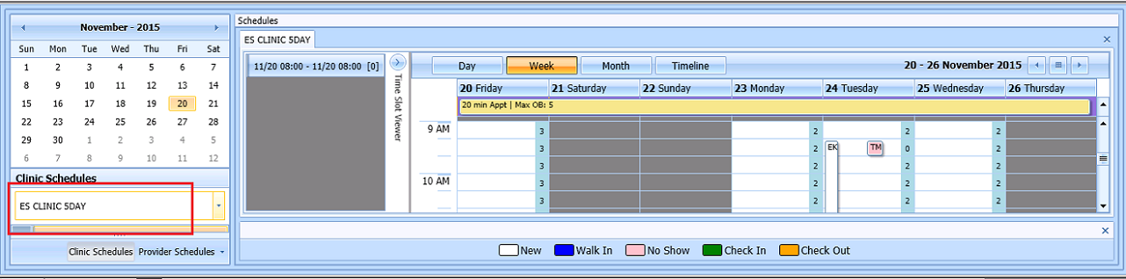

Figure : Clinic Schedules

1. In Clinic Schedule displays. Left click available time slot. Time Slot details will display in Time Slot Viewer.

**Note:** See Section 7.1.7 Time Slot Viewer for detailed information on Time Slot Viewer functionality.

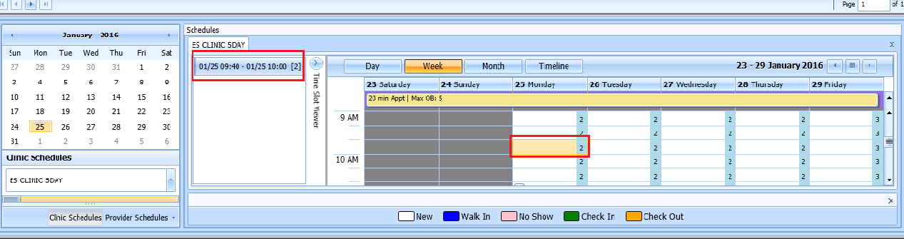

Figure : Select time slot

1. Right Click in time slot. Add Appointment option will display. Create Walk In Appointment option is only available for selection on current date. It will not be available for past or future CID/Preferred dates.



Figure : Right Click options - Add Appointment

1. Select Add Appointment.
2. New Appointment dialog displays as well as Patient Eligibility dialog. New Appointment dialog has two tabs:

* **Appointments Tab**-

**Patient Information** section displays Name, DOB, SSN, Svc Connected, SC Percent, GAF (read only), and Svc Related check box.

**Appointment Information** section displays Start Time, Appt Type, Duration, Clinic and Notes. Notes is the only editable field. Information can be added pertinent to appointment.

**Appointment conflicts** section will display any appointments already schedule that conflict with appointment being added.

* **Contact Information** **Tab** - displays the patient's address and home and work phone numbers (read only).

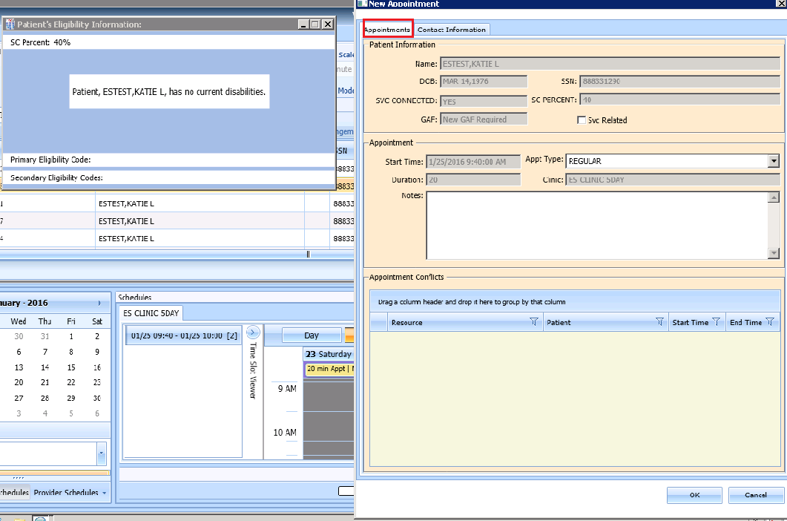

Figure : New Appointment dialog - Appointments Tab

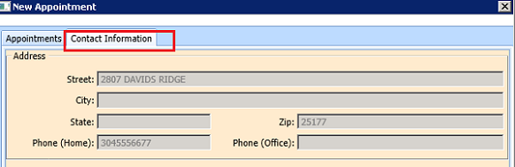

Figure : New Appointment dialog - Contact Information Tab

1. Add any applicable Notes to appointment. Click OK.
2. Print Letter? Dialog displays. Click OK to send Letter to patient. Click Cancel to not send letter.



Figure : Print Letter? Dialog

1. Consult Request is removed from Patient Request Management Grid. Next request for patient is moved up and highlighted.
2. Clinic Schedule closes.
3. New appointment displays in Pending Appointment Window in Ribbon Bar.
4. Select appointment from the Pending Appointment window to view it in the Clinic Schedule Grid. The clinic schedule will open. For past dates, the clinic schedule will open defaulted to appointment date. For current date (or appointment date less than 3 days in future), the clinic schedule will display defaulted to current date. For future dates, the clinic schedule will display -/+3 days of appointment date.

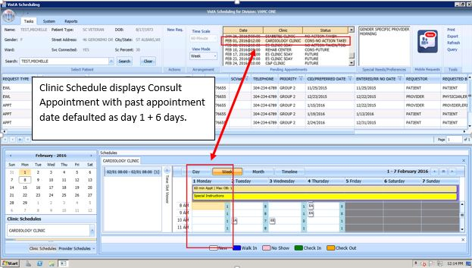

Figure : Clinic Schedule Display --Consult Past Appointment Date

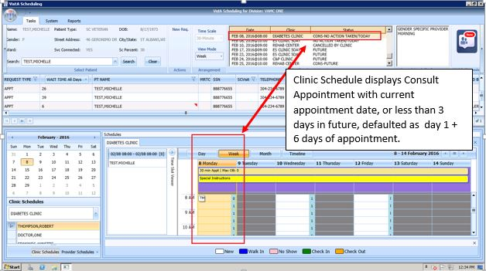

Figure : Consult with current date or less than 3 days in future in Clinic Schedule display

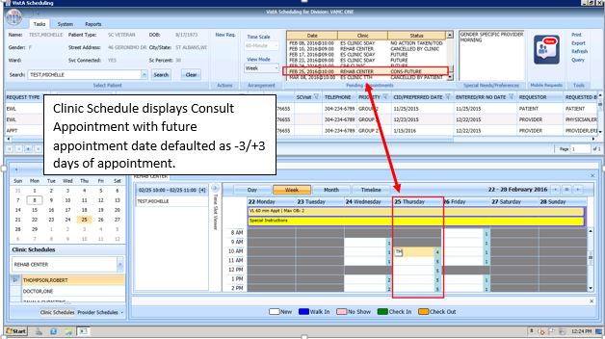

Figure : Consult future appointment date in Clinic Schedule display

## Disposition Appointments

### Edit Appointment Information

Editing appointment information can be done with in the VS GUI.

Perform the following procedure to edit appointment information:

1. Log on to VS GUI as a Scheduler.
2. In the Tasks tab display, type the patient’s last name, first name in the Search text box, click Search button, and then select the requested patient name from drop down list.
3. In **Request Type** dialog, select **Patient**.
4. Locate the appointment to be edited in the Pending Appointments Window in the Ribbon Bar.
5. The clinic schedule will be displayed. For past appointment dates, the clinic schedule will open defaulted to appointment date. For current date (or appointment date less than 3 days in future), the clinic schedule will display defaulted to current date. For future dates, the clinic schedule will display -/+3 days of appointment date.
6. In the Clinic Schedule Grid, locate the appointment, right-click on the appointment, and then select **Edit Appointment**.

**Note:** See section 7.1.7 for Time Slot Viewer details.

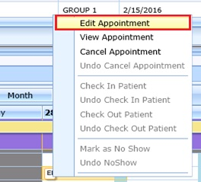

Figure : Appointment Right Click Options -- Edit Appointment

1. Edit Appointment dialog displays.
2. The only field that is editable is Notes. Make any necessary edits to the appointment information and click OK.

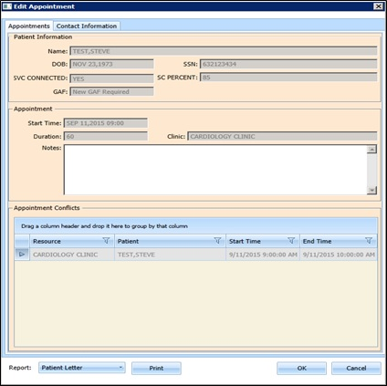

Figure : Edit Appointment Dialog

### View Appointment Information

Viewing appointment information can be done in the Clinic Schedule Grid in the VS GUI.

Perform the following procedure to view appointment information:

1. Log on to VS GUI as a Scheduler.
2. In the Tasks tab display, type the patient’s last name, first name in the Search text box, click Search button, and then select the requested patient name from drop down list.
3. In Request Type dialog, select **Patient**.
4. Locate the appointment to be viewed in the Pending Appointments Window in the Ribbon Bar.
5. The clinic schedule will be displayed. For past appointment dates, the clinic schedule will default to appointment date as Day 1 + 6 days. For current date (or appointment date less than 3 days in future), the clinic schedule will display defaulted to current date as Day 1 + 6 days. For future dates, the clinic schedule will display -/+3 days of appointment date.
6. In the Clinic Schedule Grid, locate the appointment, hover over the appointment, and the appointment details will be displayed in hover box.

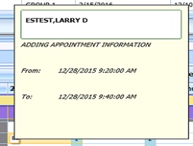

Figure : Hover box displaying appointment details

1. Right click appointment.
2. Select View Appointment.

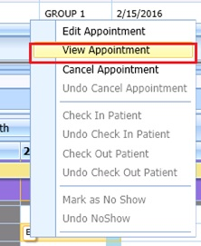

Figure : Appointment Right Click Options--View Appointment

1. View Appointment dialog displays. It is in read-only mode. No fields will be editable Click OK to close View Appointment dialog.

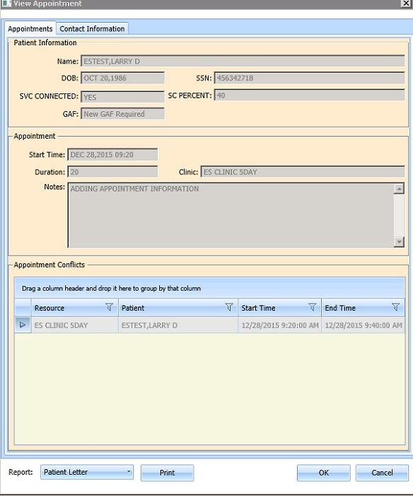

Figure : View Appointment Dialog

### Canceling an Appointment

You can cancel an appointment without rebooking it.

1. Log on to VS GUI as a Scheduler.
2. In the Tasks tab display, type the patient’s last name, first name in the Search text box, click Search button, and then select the requested patient name from drop down list.
3. In Request Type dialog, select **Patient**.
4. Select a scheduled appointment from Pending Appointment Window in Ribbon Bar.
5. The clinic schedule displays. For past appointment dates, the clinic schedule will open defaulted to appointment date. For current date (or appointment date less than 3 days in future), the clinic schedule will display defaulted to current date. For future dates, the clinic schedule will display -/+3 days of appointment date.
6. Select appointment from Clinic Schedule Grid.
7. Right-click and select **Cancel**.

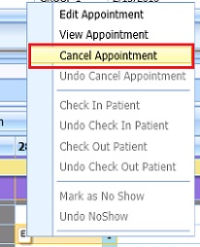

Figure : Appointment Right Click Options--Cancel Appointment

1. In the **Cancel Appointment** dialog box, select a cancellation option:
   * **Cancelled by Clinic**: The original CID/Preferred appointment date defaults to the patient desired date. The date cannot be edited.
   * **Cancelled by Patient**: The patient CID/Preferred date is available and defaults to original CID/Preferred date request. You can edit the date to change it.
2. Select **Reason for Cancellation** from list.
3. Edit CID/Preferred dates if applicable.
4. Add Remarks as needed.
5. Click **OK**. The appointment is canceled and not rebooked. If the appointment is linked to a consult, the consult status changes to Active.

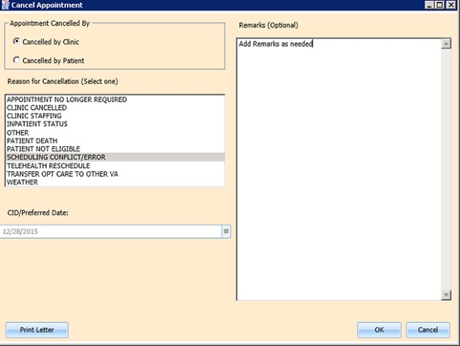

Figure : Cancel Appointment Dialog

1. Appointment will display in Pending Appointment with status of Cancelled by Clinic or Cancelled by Patient (as applicable).

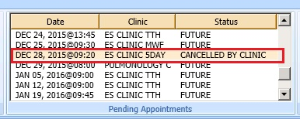

Figure : Pending Appointment Window –Appointment Status Cancelled by Clinic

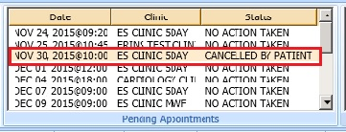

Figure : Pending Appointment Window –Appointment Status Cancelled by Patient

1. Clinic Schedule closes.
2. The patient’s appointment request reappears on the request grid for future rescheduling.
3. Select APPT Request and Clinic Schedule displays again.

**Note: Time Slot count increases when appointment is cancelled.**

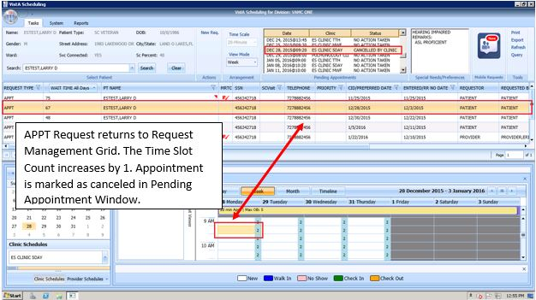

Figure : APPT Request returns to Request Management Grid and Time Slot Count Increases

### Mark as No Show Appointment

Perform the following procedure to record a no show appointment.

1. Log on to VS GUI as a Scheduler.
2. In the Tasks tab display, type the patient’s last name, first name in the Search text box, click Search button, and then select the requested patient name from drop down list.
3. In the **Request Type** dialog box, select **Patient**.
4. From **Pending Appointment** Window select appointment to mark as no show.
5. The clinic schedule will be displayed. For past appointment dates, the clinic schedule Clinic Schedule will display defaulted to appointment date. For current date (or appointment date less than 3 days in future), the clinic schedule will display defaulted to current date. For future dates, the clinic schedule will display -/+3 days of appointment date.
6. Select appointment from Clinic Schedule Grid.
7. Right click Appointment.
8. Select Mark as No Show.

**Note: Mark as Now Show is not available to select on future dated appointments.**

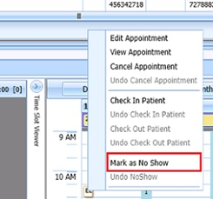

Figure : Appointment Right Click Options—Mark as No Show

1. Mark as No Show dialog displays.

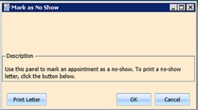

Figure : Mark as No Show Dialog

1. Click OK.
2. Appointment will display as pink in Clinic Schedule Grid and Time Slot Viewer.

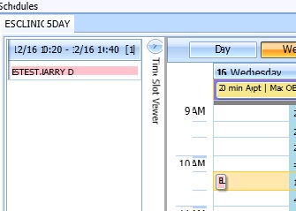

Figure : Clinic Schedule Display—No Show Pink

1. Status in Pending Appointment Window in Ribbon Bar changes to No Show.

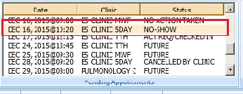

Figure : Pending Appointment Window –Appointment Status No-Show

### Undo No-Show Appointment

If a patient is recorded as a no-show but arrives in time to be seen, a previously recorded no show can be undone. Perform the following procedure to undo a no-show appointment.

1. Log on to VS GUI as a Scheduler.
2. In the Tasks tab display, type the patient’s last name, first name in the Search text box, click Search button, and then select the requested patient name from drop down list.
3. In Request Type dialog, select **Patient**.
4. In the Pending Appointments Window in Ribbon Bar, locate the No Show appointment to undone.
5. The clinic schedule will be displayed. For past appointment dates, the clinic schedule will display defaulted to appointment date. For current date (or appointment date less than 3 days in future), the clinic schedule will display defaulted to current date.
6. Right-Click Appointment.
7. Select Undo NoShow.

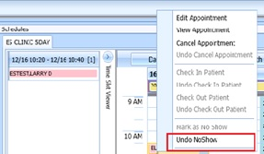

Figure : Appointment Right Click Options—Undo NoShow

1. In Clinic Schedule Grid, the appointment changes from pink to white.

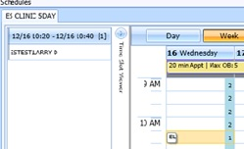

Figure : Appointment Clinic Schedule Display--Undo NoShow as white

1. Appointment status in Pending Appointment Window changes to No Action Taken.

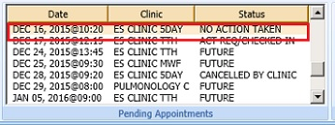

Figure : Pending Appointment Window Undo NoShow--Appointment Status No Action Taken

### Checking In a Patient

Perform the following procedure to check in a patient for an appointment.

1. Log on to VS GUI as a Scheduler.
2. In the Tasks tab display, type the patient’s last name, first name in the Search text box, click Search button, and then select the requested patient name from drop down list.
3. In the Pending Appointments Window in Ribbon Bar, locate the appointment to be checked in.
4. The clinic schedule will be displayed. For past appointment dates, the clinic schedule Clinic Schedule will open defaulted to appointment date. For current date (or appointment date less than 3 days in future), the clinic schedule will display defaulted to current date. For future dates, the clinic schedule will display -/+3 days of appointment date.
5. Right-Click Appointment.
6. Select Check In Patient.

**Note:** Check In is not available for future dated appointments.

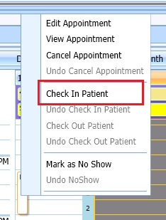

Figure : Appointment Right Click Options—Check In Patient

1. **Appointment Check In** dialog displays, edit the check in date and time as needed.

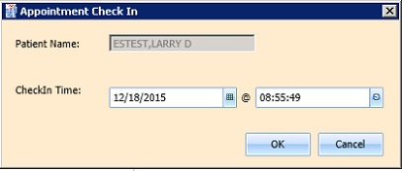

Figure : Appointment Check In Dialog

1. Click **OK**. The appointment color changes to green, signifying the patient has checked in for the appointment.

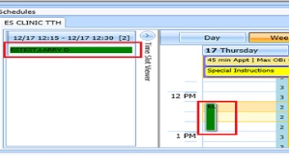

Figure : Clinic Schedule Display—Check In Green

1. In Pending Appointment Window in Ribbon Bar, appointment status changes ACT REQ/CHECKED IN**.**

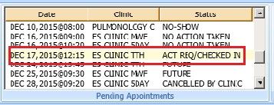

Figure : Pending Appointment Window—Appointment Status ACT REQ/CHECKED IN

### Undo a Patient Check In

If a patient is checked in by mistake, the check in can be undone.

Perform the following steps to undo a patient check in:

1. Log on to VS GUI as a Scheduler.
2. In the Clinic Schedule Grid, select the patient check in that needs to be undone.
3. Right-click and select **Undo Check In Patient**.

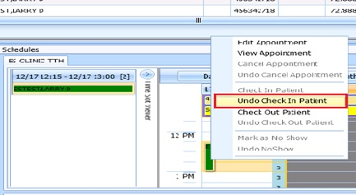

Figure : Appointment Right Click Options—Undo Check In Patient

1. Appointment will change color display from green to white.

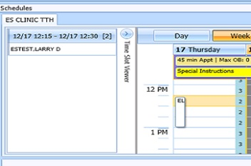

Figure : Clinic Schedule Display --Undo Check In Patient White

1. From Pending Appointment Window, appointment status changes to No Action Taken.

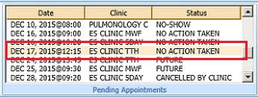

Figure : Pending Appointment Window--Appointment Status No Action Taken

### Check Out a Patient

Perform the following procedure to check out a patient.

1. Log on to VS GUI as a Scheduler.
2. In the Tasks tab display, type the patient’s last name, first name in the Search text box, click Search button, and then select the requested patient name from drop down list.
3. In the Pending Appointments Window in Ribbon Bar, locate the appointment to be checked out.
4. Clinic Schedule will be displayed. For past appointment date, Clinic Schedule will open defaulted to appointment date. For current date (or appointment date less than 3 days in future), schedule will display defaulted to current date. For future dates, schedule will display -/+3 days of appointment date.
5. Right-click and select **Check Out Patient**.

**Note:** Check Out is not available to select if Check In has not been performed.

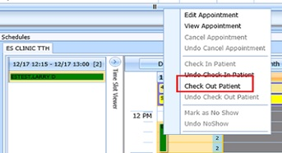

Figure : Appointment Right Click Options—Check Out Patient

1. Update the **Appointment Check Out** dialog box.
   * Confirm the date and time. Edit as needed.
   * Check Follow-up Needed, if applicable.
2. Click **OK**. The appointment status is changed to ACT REQ/**Checked Out** in Pending Appointment Window and the color changes to orange in Clinic Schedule.

**Note:** When Scheduler clicks OK, if Follow-up Needed was checked, then the New APPT Request dialog will display. This APPT Request dialog will need to be completed before Patient Check Out is complete.

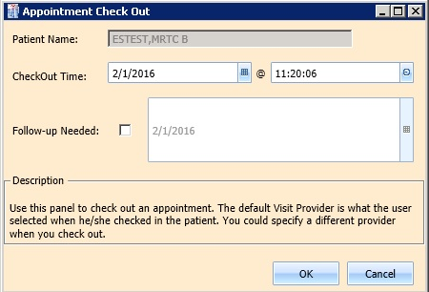

Figure : Appointment Check Out Dialog

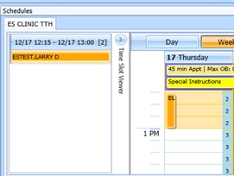

Figure : Clinic Schedule Display--Check Out Patient Orange

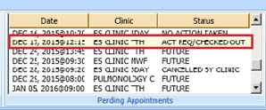

Figure : Pending Appointment Window—Appointment Status ACT REQ/CHECKED OUT

### Undo a Patient Check In

If a patient is checked out by mistake, the checkout can be undone.

Perform the following steps to undo a patient checkout:

1. Log on to VS GUI as a Scheduler.
2. In the Clinic Schedule Grid, select the patient check in that needs to be undone.
3. Right-click and select **Undo Check Out Patient**.

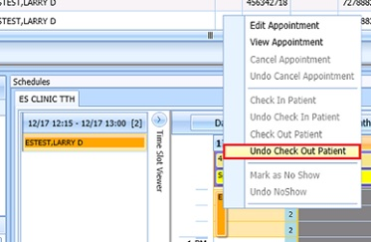

Figure : Appointment Right Click Options--Undo Check Out Patient

1. Appointment will change display from orange to green.

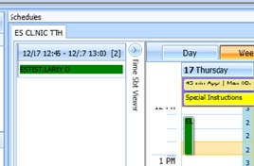

Figure : Clinic Schedule Display--Undo Check Out Patient Green

1. From Pending Appointment Window, appointment status changes to ACT REQ/CHECKED IN.

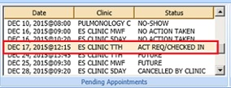

Figure : Pending Appointment Window--Appointment Status ACT REQ/CHECKED IN

### Rescheduling an Appointment

You can cancel an appointment and reschedule it for another time.

1. Log on to VS GUI as a Scheduler.
2. In the Tasks tab display, type the patient’s last name, first name in the Search text box, click Search button, and then select the requested patient name from drop down list.
3. In Request Type dialog, select **Patient**.
4. In the **Pending Appointments** Window in Ribbon Bar, locate and select the appointment to be rescheduled.
5. Clinic Schedule will be displayed. For past appointment date, Clinic Schedule will open defaulted to appointment date. For current date (or appointment date less than 3 days in future), schedule will display defaulted to current date. For future dates, schedule will display -/+3 days of appointment date.
6. In Clinic Schedule Grid, select the scheduled appointment, drag and drop it to another open time slot.
7. **Move Appointment** dialog displays.
8. Click **OK** to confirm new appointment time.

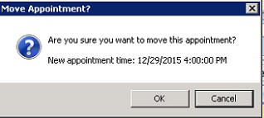

Figure : Move Appointment? Dialog

1. In the **Cancel Appointment** dialog box, define the fields as appropriate.

**Note:** See section 6.2.3 for detailed instructions on canceling appointment.

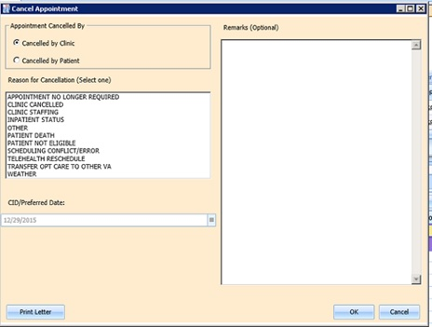

Figure : Cancel Appointment Dialog

1. Click **OK**. In Pending Appointment Window in Ribbon Bar, the original appointment is canceled and a new appointment is created. If the appointment is linked to a consult, the consult status changes to Scheduled.

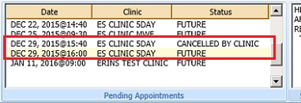

Figure : Pending Appointment Window—Appointment Status Canceled and Future

1. The patient’s appointment request no longer appears on the request grid.

## Multiple Appointment Requests and Appointments

Multiple Appointment Requests allow the scheduler to create requests and book a series of appointments at one time for a patient.

### Multiple Appointment Request

1. Log into VS GUI as a Scheduler.
2. In the Tasks tab display, type the patient’s last name, first name in the Search text box, click Search button, and then select the requested patient name from drop down list.
3. In the Request Type dialog box, select APPT to create a new request.
4. **Patient’s Eligibility Information** dialog displays.
5. In the **Appointment Request** dialog confirm Patient Information details.
6. In the **Appointment Request** dialog box, complete the Request Information section.

* Select **Clinic** or **Service/Specialty** radio button. For Clinic enter clinic name (minimum of 6 characters required). For Service/Specialty enter service or specialty (minimum of 6 characters required).
* Enter **CID/Preferred Date** for the preferred appointment date. Scheduler can enter date directly or select date from Calendar control option.

**Note:** For Multiple Appointment Requests CID/Preferred Date can only be current or future. If past date is entered the Multiple Appointments Required check box will be dimmed and not selectable.

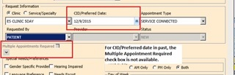

Figure : Multiple Appointments Required Disabled for Past CID/Preferred Dates

* Select **Appointment Type** if not defaulted by patient eligibility and clinic selection then choose from drop down list.
* In **Request By**, select either Provider or Patient.
* If **Provider** selected then enter provider name and select from list. (Note: If, Patient was selected in Request By field, then Provider field is dimmed and not editable.)
* **Status** is automatically populated.

1. Established – The patient has been seen at that clinic in the past 24 months
2. New – The patient has not been seen at that clinic in the past 24 months

* Multiple Appointments Required check box is enabled. Click box to enter check Mark.
  + **Number of Appointments Required** drop down is visible. Up to 60 appointments can be requested at one time.
  + **Interval Between Appointments** (In days) drop down is visible. Up to 30 days between appointments can be requested at one time.

**Note:** The combination of Number of Appointments Required and Interval Between Appointments cannot exceed 24 months. If the selected combination does exceed 24 months to complete, when the Scheduler selects OK to complete the Appointment Request the MRTC Interval/Appt.# Dialog displays, “The combination of requested appointments and the interval between appointments exceeds 24 months. Please adjust the number of requested appointments and/or the interval between appointments so that the combined duration is less than 24 months.” The adjustment must be made before the Multiple Appointment Request can be completed.

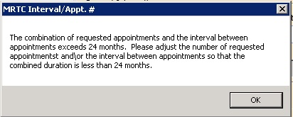

Figure : MRTC Interval/Appt. # Dialog

* In the **Appointment Request** dialog box, complete the **Special Needs/Preference** section. **Remark**s field is available to add clarifying information regarding selections made. Selected Special Needs/Preferences and Remarks will display in Ribbon Bar.
* Text can be added in **Comment** field up to 80 characters to add information regarding Appointment Request. For MRTC Requests the text will display in Request Management Grid under Comment column after the {Day, Interval} information.

1. Click **OK. Find Appointment** dialog displays to allow Scheduler to book Multiple Appointments at one time. See section 6.3.2for booking appointments from Find Appointment Dialog.

#### Note regarding Parent and Child Appointment Requests

When booking Multiple Appointment Requests the scheduler can click Close in the Find Appointment dialog. If this is done prior to the first appointment in the series being booked the Parent MRTC Request will be placed in the Request Grid. There will be a ‘P’ and check mark in MRTC Column. The {Day, Interval} requested in the Appointment Request will display in Comment column. Any text entered into Comment field of Appointment Request dialog will display in Comment column after the {Day, Interval} information. MRTC APPT Requests with Comments are flagged with a red arrow in the Request Management Grid. See Figure 144 for example.

If the scheduler books the first appointment in the series and then clicks CLOSE in the Find Appointment Dialog. The Parent Request will display in the Request Grid. Additionally, the remaining unbooked appointments will display as individual Child MRTC Requests in the Request Grid. They will have a check mark in the MRTC Column but not a ‘P’. The appointment placement in the series as well as the number of total appointments requested will display in Comments column. Any comments entered in the original MRTC Appointment Request dialog will be displayed in each individual Child Request after the {Day, Interval} information.

Selecting the Parent MRTC Request will launch the Find Appointment dialog and the scheduler can continue booking all remaining appointments for the series from Find Appointment. However, selecting a Child MRTC Request will open the Clinic Schedule and the Scheduler can only book the individual appointment following the same steps as adding an appointment for an APPT Request see section 6.1.1. The Parent MRTC Request will not be removed from the Request Grid until all appointments in the series have been booked. A Child MRTC Request will be removed from the Request Grid at the time the appointment is booked.

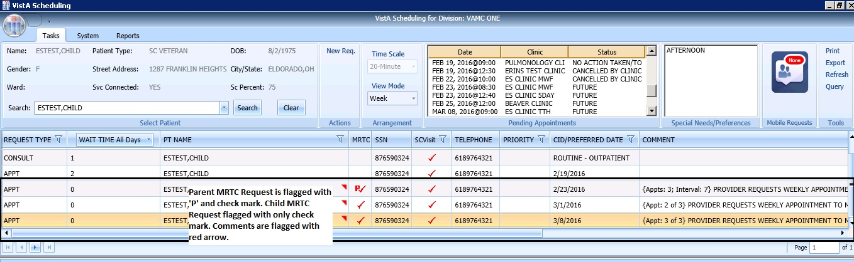

Figure : MRTC Requests displayed in Request Management Grid

### Adding Multiple Appointments from Find Appointment Dialog

When Scheduler clicks **OK** in **Appointment Request Dialog** with **Multiple Appointment Required** checked**.** The **Find Appointment** dialog displays to allow Scheduler to book Multiple Appointments at one time.

1. In the Find Appointment dialog the following information is displayed:

* **Calendar** in upper left corner. The CID/Preferred date entered in Appointment Request is highlighted.
* The **Clinic** is defaulted in drop down field from Appointment Request in Resources Section in the upper middle pane of Find Appointment dialog. This field is editable and Clinics can be switched between appointments as needed.
* Patient’s **Time of Day** and **Day of Week** preferences are defaulted in upper right pane of Find Appointment dialog. These can be edited/adjusted as needed.
* The CID/Preferred date entered in Appointment Request is displayed under the Time of Day and Day of Week preferences in Find Appointment dialog with tag labeled **Original CID:**. This is data not editable.
* **Search** button is available if availability needs recalculated due to date or clinic changes.
* **Multiple Appointment Required** information is defaulted from Appointment Request in middle of Find Appointment dialog. This information is not editable.
* **CID** drop down displays list of unbooked appointment dates. These dates are calculated based upon the original CID/Preferred Date + Number of Appointments + Interval Between Appointments.
* For clinics with special instructions defined, the **Special Instructions Button** displays in Search Results section of Find Appointment dialog. When clicked a Special Instruction dialog will display with the defined information available to review.
* The clinic’s **appointment length, variable length, and Max Overbook** settings will be displayed in label in Search Results section.
* In **Search Results** section, availability results will be displayed -/+ 3 Days of CID date for future dates. For current CID dates availability will be display Day 1 + 6 Days in Search Results field. Note: Time of Day and Day of Week preferences will limit availability results.
  + Book Column, allows Scheduler to select time slot for booking appointment.
  + Start Time Column displays start time of time slot.
  + End Time Column displays end time of time slot.
  + Resource Column displays name of Clinic currently selected.
  + Slots Column displays available time slot count. Slots available for overbooking will display based upon the Scheduler’s security key allowances.

**Note:** Time Slots will not display if no availability defined for that time period for the clinic or overbooking has been reached beyond the Scheduler’s security key allowances.

* **Number of Available Slots**: count will display at bottom of Find Appointment dialog notifying Scheduler how many slots are displaying as available for the selected CID date.
* **Next** and **Book** buttons are disabled until first Time Slot(s) is selected for booking.

1. Select time slot in Booking Column. **Note:** If Clinic DISPLAY INCREMENTS PER HOUR is defined for a count less than the defined LENGTH OF APP'T then multiple Time Slots may need to be selected to satisfy the Appointment Booking Requirements and enable the Book Button.
2. Click **Book** button. Note: If the selected time slot has reached its defined slot count and scheduler has appropriate security keys to overbook then a dialog will display alerting scheduler that continuing with scheduling appointment will result in overbooking the selected time slot. Scheduler can click OK to confirm overbooking and continue to New Appointment dialog.

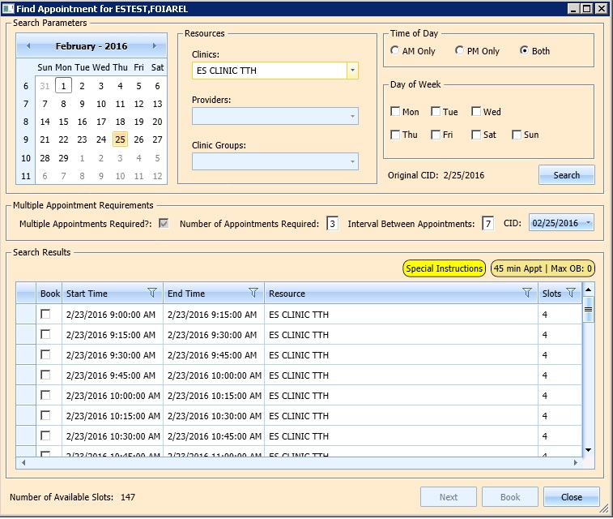

Figure : Find Appointment Dialog

1. New Appointment dialog displays. New Appointment dialog has two tabs:

* Appointments Tab:
* Patient Information Section displays Name, DOB, SSN, Svc Connected, Sc Percent, GAF (read only), and Svc Related check box.
* Appointment Information section displays Start Time, Appt Type, Duration, Clinic and Notes. Notes is the only editable field. Information can be added pertinent to appointment.
* Appointment conflicts section will display any appointments already schedule that conflict with appointment being added.
* Contact Information Tab: displays the patient's address and home and work phone numbers (read only).

1. Confirm information in New Appointment dialog and add any applicable text to Notes section. Click OK.
2. Print Letter? Dialog displays. Click OK to Print the Patient Letter. Click Cancel to close dialog and not print Patient Letter.
3. Closing Request dialog displays “This request will be closed.”
4. Click OK.
5. First MRTC Appointment is booked. CID date in Find Appointment dialog changes to next appointment date in series. MRTC Booking Status dialog displays to track appointments as they are booked. An arrow points to date in MRTC Series that is being booked and automatically updates as appointments are completed. The following information displays in the MRTC Booking Status dialog:

* CID Date—Calculated by first booked appointment date and Interval Requested.
* Appointment Date—date selected when booking appointments.
* Resource—Clinic name where appointment was booked.

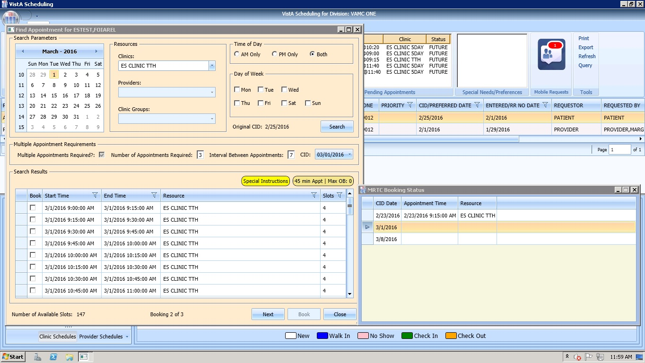

Figure : Find Appointment Dialog + MRTC Booking Status Dialog

1. Select time slot for second MRTC appointment in series.
2. Click Book.
3. New Appointment dialog displays.
4. Confirm information in New Appointment dialog and add any applicable text to Notes section. Click OK.
5. Print Letter? Dialog displays. Click OK to Print the Patient letter. Click Cancel to close dialog and not print Patient Letter.
6. Closing Request dialog displays “This request will be closed.”
7. Click OK.
8. Second MRTC Appointment is booked. CID date in Find Appointment dialog changes to next appointment date in series. Appointment date is added in MRTC Booking Status dialog for second appointment and arrow progress to next appointment (if applicable).
9. Once all MRTC Appointments have been booked for the series, the Closing Request dialog will display, “The Parent MRTC Request will be closed.”
10. If a clinic has a future inactive date and the CID date falls + 3 days after the Inactivate Date, a grey label will display in the Search Results section of the Find Appointment dialog, “There are no slots available. The selected Clinic will be deactivated on {Inactivation Date}. Please select another clinic and click Search to complete the MRTC request.” To complete adding appointments for the series, the Scheduler will need to change to an appropriate clinic in the Resources section with availability and continue adding appointments for the remainder of the series’ requests.

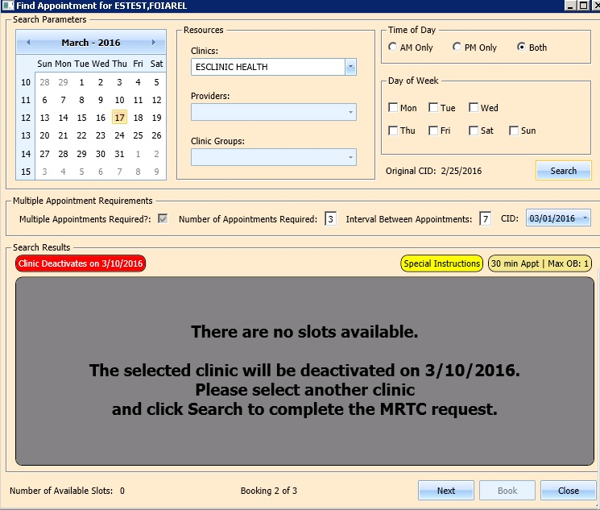

Figure : Future Clinic Inactivation Date

## Overbooking Appointments

Schedulers can overbook appointments based upon the following rules:

1. The Scheduler must have either the SDMOB security key or the SDOB security key. Schedulers cannot overbook if they are not assigned an overbooking security key.
2. The Clinic must have availability defined for the day in question. If there is no availability defined then Schedulers will not be able to overbook appointments on that day regardless of the security key assigned to them.
3. Appointments cannot be overbooked prior to the start of the days’ clinic availability.

### Overbooking Appointments with SDMOB Security Key

Schedulers assigned the Scheduling Master Overbook security key (SDMOB) can overbook anytime outside of clinic availability from clinic start time to 11:59 pm even if the Max Overbook Limit defined for a clinic has been reached.

Perform the following steps to overbook an appointment with the SDMOB security key:

1. Log into VS GUI as a Scheduler.
2. In the Tasks tab display, type the patient’s last name, first name in the Search text box, click Search button, and then select the requested patient name from drop down list.
3. In the **Request Type** dialog box, select **APPT** to create new request or select **Patient** for existing request, and then click **OK**.

**Note:** See Section 0 for steps on adding new APPT Request.



Figure : Request Type – PATIENT

1. In **Request Management** grid select **APPT** request. The Clinic Schedule Grid will display the clinic schedule based upon CID/Preferred date of request. For past dates, the clinic schedule will open defaulted to CID/Preferred date as Day 1 + 6 Days. For current date (or CID/Preferred date less than 3 days in future), the clinic schedule will display defaulted to current date as Day 1 + 6 Days. For future dates, the clinic schedule will display -/+3 days of CID/Preferred date.



Figure 149: Clinic Schedule Display –APPT Request Future CID/Preferred Date

**Note:** For newly created APPT request the system will automatically highlight APPT request and Clinic Schedule will display.

1. In Clinic Schedule Grid, select time slot in grey that is within the clinic hours, from clinic start time to 11:59, or a date/time slot that has existing overbooks.

**Note:** Clinic Max Overbook limit is displayed in Clinic Day Event notes.

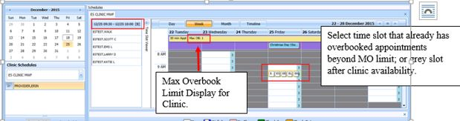

Figure : Max Overbook Limit

1. Right Click in time slot. Add Appointment option will display. Create Walk In Appointment option is only available for selection on current date. It will not be available for past or future CID/Preferred dates. **Note:** Right click options will not display if selected time slot is for a day that has no availability defined or is prior to the clinic start time.



Figure : Appointment Right Click options --Add Appointment

1. Select Add Appointment.
2. Overbook message displays.

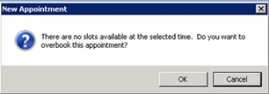

Figure : Overbook Confirmation Dialog

1. Click OK.
2. New Appointment dialog displays as well as Patient Eligibility dialog. New Appointment dialog has two tabs:

* **Appointments Tab**-
* **Patient Information** section displays Name, DOB, SSN, Svc Connected, Sc Percent, GAF (read only), and Svc Related check box.
* **Appointment Information** section displays Start Time, Appt Type, Duration, Clinic and Notes. Notes is the only editable field. Information can be added pertinent to appointment.
* **Appointment conflicts** section will display any appointments already schedule that conflict with appointment being added.
* **Contact Information** **Tab -** displays the patient's address and home and work phone numbers (read only).



Figure : New Appointment Dialog – Appointments



Figure : New Appointment Dialog -- Contact Information

1. Add any applicable Notes to appointment. Click OK.
2. Print Letter? Dialog displays. Click OK to send Letter to patient. Click Cancel to not send letter.



Figure : Print Letter? Dialog

1. Closing Request dialog displays. Click OK.



Figure : Closing Request Dialog

1. APPT Request is removed from Patient Request Management Grid. Next request for patient is moved up and highlighted.
2. Clinic Schedule closes.
3. New appointment displays in Pending Appointment Window in Ribbon Bar.
4. Select appointment from the Pending Appointment window to view it in the Clinic Schedule Grid. The clinic schedule will open. For past dates, the clinic schedule will open defaulted to appointment date. For current date (or appointment date less than 3 days in future), the clinic schedule will display defaulted to current date. For future dates, the clinic schedule will display -/+3 days of appointment date.
5. Overbook count will increase in Clinic Schedule time slot and in Time Slot Viewer. If the appointment count has filled the time slot a hover window will display showing the slot count.

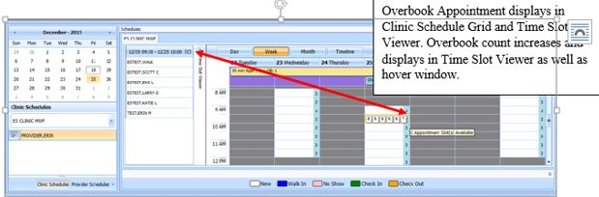

Figure : Clinic Schedule Display --Overbook Appointment

### Overbooking Appointments with SDOB Security Key

Schedulers assigned the Scheduling Overbook, SDOB, Security Key can overbook outside of clinic availability from clinic start time to 11:59pm. They cannot overbook past the Max Overbook Limit defined for a clinic.

Perform the following steps to overbook an appointment with the SDOB security key:

1. Log into VS GUI as a Scheduler.
2. In the Tasks tab display, type the patient’s last name, first name in the Search text box, click Search button, and then select the requested patient name from drop down list.
3. In the **Request Type** dialog box, select **APPT** to create new request or select Patient for existing request, and then click **OK**.

**Note: See Section 5.1.2 for steps on adding new APPT Request.**



Figure : Request Type – PATIENT

1. Select APPT request in the **Request Management** Grid. The Clinic Schedule Grid will display the clinic schedule based upon CID/Preferred date of request. For a past date, clinic schedule will open defaulted to CID/Preferred date as Day 1 + 6 days. For a current date (or CID/Preferred date less than 3 days in future), the clinic schedule will display defaulted to current date as Day 1 + 6 days. For future dates, the clinic schedule will display -/+3 days of CID/Preferred date.

**Note:** For newly created APPT request the system will automatically highlight the APPT request and the Clinic Schedule will display.

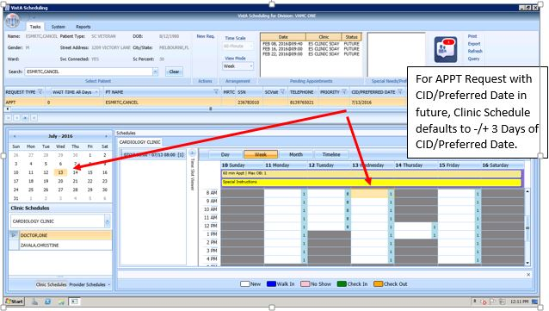

Figure : Clinic Schedule Display -- APPT Request Future CID/Preferred Date

In Clinic Schedule Grid, select time slot in grey that is within the clinic hours, close of clinic hours to 11:59, or a date that does not already have existing overbooks. **Note:** Clinic Max Overbook limit is displayed in Clinic Day Event notes.

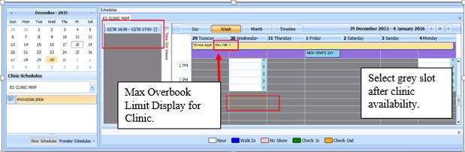

Figure : Overbook After Hours Time Slot

1. Right Click in time slot. Add Appointment option will display. The Create Walk In Appointment option is only available for selection on current date. It is not be available for past or future CID/Preferred dates.

**Note:** Right click options will not display if selected time slot is for a day that has no availability defined, is prior to the clinic start time, or the Max Overbook limit has been met for the day.



Figure : Appointment Right Click Options – Add Appointment

1. Select Add Appointment.
2. Overbook message displays.



Figure : Overbook Confirmation Dialog

1. Click OK.
2. New Appointment dialog displays as well as Patient Eligibility dialog. New Appointment dialog has two tabs:

* **Appointments** tab displays the following-
* **Patient Information** section -Name, DOB, SSN, Svc Connected, Sc Percent, GAF (read only), and Svc Related check box.
* **Appointment Information** section -Start Time, Appt Type, Duration, Clinic and Notes. Notes is the only editable field. Information can be added pertinent to appointment.
* **Appointment Conflicts** section -Appointments already scheduled that conflict with appointment being added.
* **Contact Information** tab displays the patient's address and home and work phone numbers (read only).



Figure : New Appointment Dialog – Appointments Tab



Figure : New Appointment Dialog – Contact Information Tab

1. Add any applicable Notes to appointment. Click OK.
2. Print Letter? Dialog displays. Click OK to print Patient Letter. Click Cancel to exit dialog and not print Patient Letter.



Figure : Print Letter? Dialog

1. Closing Request dialog displays. Click OK.



Figure : Closing Request Dialog

1. APPT Request is removed from the Patient Request Management Grid. Next request for patient is moved up and highlighted.
2. Clinic Schedule closes.
3. New appointment displays in Pending Appointment Window in Ribbon Bar.
4. Select appointment from the Pending Appointment window to view it in the Clinic Schedule Grid. The clinic schedule will open. For past dates, the clinic schedule will open defaulted to appointment date. For current date (or appointment date less than 3 days in future), the clinic schedule will display defaulted to current date. For future dates, the clinic schedule will display -/+3 days of appointment date.
5. Overbook count will increase in clinic schedule time slot and in Time Slot Viewer. If the appointment count has filled the time slot a hover window will display showing the slot count.

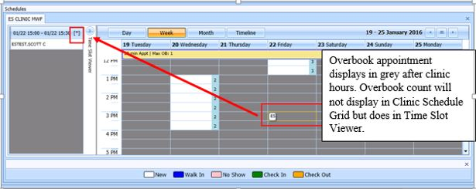

Figure : Clinic Schedule Display--Overbook Appointment After Hours

## Variable Length Appointment

Scheduling appointments can typically be done in fixed length intervals based upon the clinic definitions. However, a clinic can be setup as a variable length clinic, allowing a user to schedule an appointment for an extended amount of time as needed rather than scheduling multiple appointments.

### Identifying a Variable Length Clinic

In order to identify if a clinic is set up for variable length scheduling, perform the following steps:

1. Log on to VS GUI
2. From Clinic Schedules, search and select clinic (6 character minimum).

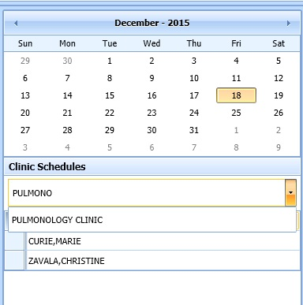

Figure : Clinic Schedules – Clinic Search

1. The selected clinic’s schedule will display defaulted to current date as Day 1 + 6 days.

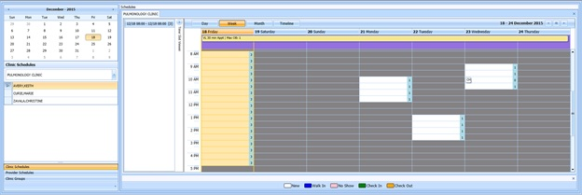

Figure : Clinic Schedule Grid

1. To confirm clinic is able to book variable length appointments, view the All Day Event Bar in Clinic Schedule Grid. A label displays the clinic’s defined appointment length and max overbooking limit. If the clinic is designated as a variable length clinic, the letters ‘VL’ will be displayed before the appointment length.

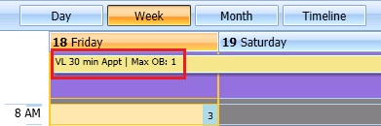

Figure : Variable Length Indicator

### Add a Variable Length Appointment

Perform the following steps to add a Variable Length Appointment:

1. In the clinic schedule, select the time slot that the appointment shall begin at.

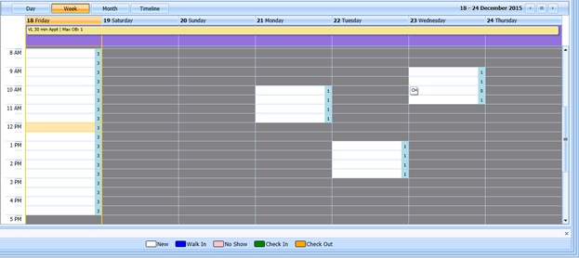

Figure : Clinic Schedule Display – Left Click Open Time Slot

1. While pressing and holding the Shift key, select a future time slot at which time the appointment shall end (i.e. A 1-hour appointment will take 2 30-minute slots)

**Note:** An appointment cannot be scheduled in the middle of a defined time slot. For example, if the slot is 30 minutes starting at 12:00pm, the user cannot select 12:15 pm to begin the appointment or 1:15pm to end the appointment.

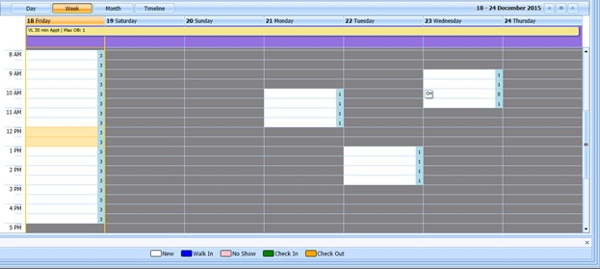

Figure : Clinic Schedule Display -- Multiple Time Slot Selected

1. After selecting the appropriate number of time slots, right-click and select Add Appointment

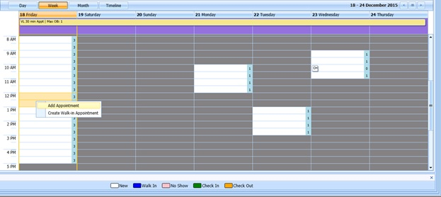

1. Figure 172: Clinic Schedule Display -- Multiple Time Slot Selected
2. The New Appointment dialog box will appear. Confirm that the appointment duration reflects the correct amount of time.

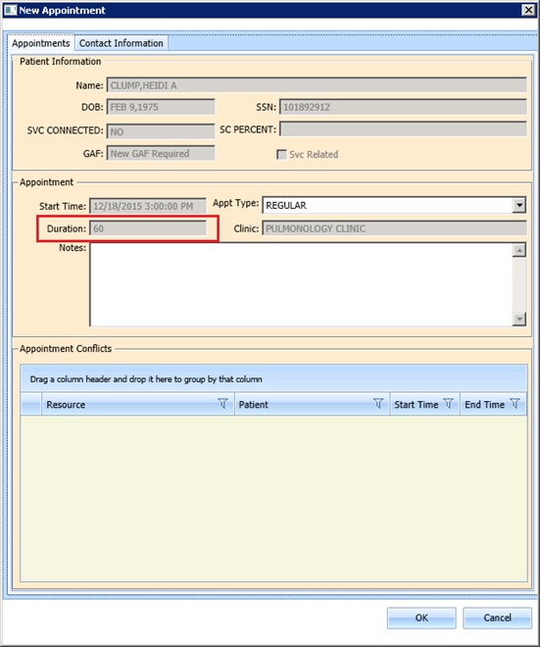

Figure : New Appointment Dialog -- Variable Length Appointment Duration

1. Click OK. The Print Letter? dialog box will display.
2. Click Cancel. The Closing Request dialog box will display ‘This request will be closed’.
3. Click OK. New appointment will display in Pending Appointment Window.
4. Select appointment from Pending Appointment Window. Clinic Schedule will display with booked appointment spanning two time slots, indicating a variable length appointment.

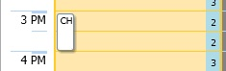

Figure : Clinic Schedule Display -- Appointment Length Extended

## Compensation and Pension Appointments

### Adding Compensation & Pension APPT Request.

1. Log into VS GUI.
2. In the Tasks tab display, type the patient’s last name, first name in the Search text box, click Search button, and then select the requested patient name from drop down list.
3. Select APPT Request Type.
4. Complete APPT Request dialog. See section xxx for instructions on complete APPT Request dialog.
5. Select appropriate Clinic for Compensation and Pension appointment.
6. Enter CID/Preferred Date.
7. In Appointment Type drop down, select Compensation & Pension.
8. Click OK.
9. APPT Request is displayed in patient’s Request Management Grid.

### Add Compensation & Pension appointment for pending 2507 Request NOT previously linked to appointment.

1. Log into VS GUI.
2. In the Tasks tab display, type the patient’s last name, first name in the Search text box, click Search button, and then select patient name with pending C&P APPT Request from drop down list.
3. Select PATIENT Request Type.
4. Click OK.
5. In Request Management Grid, select pending C&P APPT Request.
6. In Clinic Schedule Grid, left click open time slot.
7. Right Click, select Add Appointment. Note: Create Walk-In Option is available if current day is selected in Clinic Schedule.
8. New Appointment dialog displays.
9. Confirm Appointment Type is listed as Compensation & Pension. If not, select from drop down list.
10. Add any applicable appointment information to Notes section.
11. Click OK.
12. Dialog displays Dialog displays:

“AMIE C&P Exam Tracking Record Updated.”

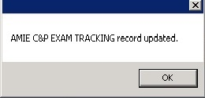

Figure : AMIE C&P EXAM TRACKING Record Updated.

**Note:** If patient did NOT have pending 2507 Request on file a dialog will display, “You have made a C&P Appointment for a patient who has no pending 2507 request.”

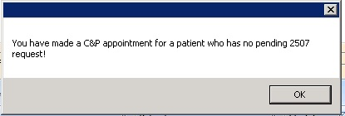

Figure : C&P Appointment for Patient with No Pending 2507 Request

1. Click OK.
2. Print Letter? Dialog displays.
3. Click OK to print Patient Letter. Click Cancel to exit out of dialog and not print patient letter.
4. Closing Request Dialog displays:

“This request will be closed."

1. Click OK.
2. New C&P Appointment displays in Pending Appointment Window. AMIE Tracking Link is updated.

### Add Compensation & Pension appointment for pending 2507 request already linked to appointment NOT due to cancellation.

1. Log into VS GUI.
2. In the Tasks tab display, type the patient’s last name, first name in the Search text box, click Search button, and then select the patient name with pending C&P APPT Request from drop down list.
3. Select PATIENT Request Type.
4. Click OK.
5. In Request Management Grid, select pending C&P APPT Request.
6. In Clinic Schedule Grid left click open time slot.
7. Right Click, select Add Appointment. Note: Create Walk-In Option is available if current day is selected in Clinic Schedule.
8. New Appointment dialog displays.
9. Confirm Appointment Type is listed as Compensation & Pension. If not, select from drop down list.
10. Click OK.
11. Comp & Pension Requests dialog displays with the following information:

"Please select a Compensation and Pension request.”

* Name: veteran name
* Request Date: date 2507 Request created

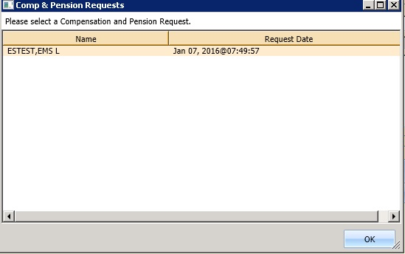

Figure : Comp & Pension Requests Dialog

1. Select appropriate 2507 Request from list.
2. Click OK.
3. Comp & Pension Request displays with option to select Yes or No:

"This 2507 already has appointments. Is this due to cancellation?"

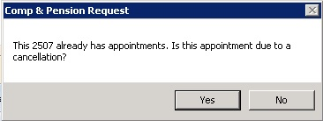

Figure : Comp & Pension Request Due to Cancellation Dialog

1. Click NO.
2. Dialog displays:

"AMIE C&P EXAM Tracking Record Added."



Figure : AMIE C&P EXAM TRACKING Record Updated

1. Click OK.
2. Print Letter? Dialog displays.
3. Click OK to print Patient Letter. Click CANCEL to exit out of dialog and not print Patient Letter.
4. Closing Request dialog displays:

“This request will be closed.”

1. New C&P Appointment displays in Pending Appointment Window. AMIE Tracking Link is updated.

### Add Compensation & Pension appointment for pending 2507 Request due to Clinic Cancellation

1. Log into VS GUI.
2. In the Tasks tab display, type the patient’s last name, first name in the Search text box, click Search button, and then select the patient name with pending C&P APPT Request from drop down list.
3. Select PATIENT Request Type.
4. Click OK.
5. In Request Management Grid, select pending C&P APPT Request.
6. In Clinic Schedule Grid, left click open time slot.
7. Right Click time slot, select Add Appointment. Note: Create Walk-In Option is available if current day is selected in Clinic Schedule.
8. New Appointment dialog displays.
9. Confirm Appointment Type is listed as Compensation & Pension. If not, select from drop down list.
10. Click OK.
11. Comp & Pension Requests dialog displays with the following information:

"Please select a Compensation and Pension request.”

* Name: veteran name
* Request Date: date 2507 Request created



Figure : Comp & Pension Requests Dialog

1. Select appropriate 2507 Request from list.
2. Click OK.
3. Comp & Pension Request displays with option to select Yes or No:

"This 2507 already has appointments. Is this due to cancellation?"



Figure : Comp & Pension Request Due to Cancellation Dialog

1. Click YES.
2. Comp & Pension Appointment Links dialog displays with the following information and OK or CANCEL available to select:

Direction to "Please select a Compensation and Pension Appointment Request Appointment Link."

* Initial Appointment Date
* ClockStop Appointment Date
* Current Appointment Date
* Clinic Name

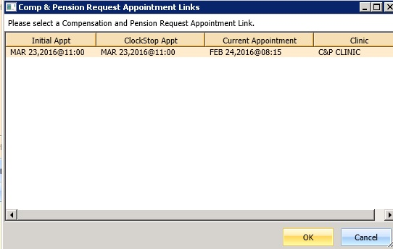

Figure : Comp & Pension Request Appointment Links Dialog

1. Click OK.

**Note:** If Scheduler clicks CANCEL instead of OK, the following dialog displays, “You have not selected the linked appointment being rescheduled. You may need to adjust the link to the appointment with the AMIE link management option to ensure the proper processing time calculation for this 2507.

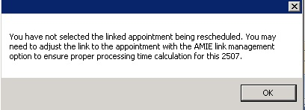

Figure : C&P Appt Links Due to Veteran Cancellation or No Show

1. C&P Appt Links dialog displays with option to select YES or NO:

"Is this due to a veteran requested cancellation or 'No Show'?"

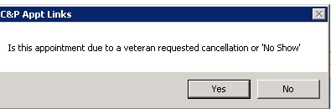

Figure : Comp & Pension Due to Cancellation Dialog

1. Click NO.
2. Dialog displays:

"Adjusting C&P Appointment Link for 2507 Request dated {2507 Request date}. Remember to cancel the appointment for {Previous Appointment Date}."

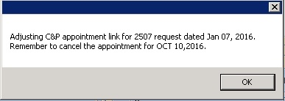

Figure : C&P Appointment Link Adjustment Dialog

1. Click OK.
2. Print Letter? Dialog displays.
3. Click OK to print Patient Letter. Click CANCEL to exit out of dialog and not print Patient Letter.
4. Closing Request dialog displays:
5. “This request will be closed.”
6. New C&P Appointment displays in Pending Appointment Window. AMIE Tracking Link is updated.

**Note: Previous appointment linked to 2507 Request will need to be manually dispositioned.**

### Add Compensation & Pension appointment for pending 2507 Request due to Veteran Cancellation/No Show.

1. Log into VS GUI.
2. In the Tasks tab display, type the patient’s last name, first name in the Search text box, click Search button, and then select the patient name with pending C&P APPT Request from drop down list.
3. Select PATIENT Request Type.
4. Click OK.
5. In Request Management Grid, select pending C&P APPT Request.
6. In Clinic Schedule Grid, left click open time slot.
7. Right Click time slot, select Add Appointment. Note: Create Walk-In Option is available if current day is selected in Clinic Schedule.
8. New Appointment dialog displays.
9. Confirm Appointment Type is listed as Compensation & Pension. If not, select from drop down list.
10. Click OK.
11. Comp & Pension Requests dialog displays with the following information:

"Please select a Compensation and Pension request.”

* Name: veteran name
* Request Date: date 2507 Request created



Figure : Comp & Pension Request Dialog

1. Select appropriate 2507 Request from list.
2. Click OK.
3. Comp & Pension Request displays with option to select Yes or No:

"This 2507 already has appointments. Is this due to cancellation?"



Figure : Comp & Pension Request Due to Cancellation Dialog

1. Click YES.
2. Comp & Pension Appointment Links dialog displays with the following information:

Direction to "Please select a Compensation and Pension Appointment Request Appointment Link."

* Initial Appointment Date
* ClockStop Appointment Date
* Current Appointment Date
* Clinic Name



Figure : Comp & Pension Request Appointment Links Dialog

1. Click OK.

**Note:** If Scheduler clicks CANCEL instead of OK, the following dialog displays, “You have not selected the linked appointment being rescheduled. You may need to adjust the link to the appointment with the AMIE link management option to ensure the proper processing time calculation for this 2507.



Figure : Comp & Pension Canceled Appointment Links Dialog Warning

1. C&P Appt Links dialog displays with option to select YES or NO:

"Is this due to a veteran requested cancellation or 'No Show'?"



Figure : C&P Appt Links Due to Veteran Cancellation or No Show

1. Click YES.
2. Dialog displays:

“AMIE C&P EXAM TRACKING record updated.”



Figure : AMIE C&P EXAM TRACKING Record Updated

1. Click OK.
2. Print Letter? Dialog displays.
3. Click OK to print Patient Letter. Click CANCEL to exit out of dialog and not print Patient Letter.
4. Closing Request dialog displays:
5. “This request will be closed.”
6. New C&P Appointment displays in Pending Appointment Window. AMIE Tracking Link is updated.

**Note:** Previous appointment linked to 2507 Request will need to be manually dispositioned.

### Disposition Appointment linked to pending 2507 Request.

1. Log into VS GUI.
2. In the Tasks tab display, type the patient’s last name, first name in the Search text box, click Search button, and then select the patient name from drop down list with booked appointment linked to pending 2507 Request.
3. Select PATIENT Request type.
4. Click OK.
5. In Pending Appointment Window, select pending C&P Appointment linked to pending 2507 Request.
6. In Clinic Schedule Grid, left click appointment.
7. Right Click the following options are available to select:

* Edit Appointment
* View Appointment
* Cancel Appointment

1. Select Cancel Appointment
2. Cancel Appointment dialog displays. See section 6.2.3 for detailed instructions on completing Cancel Appointment dialog.
3. Select Appointment Cancelled By.
4. Select Reason for Cancellation.
5. Edit CID/Preferred Date if applicable.
6. Enter Remarks.
7. Click OK.
8. Dialog displays:

"The associated 2507 request link has been updated."

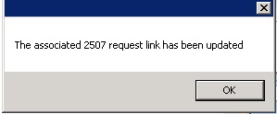

Figure : C&P Cancel Appointment Associated 2507 Request Updated

**Note:** If C&P appointment was NOT linked to 2507 request the following message displays in dialog “Appointment {appointment date} was not linked to a 2507 request or was manually rebooked and linked to another appointment. (If the appointment was manually rebooked, you do not want to auto-rebook.) If the appointment was not properly linked, it will need to be linked with the AMIE/C&P appointment link management option.”

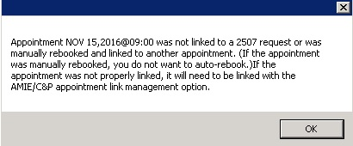

Figure : C&P Cancel Appointment NOT linked to Pending 2507 Request

1. Click OK.
2. Appointment status is updated in Pending Appointment Window. Appointment is removed from Clinic Schedule. AMIE Link is updated.

## Veteran Appointment Request Scheduling

The Veteran Appointment Request (VAR) Interface provides an interface between the VS GUI and the VAR appointment request database, including:

* Link the appointment requested in VAR and processed in VistA such that the state of the appointment in VistA (e.g. cancelled, checked out) can be displayed in the GUI application
* View appointment requests within the GUI
* Communicate or message the Veteran from within the GUI up to a limit of four times
* Close out requests from within the GUI

VAR requests are displayed on the **Tasks** tab display in the **Mobile Requests** section. A counter, showing the number of pending mobile requests is displayed in the section, as well.

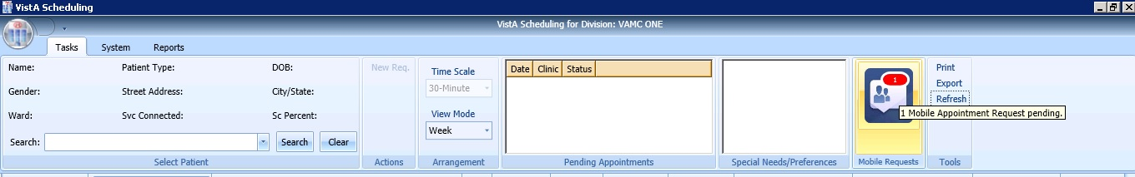

Figure : Mobile Requests

### Scheduling a Mobile Request

Perform the following steps to schedule a mobile request.

1. In the **Tasks** tab display, click on the Mobile Requests button. The Mobile Request List displays.

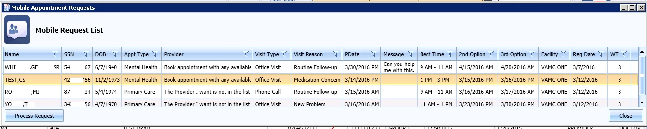

Figure : Mobile Request List

1. Click on the mobile request and select Process Request. This locks the request, so that other schedulers cannot work on the request at the same time. It will remain open until the APPT request is created or an appointment cannot be booked.

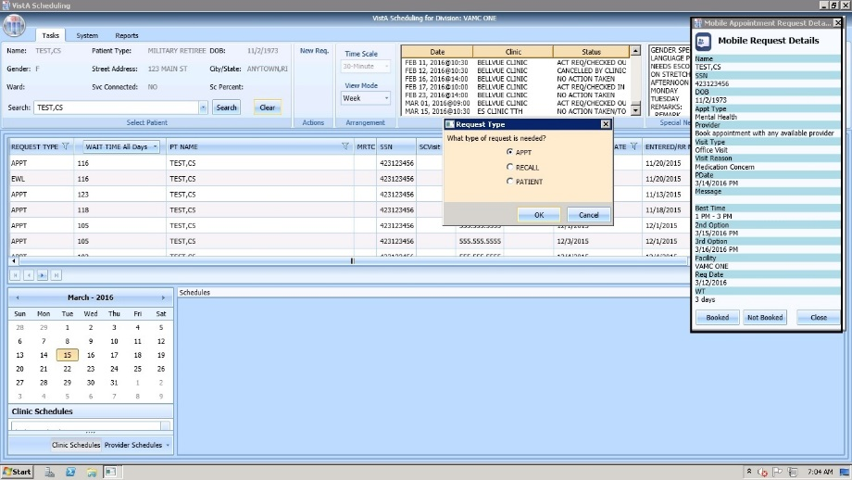

Figure : Mobile Request Selected

1. The primary date selected by Veteran will default to the CID/Preferred date in the request. The AM/PM selection will default to the Time of Day in APPT Request dialog.
2. Once completed, the appointment request will display as a VETERAN Request in the Request Management Grid. The Clinic Schedule will display -/+ 3 days for future CID/Preferred dates.
3. If the selected clinic has availability that meets the Veteran Request requirements, the user can schedule the appointment by doing right-click and select Add Appointment in the available time slot in Clinic Schedule Grid.
4. The New Appointment dialog will display. The user can click OK and complete the appointment booking.
5. If the request is scheduled, click **Booked** in the **Mobile Request Details** window. The request will be removed from the Mobile Request List and the user can send a **Booked** message to the Veteran.
6. If the request cannot be scheduled, click **Not Booked**. A Request Not Available dialog displays allowing the user to send a **Not Booked** message is to the Veteran.

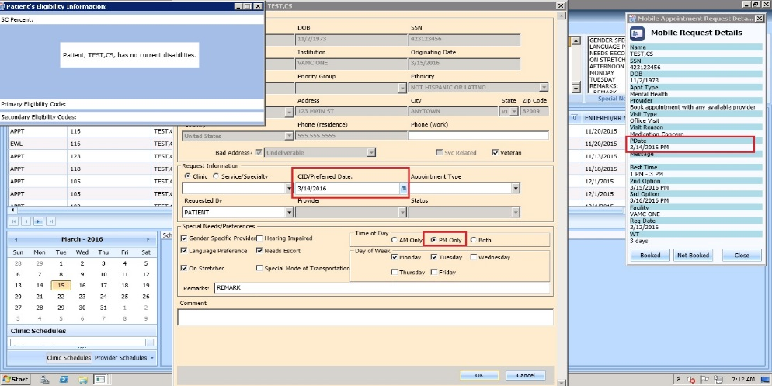

Figure : Veteran APPT Request

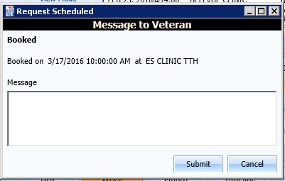

Figure : Message to Veteran Dialog

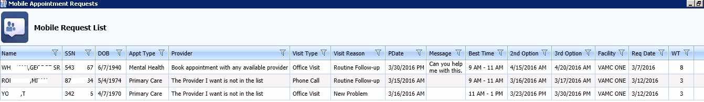

Figure Mobile Request Removed from Grid

# Clinics

## Task Tab

### Viewing Clinic Schedule Availability

The VS GUI will display consistent color visual indicator for clinic’s workable hours including bookable holidays, non-workable hours including non-bookable holiday, clinic cancellation and no availability as follows:

|  |  |
| --- | --- |
| **Appointment Availability Type** | **Color** |
| Available/Hours of Operation | White |
| Unavailable/ Non-workable hours during day with availability defined (i.e. clinic lunch breaks). | Grey |
| Cancelled Availability for Clinic—Partial and All Day Cancellation. | Cancelled-Grey + hash mark (\\) |
| Holiday but bookable | White |
| Holiday but NOT bookable | Grey |
| No availability defined for day (i.e. Saturday or Sunday). | Grey |
| No availability defined for the clinic | Grey |

Use the following procedure to search for a clinic and view the clinic schedule:

1. In the **Tasks** tab, from Clinic Schedules, enter a partial name of a clinic (6 characters minimum)

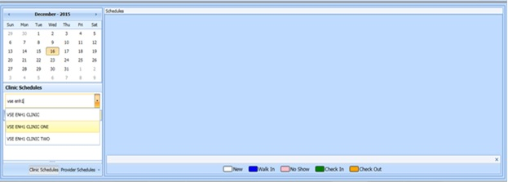

Figure : Clinic Schedules Search

1. Select the desired clinic from the returned list
2. The selected clinic schedule displays to the user

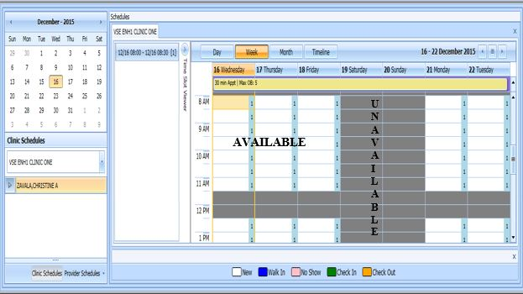

Figure : Clinic Schedules Display Available vs Unavailable

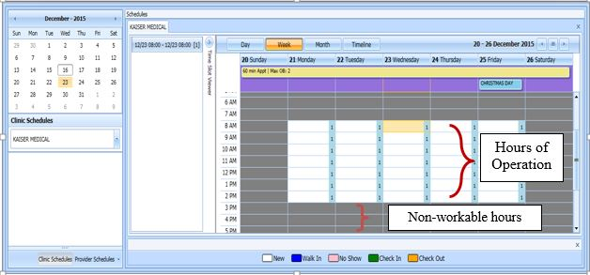

Figure : Clinic Schedules Display Hours of Operation

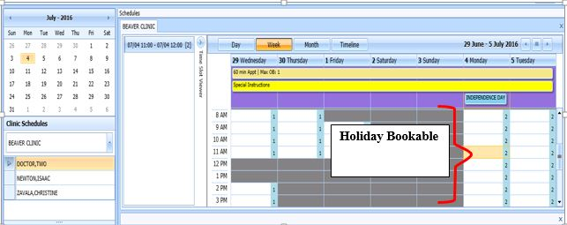

Figure : Clinic Schedules Display -- Holiday Bookable

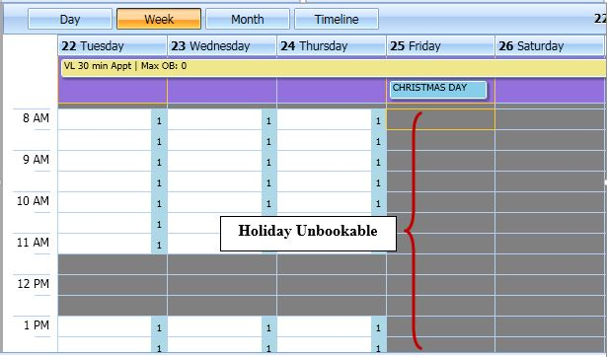

Figure : Holiday Unbookable

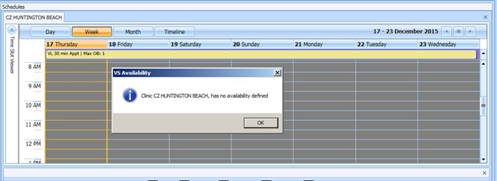

Figure : Clinic Schedule Display – No Availability Defined

### Viewing Clinic’s Availability Cancellation

Clinic Schedule will display full or partial day cancellation with grey + \\ over the cancelled time slots.

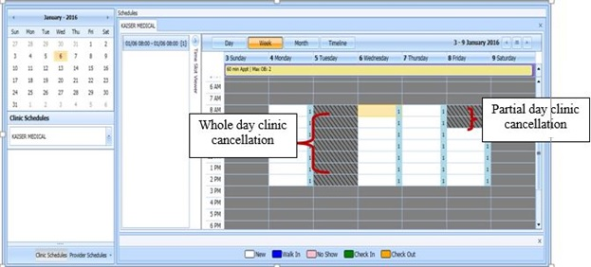

Figure : Clinic Schedule Display – Cancel Availability

### Viewing clinic’s length of appointment and maximum overbook

A label in the All Day Event Bar will display Length of Appointment and Maximum Overbook values defined for the selected Clinic.

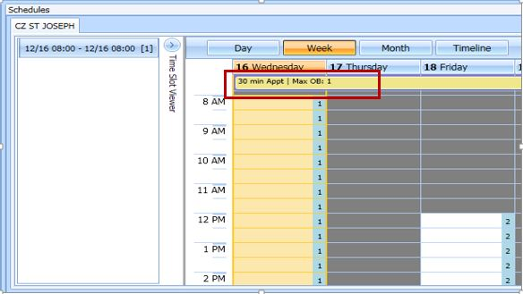

Figure : Appointment Length and Max Overbook Allowed

### Viewing clinic’s variable length indicator

For clinics defined as Variable Length, a flag ‘VL’ will display before the Length of Appointment information in the All Day Event Bar in the Clinic Schedule Grid. **Note:** See Section 6.5.2 on How to Add Variable Length Appointment.

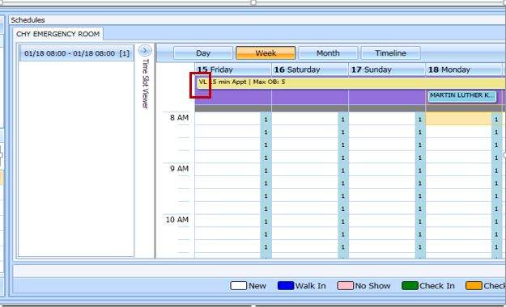

Figure : Variable Length Indicator

### Viewing clinic’s special instructions

Use the following procedure to display clinic’s special instructions:

1. In the **Tasks** tab, from Clinic Schedules, enter a partial name of a clinic (6 characters minimum)
2. Select the desired clinic from the returned list
3. The selected clinic schedule displays to the user. Special Instruction Indicator displays in All Day Event Bar in Clinic Schedule.
4. Click on the **Special Instructions** indicator.

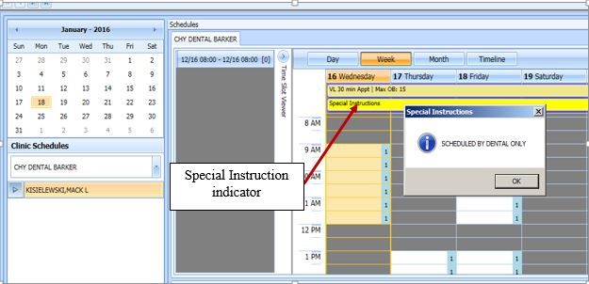

Figure : Special Instruction Indicator

### Viewing clinic’s available slots

Time Slot Count for availability displays as follows: 0-9 and j-z --denote available slots where j=10,k=11...z=26. Upper Case Letters, A-W , denote overbooks with A being the first slot to be overbooked and B being the second for that same time, etc. Special characters, *,$,!,@,# , denote overbooks or appointments that fall outside of a clinic's regular hours.

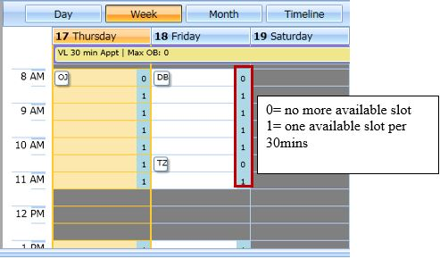

Figure : Time Slot Count

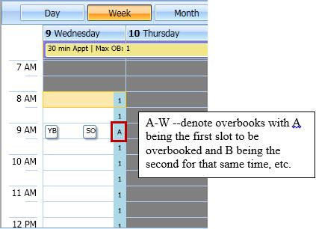

Figure : Overbook Time Slot Count

### Time Slot Viewer

The Time Slot Viewer was added to the left of the Clinic Schedule Grid. It will display appointment information per selected time slot. For appointments booked in the time slot the full patient name will display in a list in the order they were added to the time slot.

1. In the **Tasks** Tab, from Clinic Schedules, enter a partial name of a clinic (6 characters minimum)
2. Select the desired clinic from the returned list
3. The selected clinic schedule displays to the user
4. Time Slot Viewer can be expanded or minimized in Clinic Schedule Grid.

Figure : Minimized Time Slot Viewer

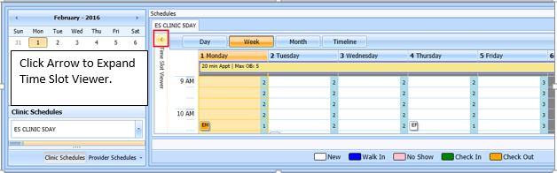

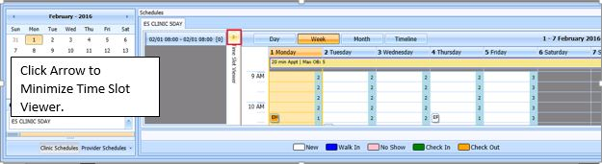

Figure : Expanded Time Slot Viewer

1. Selecting a time slot from the Clinic Schedule populates the Time Slot Viewer with the following information:

* Date/Time of Time Slot.
* Available slot count left for time slot.
* Patient names are listed, in the order they were booked, for any appointments scheduled in the time slot.

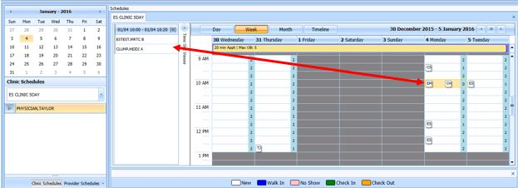

Figure : Time Slot Viewer Displays Slot Details

1. Appointments can be added from Time Slot Viewer.

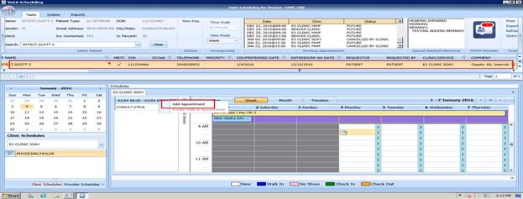

Figure : Time Slot Viewer Right Click Options — Add Appointment

1. For booked appointments, right click extended action options are available from Time Slot Viewer, the same as in Clinic Schedule Grid.

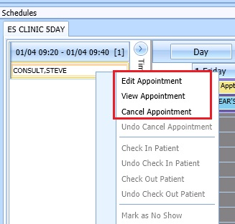

Figure : Time Slot Viewer Right Click – Edit, View, Cancel

1. Check In Patient from Time Slot Viewer the same as from Clinic Schedule Grid.

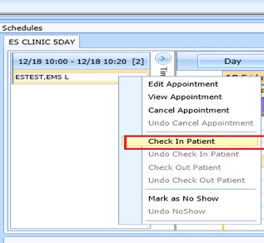

Figure : Time Slot Viewer – Check In Patient

1. Check Out from Time Slot Viewer the same as from Clinic Schedule Grid.

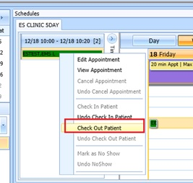

Figure : Time Slot Viewer -- Check Out Patient

1. Mark as No Show from Time Slot Viewer the same as from Clinic Schedule Grid.

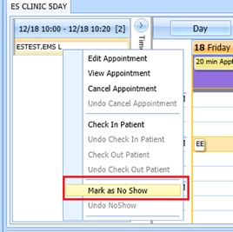

Figure : Time Slot Viewer – Mark as No Show

### Viewing Provider Availability

Use the following procedure to search for a provider and view the provider’s schedule:

1. In the **Tasks** tab, under the request grid calendar, select Provider Schedules.

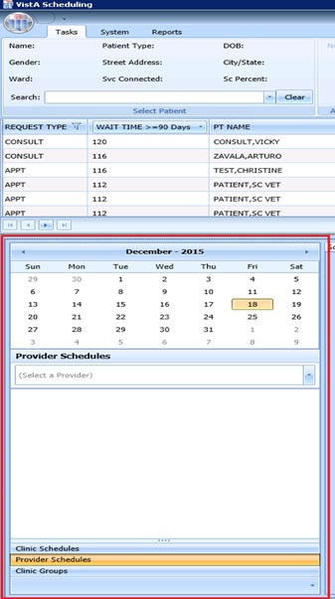

Figure : Provider Schedules

1. Enter a partial name of a provider (3 characters minimum). Select the desired provider from the returned drop down list.

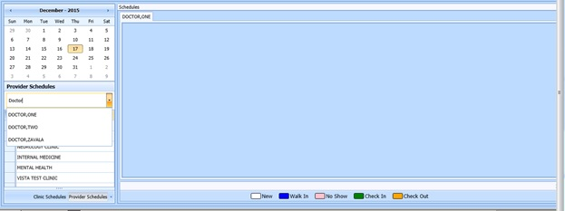

Figure : Provider Schedules Selection List

1. The selected provider schedule displays to the user.

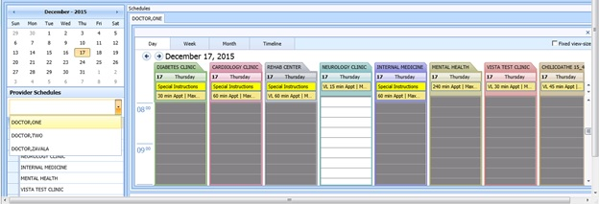

Figure : Provider Schedule Display

1. The provider’s availability across all clinics will be displayed. If provider has only one clinic, that clinic’s schedule and availability will appear.

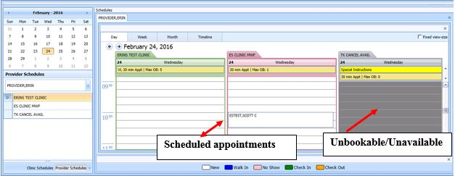

Figure : Provider Schedules Booked Appointments

1. Available appointment slots will display as white space which Scheduler can select to add an appointment.
2. Appointments will display with the name of the patient in a specific Clinic Schedule time slot.
3. Greyed time slots in the Clinic Schedule indicate no availability and Scheduler will be unable to add appointments for those specific slots.

**Note:** See section 0 for Appointment Management instructions on how to Add, Check-In, Check-Out, and Cancel Appointments.

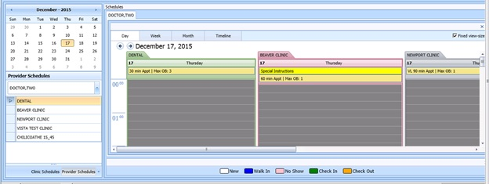

Fixed view size

Figure : Fixed View Size

1. By selecting Fixed View Size option, when viewing multiple provider schedules for different clinics, the system will adjust all the slots to the same expanded width view.

### Viewing Clinic Group Availability

Use the following procedure to search for a clinic group and view the clinic group’s schedule:

1. In the **Tasks** tab, under the request grid calendar, select Clinic Groups

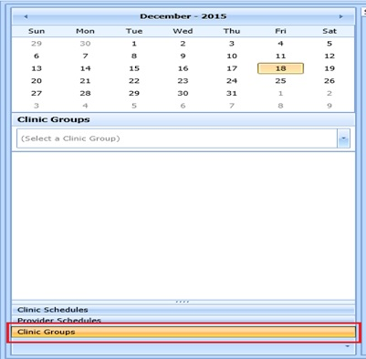

Figure : Clinic Groups

1. Enter a partial name of a clinic group (6 characters minimum). Select the desired Clinic Group from the returned list.

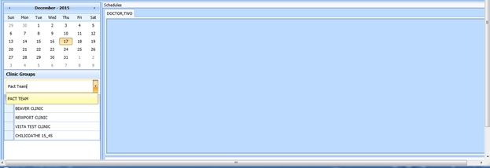

Figure : Clinic Groups Search Result List

1. The selected clinic group schedule(s) will display, starting with today’s date in the Day view.

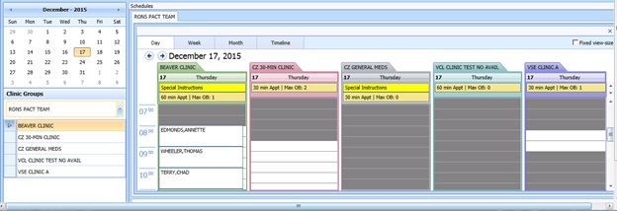

Figure : Clinic Groups Schedule Display

**Note:** See section 0 for Appointment Management instructions on how to Add, Check-In, Check-Out, and Cancel Appointments.

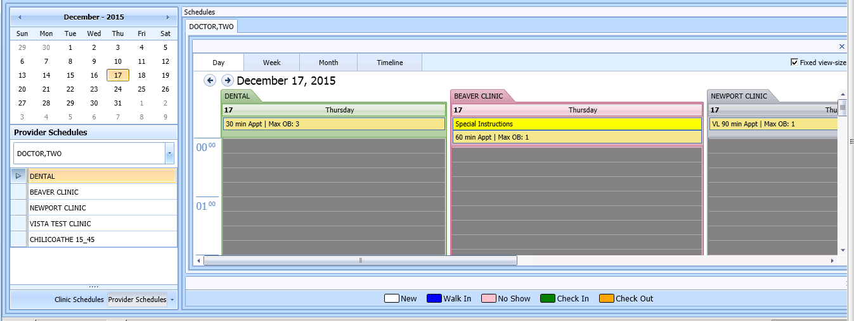

Fixed view size

Figure : Provider Schedules –Fixed View Size

1. By selecting Fixed View Size, when viewing multiple Clinic Group schedules for different clinics, the system will adjust all the slots to the same expanded width view.

## System Tab

The **System** tab requires the SDECZMGR security key in order to be able to access it.

### Viewing Clinic Availability Information

Use the following procedure to quickly search for clinic availability. Clinic availability cannot be modified from the VS GUI.

1. In the **Systems** tab display, Click **Availability** in the **Resource Schedules** section.
2. In the **Availability Selection** dialog, type in the desired clinic name.
3. Select the desired clinic and click on **OK**.

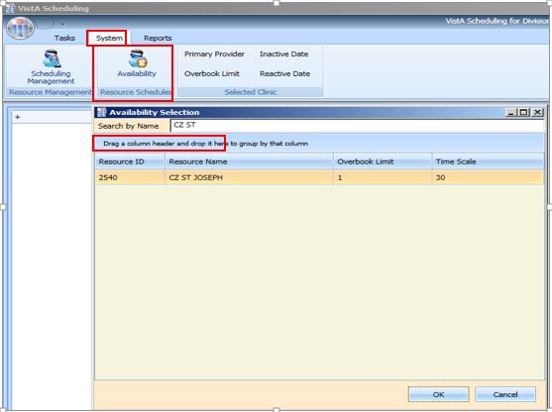

Figure : Clinic Availability Search

1. The Schedule displays for the selected clinic. Primary Provider, Overbook Limit, Inactive Date, and Reactive Date, as applicable, are also displayed in the **Selected Clinic** section of the display. The Schedule also displays the number of appointments per slot and the number of slots total per appointment length in minutes and total number of minutes that are bookable. The Schedule also displays the same visual coloration as in Clinic Schedule for workable hours, non – workable hours, and no availability

Figure : Clinic Availability

### Adding and Removing Privileged Users

#### Add Privileged User

Perform the following procedure to ADD a privileged user(s) to a prohibited clinic.

1. In the Systems tab display, Click Scheduling Management
2. In the **Prohibited Clinic** search box, type in a partial or full name of the clinic.
3. Click **Find**. A list of prohibited clinics is presented to the user
4. Select the appropriate prohibited clinic. A list of privileged users for the selected clinic is displayed.

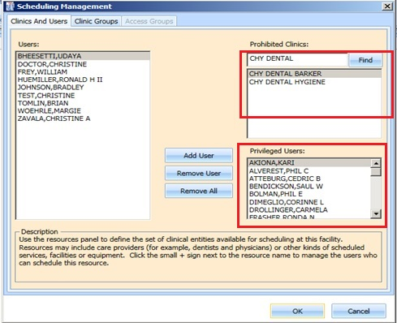

Figure : Clinics and Users

1. Select a user from the left and click **Add User**.

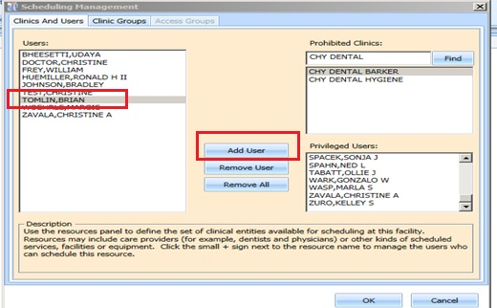

Figure : Add Privileged User

1. Click **OK** to file the change.

#### Remove Privileged User

Perform the following procedure to REMOVE a privileged user(s) from a prohibited clinic.

1. In the Systems tab display, Click Scheduling Management
2. In the **Prohibited Clinic** search box, type in a partial or full name of the clinic.
3. Click **Find**. A list of prohibited clinics is presented to the user
4. Select the appropriate prohibited clinic. A list of privileged users for the selected clinic is displayed.
5. Select a user from the **Privileged User** list for the selected prohibited clinic and click **Remove User** or if all privileged users need to be removed click **Remove All.**

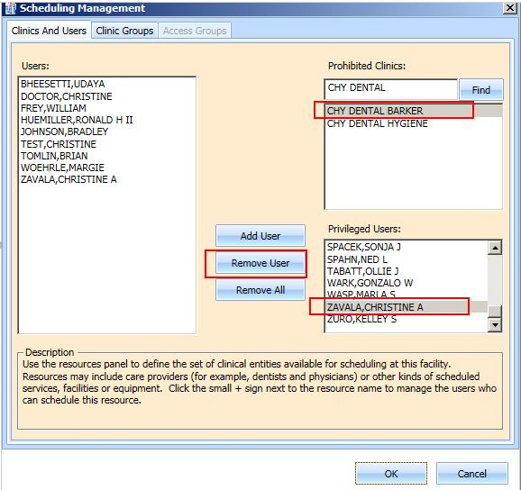

Figure : Remove Privileged User

### Creating Clinic Groups

Perform the following procedure to create a Clinic Group.

1. In the Systems tab display, Click **Scheduling Management**
2. Select Clinic Groups tab
3. Click New Group
4. Enter name in the **Clinic Group Name** text box.

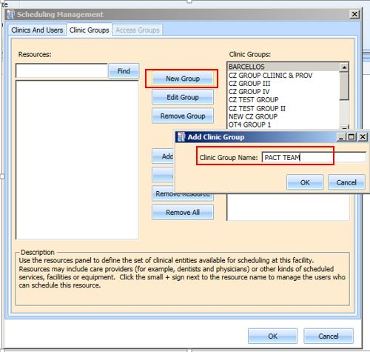

Figure : Create New Clinic Group

1. Click **OK.**
2. Select the newly added **Clinic Group**
3. Enter partial name search for a **Resource** and click **Find.** A resource can be a clinic or a provider that is active with an active person class.

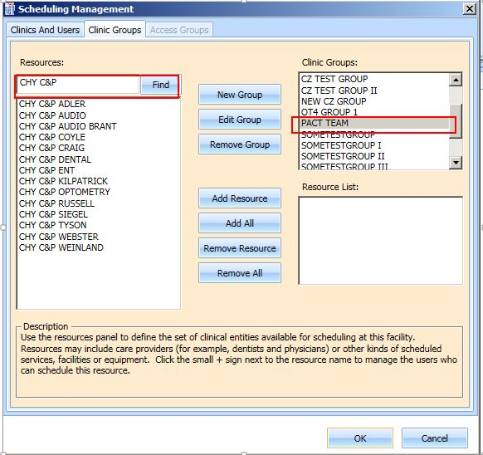

Figure : Find Resource

1. Select the appropriate resource to add to the Clinic Group and click **Add Resource**. If all of the resource listed from the search needs to be all added, **Add All** can be selected.

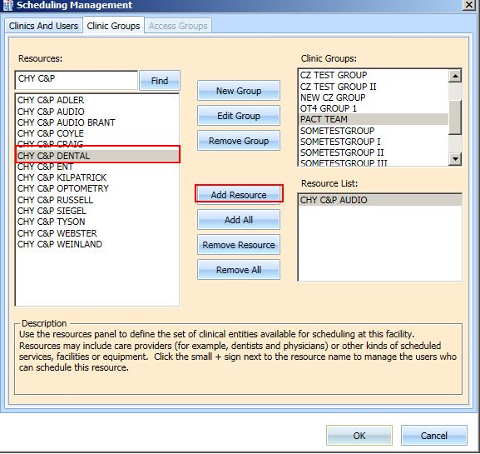

Figure : Add Resource to Clinic Group

1. Click **OK** to file.

### Removing Resource(s) from a Clinic Group

Perform the following procedure to remove a resource(s) from a Clinic Group.

1. In the Systems tab display, Click **Scheduling Management**
2. Select Clinic Groups tab
3. Select a clinic group to be edit from the **Clinic Group** list. Resources defined for the Clinic Group is displayed in the **Resource List** box
4. Select a resource to remove and Click **Remove Resource**. If all resource needs to be removed, **Remove All** can be selected.

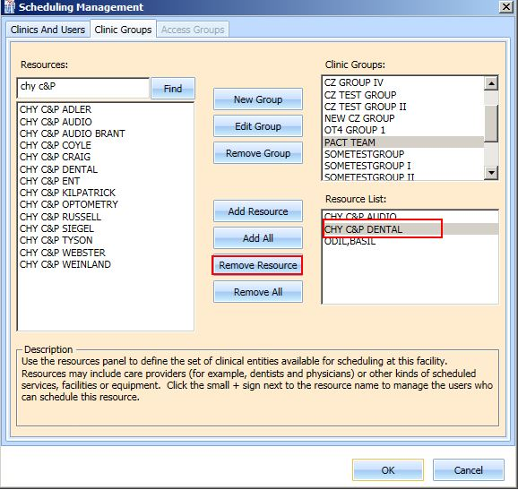

Figure : Remove Resource from Clinic Group

# Reports

The **Reports** tab display provides a means to view and print various reports. The Reports tab requires the SDECZMGR manager security key in order to be able to access it. The following selections and reports are available:

* Audit Activity Report
* Clinics
* Management Reports

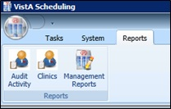

Figure : Reports Tab Selections

## Audit Activity Report

Audit Activity reports can be generated for individual schedulers by name or for All Schedulers.

### Generating an Audit Activity Report for Individual Scheduler

1. Perform the following procedure to view Audit Activity for individual scheduler. From the **Reports** tab display, select **Audit Activity**. The Audit Activity dialog displays.
2. Select the individual **Scheduler** name from drop down list.
3. Select **Start** **Date**, and **End** **Date** either by typing or calendar control.

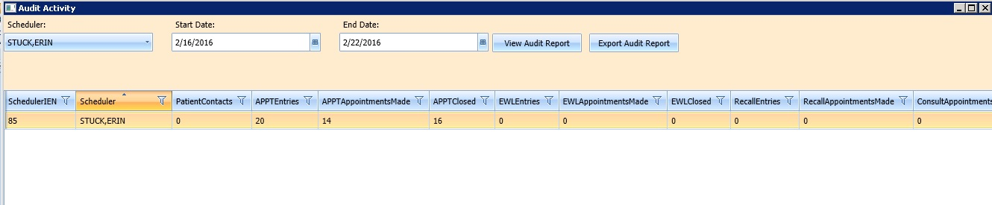

Figure : Audit Activity Report—Individual Scheduler

1. The following columns display data for selected Scheduler based upon time frame specified:

* SchedulerIEN (New Person File)
* SchedulerName
* PatientContacts
* APPTEntries
* APPTAppointmentsMade
* APPTClosed
* EWLEntries
* EWLAppointmentsMade
* EWLClosed
* RecallAppointmentsMade
* ConsultAppointmentsMade
* AppointmentsCancelled
* TotalActions

1. Click Close to exit Audit Activity report dialog.

### Generating Audit Activity Report for All Schedulers

1. From Reports Tab select Audit Activity.
2. Audit Activity dialog displays.
3. In **Scheduler** drop down select All.
4. Enter Start Date and End Date for audit report.
5. Click View Audit Report button.
6. The following columns display data for All Schedulers based upon time frame specified:

* SchedulerIEN (New Person File)
* SchedulerName
* PatientContacts
* APPTEntries
* APPTAppointmentsMade
* APPTClosed
* EWLEntries
* EWLAppointmentsMade
* EWLClosed
* RecallAppointmentsMade
* ConsultAppointmentsMade
* AppointmentsCancelled
* TotalActions

1. Click Close to exit Audit Activity report dialog.

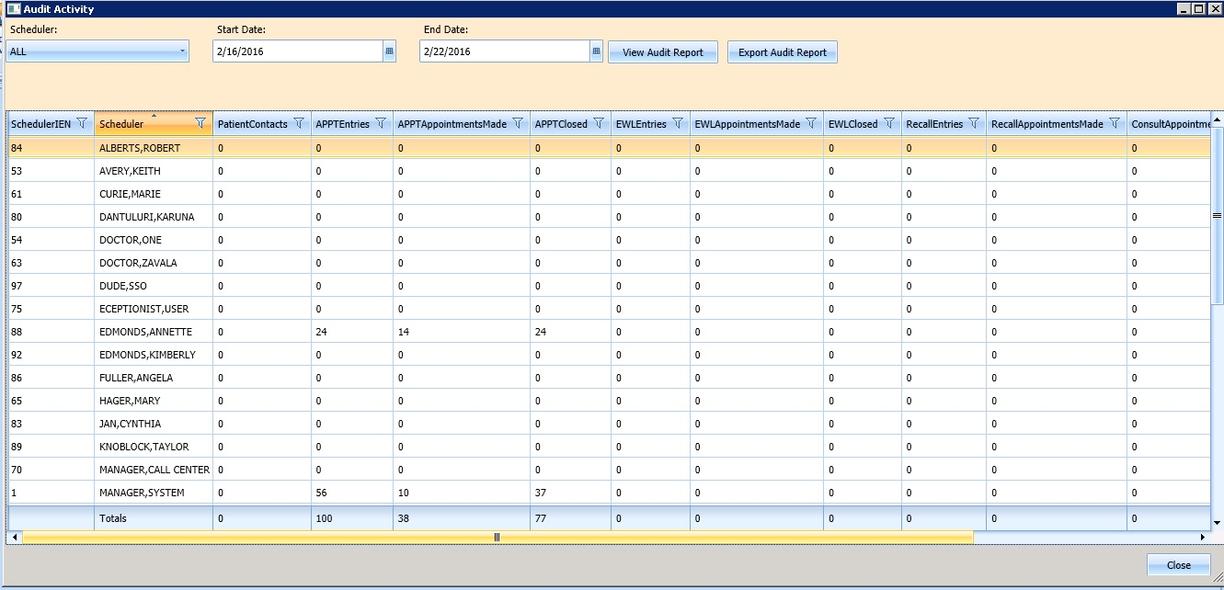

Figure : Audit Activity Report –All Schedulers

### Working with Audit Activity Report data

#### Sorting by column header

1. Log into VS GUI.
2. Select Reports Tab.
3. Select Audit Activity from Reports Section.
4. Audit Activity dialog displays for all schedulers defined in New Person file (File #200).
5. The following data displays on screen for the selected scheduler(s):
   1. SchedulerIEN (New Person File)
   2. SchedulerName
   3. PatientContacts
   4. APPTEntries
   5. APPTAppointmentsMade
   6. APPTClosed
   7. EWLEntries
   8. EWLAppointmentsMade
   9. EWLClosed
   10. RecallAppointmentsMade
   11. ConsultAppointmentsMade
   12. AppointmentsCancelled
   13. TotalActions
6. To change the sort for the report by data specified in different column, select the applicable column header. The first click of column header will sort report by data in specified column in ascending order. The second click of column header will sort report by data in specified column in descending order.
7. Click Close to exit Audit Activity Report dialog.

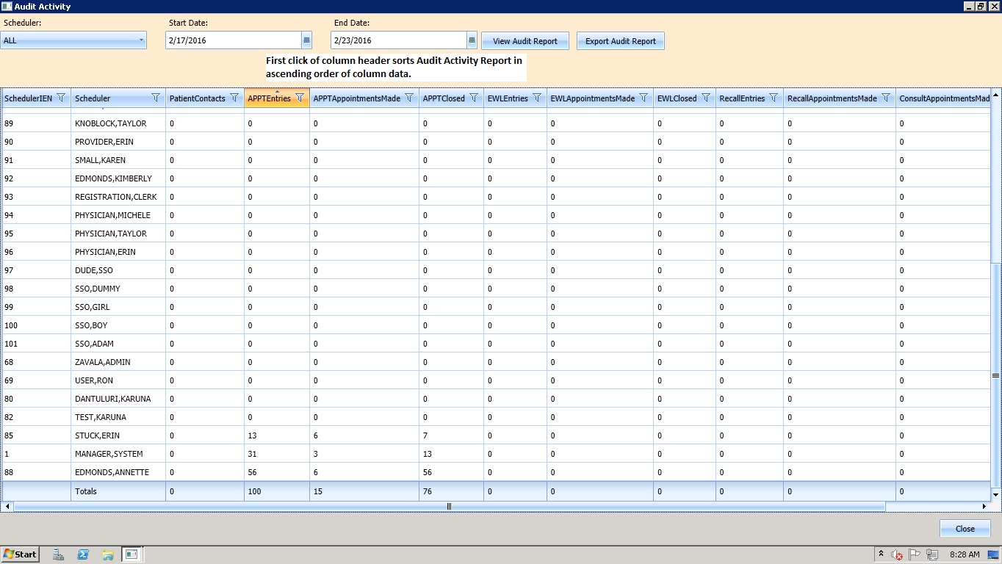

Figure : Audit Activity Sort –Ascending

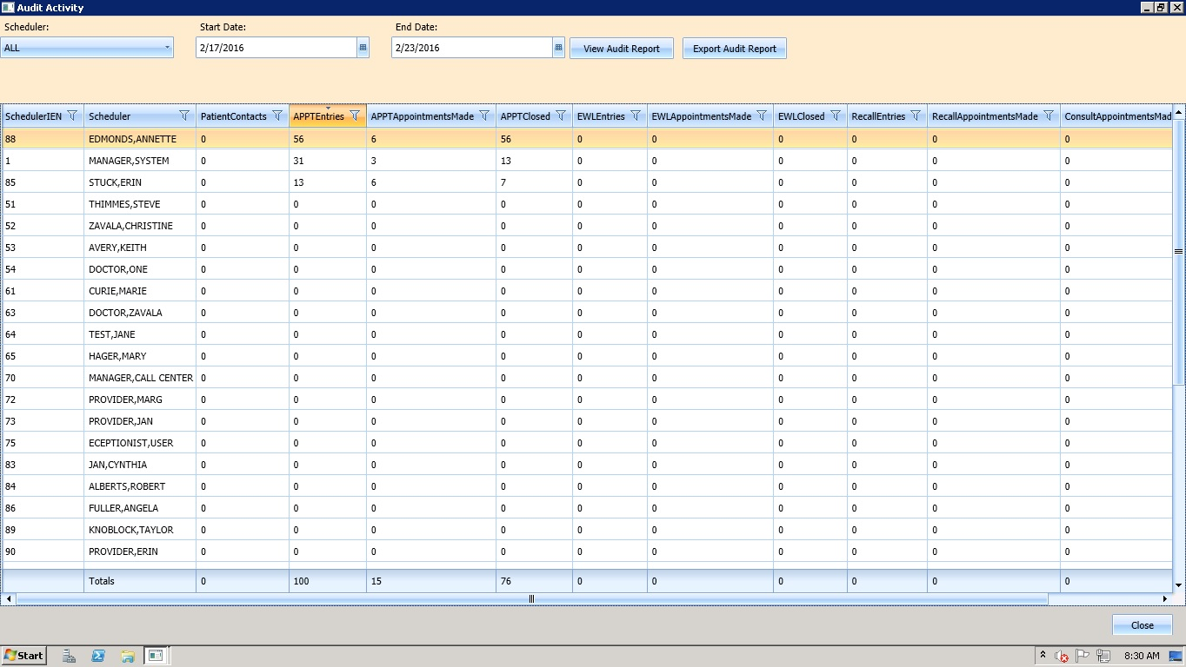

Figure : Audit Activity Sort –Descending

#### Filtering by column data

1. Data in Audit Activity report can be filtered by selecting a filter option available in each column header (i.e. All Schedulers who have greater than or equal to 10 APPTAppointmentMade in the selected date range). 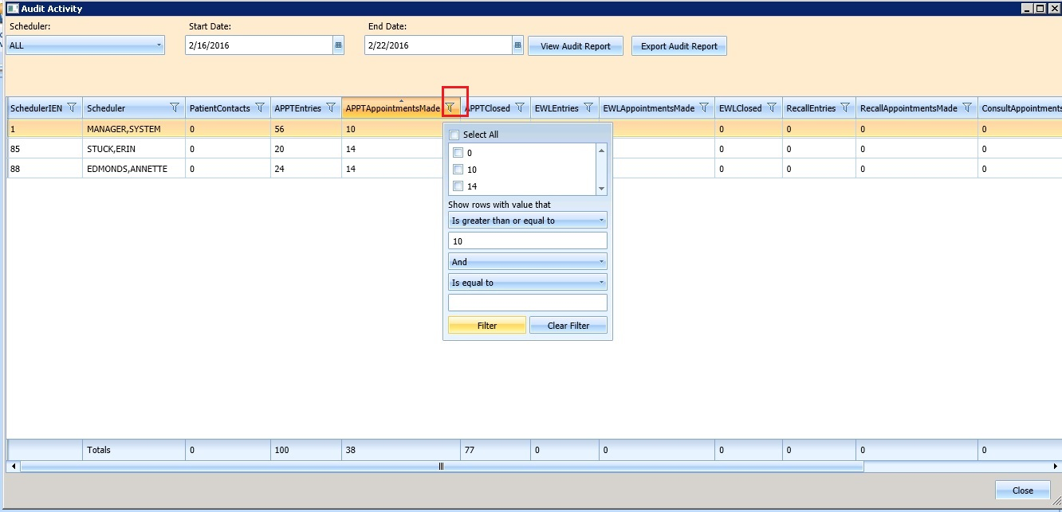

Figure : Audit Activity Report –Filtered

1. Multiple filters can be selected to refine results. (i.e. All Schedulers who have greater than or equal to 10 APPTEntries but less than or equal to 30 APPTClosed for the selected date range).
2. Selected filters are highlighted in column headers.
3. To remove filters, select filter option in column header and click Clear Filter button.
4. Click Close to exit Audit Activity report dialog.

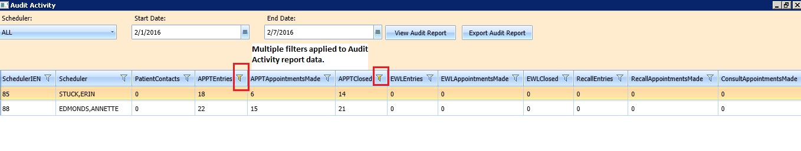

Figure : Audit Activity Report --Multiple Filters

### Export Audit Activity Report for Individual or All Schedulers

The data displayed on screen can be exported to an Excel spread sheet.

1. To export audit report, click on Export Audit Report button.
2. Save As dialog displays.
3. Select location to save report file.
4. File name defaults as Audit Report (edit as necessary).
5. Confirm ‘Save As Type’ is Excel files.
6. Click Save.
7. Report is generated containing data displayed on screen in Audit Activity dialog and saved to the location specified in the Save As dialog.
8. Click Close to exit Audit Activity report dialog.

## Clinics Report

The Clinic Report is accessed in the **Reports** tab display by selecting **Clinics** from the Reports section. The report displays clinic activity for all clinics defined in Hospital Location file as the default. The Clinic Report can be limited to individual clinics using the following steps.

### Clinic Activity Report—Individual Clinic

1. Log into VS GUI.
2. Select Reports Tab.
3. From Reports Section, click Clinics.
4. In Clinic Activity dialog, enter clinic name (6 character minimum) defined Hospital Location file. Click Search button.
5. The following data displays on screen for the selected clinic:

* Clinic name
* Division
* Stop Code
* Service
* CreateDT
* InactiveDT
* ReactiveDT
* AppType
* DefaultProv
* AdditionalProv
* ApptLength
* Variable
* MaxDays

1. Click Clear button to remove search criteria and return to Clinic Activity report for all clinics.
2. Click Exit to close Clinic Activity Report dialog.

### Working with Clinic Activity Report

#### Sorting by Column Headers

1. Log into VS GUI.
2. Select Reports Tab.
3. Select Clinics from Reports Section.
4. Clinic Activity dialog displays for all clinics defined in Hospital Location file (File #44).
5. The following data displays on screen for the selected clinic:

* Clinic name
* Division
* Stop Code
* Service
* CreateDT
* InactiveDT
* ReactiveDT
* AppType
* DefaultProv
* AdditionalProv
* ApptLength
* Variable
* MaxDays

1. The sort default is by alphabetical order by Clinic name.
2. To change the sort for the report by data specified in different column, select the applicable column header. The first click of column header will sort report by data in specified column in ascending order. The second click of column header will sort report by data in specified column in descending order.
3. Click Exit to close Clinic Activity Report dialog.

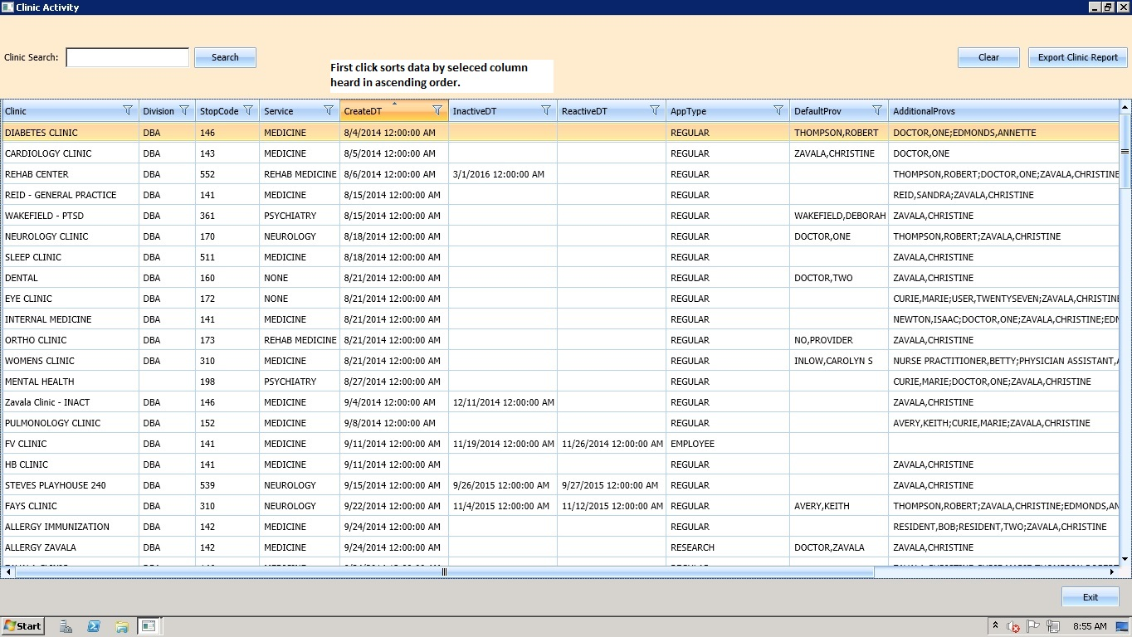

Figure : Clinic Activity Report –Sorted Ascending Order

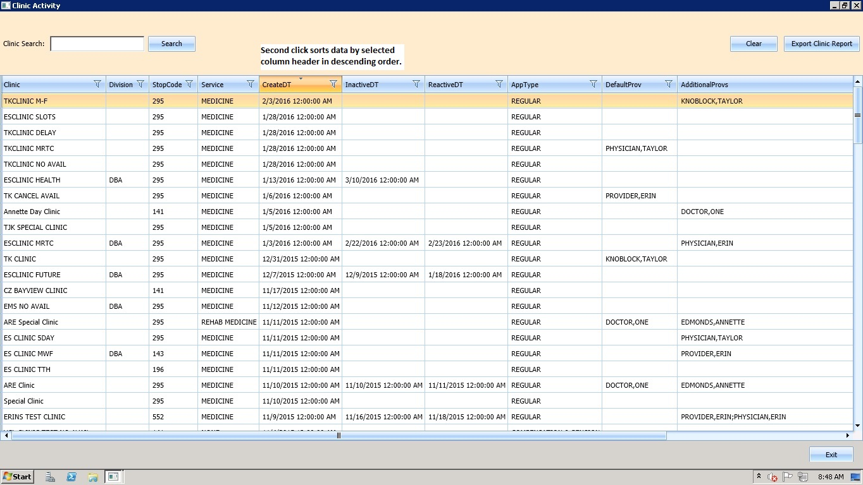

Figure : Clinic Activity Report –Sorted Descending Order

#### Filtering by column data

1. Data in Clinics Activity report can be filtered by selecting filter option in each column headers (i.e. Clinic Activity data can be filtered by all Clinics with a defined Service of Rehab Medicine.)

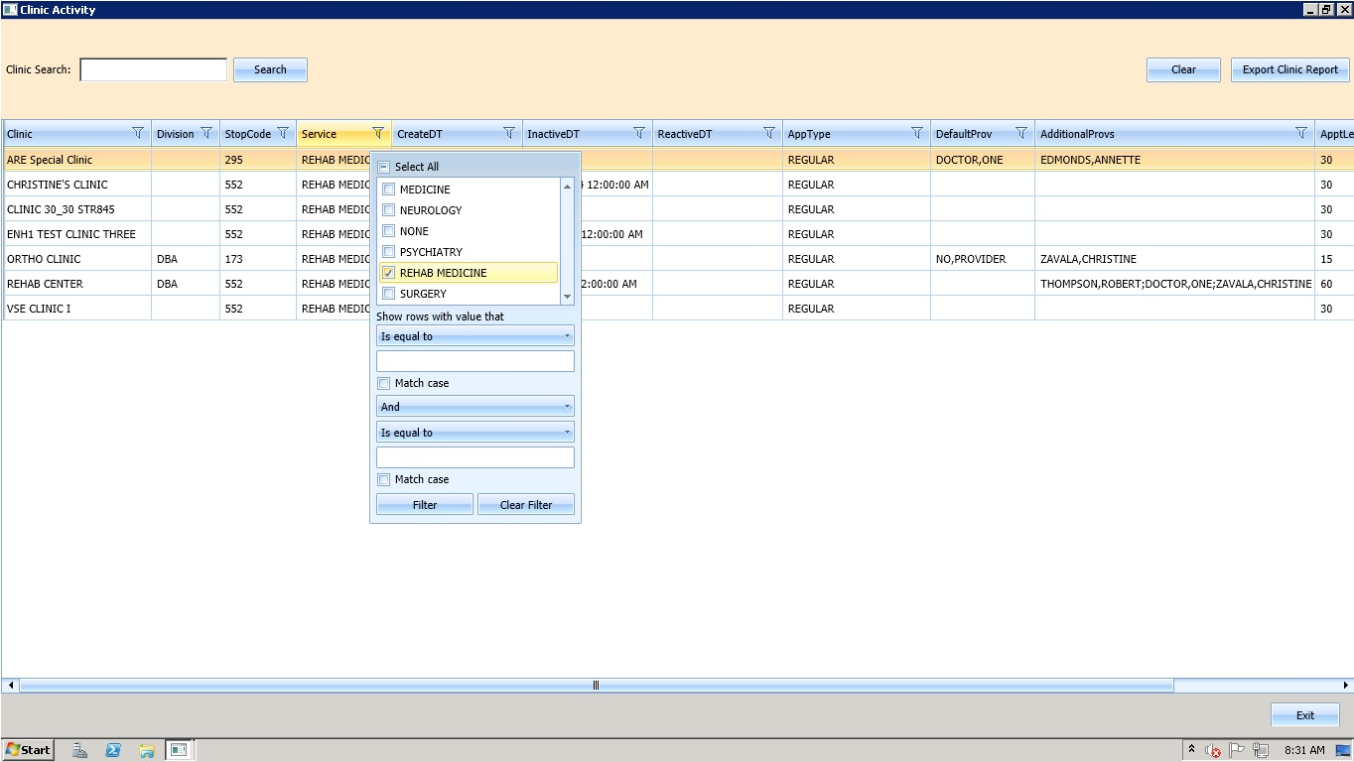

Figure : Clinic Activity Report—Filtered

1. Multiple filters can be selected to refine results. (i.e. Clinic Activity data can be filtered by all Clinics with a defined Service of Rehab Medicine that also have no DefaultProv defined.)
2. Selected filters are highlighted in column headers.
3. To remove filters, select filter option in column header and click Clear Filter button.
4. Click Exit to close Clinic Activity report dialog.

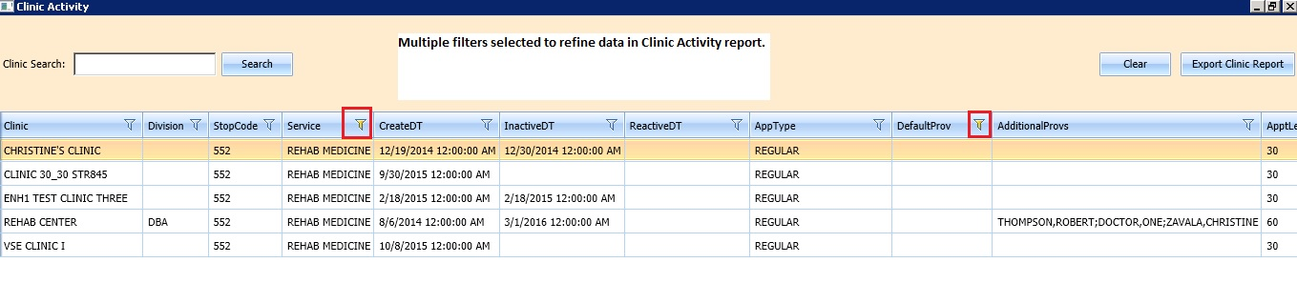

Figure : Clinic Activity Report –Multiple Filters

### Exporting a Clinic Report

Use the following procedure to export a Clinic Report.

1. In the **Reports** tab display, in the **Reports** section, select **Clinics.**
2. The **Clinic Activity** dialog opens, displaying the report.

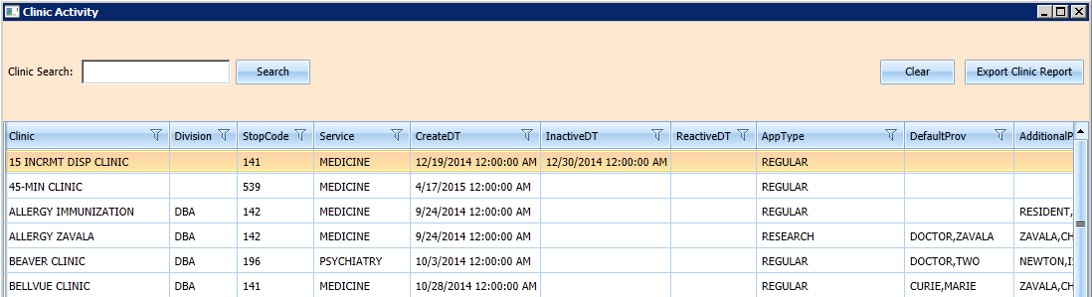

Figure : Clinic Activity

1. If applicable, search for specific clinic in Clinic Search field. Click Search button.
2. Click on Export Clinic Report.
3. A **Save As** dialog box displays.
4. Select location to save report.
5. Confirm File name (defaults to Clinic Report).
6. Confirm Save as Type is Excel files.
7. Click Save.
8. Data displayed on screen will be exported into file and saved to specified location with defined name.
9. Click Exit to close Clinic Activity report dialog.

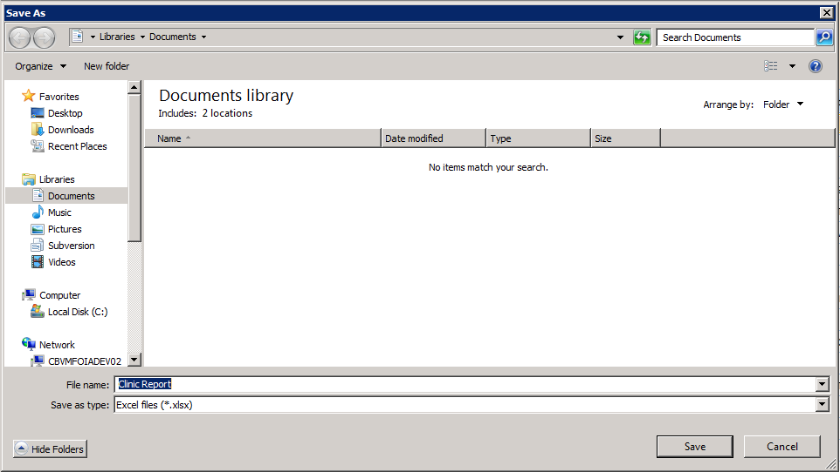

Figure : Save As

### Resource Management Reporting

Resource Management Reporting allows users to create reports that display pertinent Resource Management metrics in a single view. The application is used by individual facilities and staff to measure and track supply, demand metrics related to clinic appointments and patient encounters in VistA.

To generate a Resource Management Report, follow the instructions listed below:

1. From the **Reports** tab, select **Management Reports**. The **Report Management Report Selection** dialog box. To abort process user can click **Close** button.

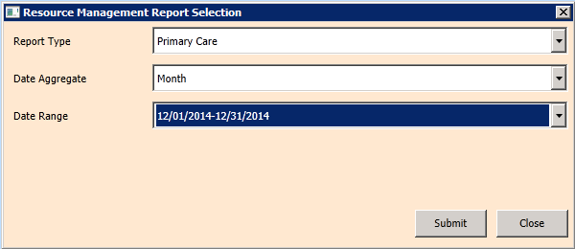

Figure : Resource Management Report Selection Dialog

1. From the **Report Type** drop down, select the type of report you would like to generate.

* Mental Health
* Primary Care
* Specialty Care

1. From the **Date Aggregate** drop down, select the aggregate you would like to generate.

* Year
* Quarter
* Month
* Week
* Date

1. From the **Date Range** drop down, select the range of dates you would like to generate.
2. Click **Submit**.
3. Report Management Report Selection dialog displays with white background while information is gathered for report. To abort process user can click Close button.
4. Once data is loaded the **Report Console** window displays.

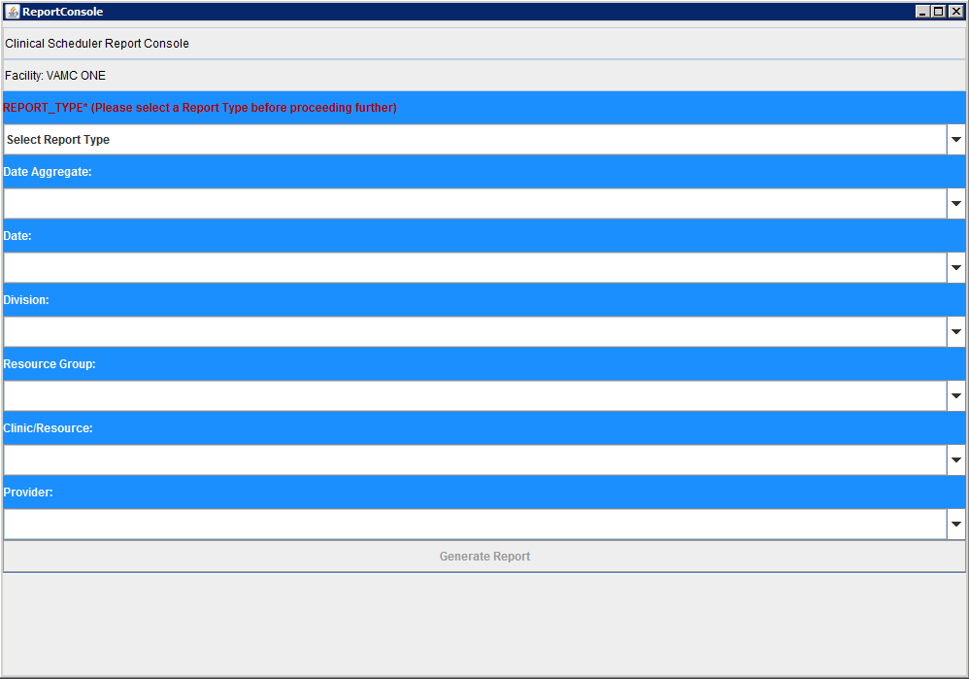

Figure : Report Console

1. From the **Division** drop down, select the division to sort by.
2. From the **Resource** **Group** drop down, select the resource group to sort by.
3. From the **Clinic/Resource** drop down, select the clinic/resource to sort by.
4. From the **Provider** drop down, select the provider to sort by.
5. Click **Generate Report**. The report will display.

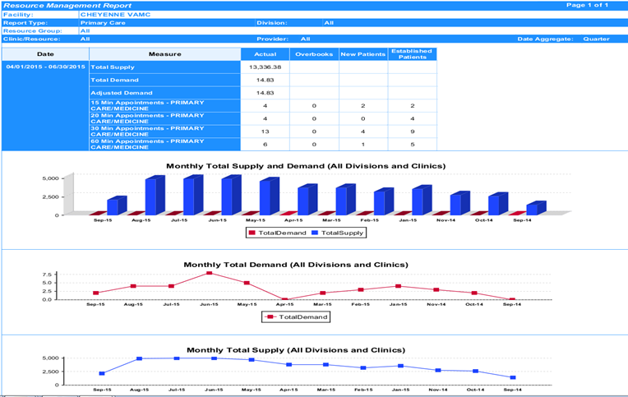

Figure : Generated Resource Management Report

# VistA Scheduling 508 Compliance

The following section outlines the process for executing VistA Scheduling Application functionality from the keyboard.

## Tasks Tab

The Hot Key, **Ctrl + T**, is used to navigate to the **Tasks Tab**.

### Ribbon Bar

**Tabbing:**

1. Log on to VS GUI as a Scheduler.
2. Focus is on Search field indicated by field being highlighted and cursor blinking.
3. The Scheduler can use the **Tab** key to advance through the Ribbon Bar. Beginning at the **Patient Search** field, the order will be going left to right. If the controls in each section listed below are enabled tabbing will highlight each one:

* Patient Search Field
* Search Button
* Clear Button
* Actions
* Arrangement
* Pending Appointments
* Special Needs/Remarks
* Mobile Requests
* Tools
* Print
* Export
* Refresh
* Query

1. After leaving the **Tools** section, control will go back to **Patient Search** field.

**Hot Keys:**

|  |  |
| --- | --- |
| Ribbon Bar Component | Hot Key |
| Patient Search Field | **Alt + S** |
| Action | **Alt + A** |
| Arrangement | **Alt + G** |
| Pending Appointment Window | **Alt + P** |
| Special Needs/Preferences | **Alt + N** |
| Mobile Requests | **Alt + M** |
| Tools | **Alt + T** |

### Request Type Dialog

**Tabbing:**

1. From the **Actions Pane**, with **New Req.** highlighted, press **Enter**. The **Request Type** dialog box displays.
2. Focus is **OK**.
3. Tab to **CLEAR**.
4. Tab to **APPT Request Type**.
5. Tab to **RECALL Request Type**.
6. Tab to **Patient**.
7. To select a **Request Type**, tab to highlight and press **Space Bar** key to select.
8. Tab to **OK**.
9. Press **Enter**.
10. *Arrow keys can also be used to navigate Request Type dialog box.*

**Hot Keys:**

|  |  |
| --- | --- |
| Ribbon Bar Component | Hot Key |
| OK | **Alt + O** |
| Clear | **Alt + C** |

### Appointment Request Dialog

**Tabbing:**

1. The **Appointment Request Dialog** displays with focus on **OK** button.
2. Tab to **CLEAR**.
3. Tab to the **Patient Information** section to the first incomplete field (if applicable).
4. Tab to the **Svc Related** check box. Press the **Space Bar** to select.
5. Tab to the **Clinic** radio button (default selection).
6. Tab to **Service/Specialty**. Press the **Space Bar** to select.
7. Tab to the **Clinic** field. Enter the **Clinic Name** (six character minimum).
8. Tab to the **CID/Preferred Date** field.
9. Once highlighted press **Enter** to display **Calendar** control.
10. Use the up and down arrow keys to navigate dates in the calendar and press **Enter** to select date.
11. Tab to **Appointment Type**.
12. Use the up and down arrow keys to select **Appointment Type**.
13. Tab to the **Requested By** field.
14. Use the arrow keys to select **Requested By**.
15. Tab to the **Provider** field (if applicable) to enter the **Provider** name (character minimum).
16. Tab to the **Multiple Appointments Required** check box. Press the **Space Bar** to select.
17. Tab to the **Number of Appointments Required** field.
18. Use the up and down arrow keys to select the number of appointments required.
19. Tab to the **Interval Between Appointments** field.
20. Use the up and down arrow keys to select the number of days between appointments.
21. Tab to the **Special Needs/Preferences** section.
22. Tab through the check box options. To select the applicable **Special Needs/Preference** option, press the **Space Bar**.
23. Tab to the **Time of Day** section.
24. Tab through the radio button options. To select the applicable **Time of Day** option, press the **Space Bar**.
25. Tab to the **Day of Week** section.
26. Tab through the **Day of Week** check box options. To select the applicable **Day of Week** option, press the **Space Bar**.
27. Tab to the **Remarks** field.
28. Enter text in the **Remarks** field.
29. *Arrow keys can be utilized to navigate* ***Special Needs/Preferences*** *section.*
30. Tab to the **Comments** field.
31. Enter text in the **Comments** field.
32. Tab to the **OK** Button.
33. Press **Enter** to select and create APPT Request.
34. Tab to the **CLEAR** button.
35. Press **Enter** key to select and exit dialog.

**Hot Keys:**

|  |  |
| --- | --- |
| Ribbon Bar Component | Hot Key |
| OK | **Alt + O** |
| Clear | **Alt + C** |

### Query Dialog

1. The **Query Dialog** displays with focus on **Patient** field.
2. Enter the patient name **Last Name**, **First Name**.
3. Tab to the **Find** button.
4. Press **Enter**.
5. Use the **Down Arrow** key to highlight names in **Patient** list.
6. Use the **Enter** key to select patients from list to include in query.
7. Tab to the **Patients** column.
8. Use the **Down Arrow** key to highlight names listed. To remove names from selection press **Enter**.
9. Tab to the **Request Type Filter**.
10. Press **Enter** to display **Request Types** dialog box.
11. Use the arrow keys to navigate the **Request Type** selection grid.
12. Press the **Space Bar** key to select highlighted **Request Type**.
13. Tab to **OK** to confirm selection.
14. Tab to **Cancel** to quit selection and exit dialog.
15. Tab to the **Clinic/Service Filter**.
16. Press **Enter** to display **Clinics** dialog box.
17. Enter the **Clinic/Service** name in field (six character minimum).
18. Tab to the **Find** button.
19. Tab to the **Select All** check box.
20. Press **Space Bar** key to **Select All**.
21. Tab to the **Clinics** or **Services** radio button.
22. The **Clinics** radio button is defaulted. The **Services** radio button can be selected by pressing the **Space Bar** key.
23. Use the arrow keys to navigate up and down **Clinics/Service Grid**.
24. Use the **Space Bar** key to select/unselect from list.
25. Tab to **OK** and press **Enter** to confirm selections for query.
26. Tab to **Cancel** and press **Enter** to quit selection and exit dialog.
27. Tab to **Priority Group Filter**.
28. Press **Enter** to display **Priority Group** dialog box.
29. Tab to the **Select All** check box.
30. Press the **Space Bar** key to select (if applicable).
31. Tab to the **Priority Group** grid list.
32. Use the arrow keys to navigate up and down list.
33. Use the **Space Bar** key to select/unselect **Priority Group** options.
34. Tab to **OK** and press **Enter** to confirm selections for query.
35. Tab to **Cancel** and press **Enter** to quit selection and exit dialog.
36. Tab to the **Wait Time** drop down.
37. Use the arrow keys to navigate options for query selection.
38. Tab to the **ScVisit?** drop down.
39. Use the arrow keys to navigate options for query selection.
40. Tab to the **Service Connected?** drop down.
41. Use the arrow keys to navigate options for query selection.
42. Tab to the **Origination Date** field.
43. Enter the date for query selection as applicable.
44. Tab to the **CID/Preferred Date** field.
45. Enter the date for query selection as applicable.
46. Tab to the **Urgency** field (Applicable to Consult Requests only)
47. Use the arrow keys to navigate list for query selection.
48. Tab to the Change **Sort** field.
49. Use the arrow keys to navigate list for query selection.
50. Tab to the **Clear** button.
51. Press **Enter**. The **Clear Filter** dialog box displays.
52. Tab to **OK**.
53. Press **Enter** to clear the **Request Query** dialog box of all filter selections and start query selection process again.
54. Tab to **Cancel**.
55. Press **Enter** to **Cancel Clear Filter** selection and exit dialog. (Note: Selecting **Cancel** in this dialog will keep current **Request Query** dialog filter selections for query.)
56. Tab to **Submit** button.
57. Press **Enter**. The **Request Query Confirmation** dialog box displays.
58. Tab to **OK**.
59. Press **Enter** to display query results in **Request Management Grid**.
60. Tab to **Cancel**.
61. Press **Enter** to key to abort query results and return to **Request Query** dialog box.
62. Tab to the **Close** button.
63. Press **Enter** to close **Request Query** dialog box.

## Systems Tab

The Hot Key, **Ctrl + Y**, is used to navigate to the **Systems Tab**.

### Systems Tab Ribbon Bar

**Tabbing:**

1. Tab to **Scheduling Management**.
2. Press **Enter** to display **Scheduling Management** dialog box.
3. Tab to **Availability**.
4. Press **Enter** to display **Availability Selection** dialog box.

**Hot Keys:**

| Ribbon Bar Component | Hot Key |
| --- | --- |
| Systems Tab | **Ctrl + Y** |
| Scheduling Management | **Alt + M** |
| Availability | **Alt + H** |
| Select Clinic | **Alt + L** |

### Scheduling Management Dialog

#### Clinics and Users Tab

**Tabbing:**

1. The **Scheduling Management Dialog** displays with **Clinics** and **Users** tab enabled. Focus is on **OK** button.
2. Tab to the **Users Selection List**.
3. Use the **Down** **Arrow** key to highlight the **First Name** in **Users List**.
4. Press **Enter** to select **User Name**.
5. Tab to the **Prohibited Clinic** field.
6. To select the **Prohibited Clinic**, and enter the **Clinic Name**.
7. Tab to **Find Button** and press **Enter**. The **Prohibited Clinic List** is displayed.
8. Use the arrow keys to navigate up and down the list.
9. Tab to the **Privileged Users List** that are assigned to selected clinic.
10. Tab to the **Add User** button.
11. Tab to the Remove **User** button.
12. Tab to the **Remove All** button.

**Hot Keys:**

| Ribbon Bar Component | Hot Key |
| --- | --- |
| Add User | **Alt + A** |
| Remove User | **Alt + R** |
| Remove All | **Alt + E** |
| Find | **Alt + F** |
| OK | **Alt + O** |
| Cancel | **Alt + C** |

#### Clinic Groups Tab

**Tabbing:**

1. The **OK** button has the focus when **Clinic Group** **Tab** displays.
2. Tab to **Resources**.
3. Enter **Clinic Schedule Resource**—**User name**, **Clinic Name**, **Clinic Group**.
4. Tab to **Find Button** and press **Enter** to search.
5. Use the **Down Arrow** to highlight first name in **Resource List**.
6. Tab to the **New Group** button.
7. Tab to the **Edit Group** button.
8. Tab to the Remove **Group** button.
9. Tab to the **Clinic Groups List**.
10. Tab to the **Add Resource** button.
11. Tab to the **Add All** button.
12. Tab to the **Remove Resource** button.
13. Tab to the **Remove All** button.

**Hot Keys:**

| Ribbon Bar Component | Hot Key |
| --- | --- |
| New Group | **Alt + N** |
| Edit Group | **Alt + E** |
| Remove Group | **Alt + R** |
| Add Resource | **Alt + S** |
| Add All | **Alt + L** |
| Remove Resource | **Alt + D** |
| Remove All | **Alt + X** |
| OK | **Alt + O** |
| Cancel | **Alt + C** |

### Availability Selection Dialog

**Tabbing:**

1. The **Availability Selection Dialog** displays with focus on **OK** button.
2. Tab to the **Cancel** button.
3. Tab to the **Search by Name** field.
4. Enter the **Clinic Name** (six character minimum).
5. Tab to the **Resource List Grid**.
6. Use the arrow keys to navigate up and down **Resource List**.
7. Press **Enter** to select the highlighted **Resource**. **Select** **Clinic Availability** displays.

**Hot Keys:**

| Ribbon Bar Component | Hot Key |
| --- | --- |
| Search Field | **Alt + S** |
| First Row of Results Grid | **Alt + G** |
| OK | **Alt + O** |
| Cancel | **Alt + C** |

## Reports Tab

The Hot Key, **Ctrl + R**, is used to navigate to the **Reports Tab**.

### Reports Tab Ribbon Bar

**Tabbing:**

1. Tab to **Audit Activity**.
2. Tab to **Clinics**.
3. Tab to **Management Reports**.

**Hot Keys:**

| Ribbon Bar Component | Hot Key |
| --- | --- |
| Reports Tab | **Ctrl + R** |
| Reports | **Alt + R** |

### Audit Activity Dialog

**Tabbing:**

1. The **Audit Activity** dialog box displays with focus on Close button.
2. Tab to the **Scheduler** drop down.
3. Default is **All**.
4. Use **Down** **Arrow** key to select user name (listed in alphabetical order).
5. Enter the user name (last name, first name) to jump to specific user.
6. Tab to the **Start** **Date** field.
7. Press **Enter** to select **Calendar** control.
8. Use the arrow keys to select date.
9. Tab to the **End Date** field.
10. Press **Enter** to select **Calendar** control.
11. Use arrow keys to select date.
12. Tab to the **View Audit Report**.
13. Press **Enter** to display **Audit Report in Grid**.
14. Tab to the **Export Audit Report**.
15. Press **Enter** to display **Save As** dialog box. (Note: Only data outputted to screen will appear in exported **Audit Report**.)
16. Tabbing is enabled for **Audit Report Grid**.

**Hot Keys:**

| Ribbon Bar Component | Hot Key |
| --- | --- |
| Scheduler drop down | **Alt + S** |
| Audit Report | **Alt + V** |
| Export Report | **Alt + E** |
| Close | **Alt + C** |

### Clinic Activity Dialog

**Tabbing:**

1. The **Clinic Activity** dialog box displays with focus on **Exit** button.
2. Tab to **Clinic Search** field.
3. Enter the **Clinic** N**ame** (six character minimum).
4. Tab to the **Search** button.
5. Press **Enter**.
6. Tab to the **Clinic Results Grid**.
7. Tab through **Clinic Results Grid** including **Column Headers** and **Filter** dialogs.

**Hot Keys:**

| Ribbon Bar Component | Hot Key |
| --- | --- |
| Search Button | **Alt + S** |
| Clear | **Alt + C** |
| Export | **Alt + E** |
| Exit | **Alt + X** |

### Management Reports Dialog

1. The **Management Reports** dialog box displays with focus on **Report Type** drop down.
2. Use the arrow keys to select from **Report Type** options.
3. Tab to the **Date Aggregate** drop down.
4. Use the arrow keys to select from the **Date Aggregate** options: **Year**, **Quarter**, **Month**, **Week**, **Date**.
5. Tab to the **Date** drop down.
6. Enter the date to populate the **Date** field. (Note: Date displayed is based upon Date Aggregate option selected).
7. Tab to the **Close** button.
8. Press **Enter** to exit the dialog.
9. Tab to **Submit** button.
10. Press **Enter** to submit report query and open **Report Console**. (Note: Submit button is not enabled until all fields are completed.)

**Hot Keys:**

| Ribbon Bar Component | Hot Key |
| --- | --- |
| Reports Type | **Alt + T** |
| Date Aggregate | **Alt + D** |
| Date Range | **Alt + R** |
| Submit | **Alt + S** |
| Close | **Alt + C** |

# Troubleshooting

Contact the help desk for any problems with the VS GUI module.

## **Changing User ID and Password**

Contact your supervisor or System Administrator for User ID or Password changes.

## Special Instructions for Error Correction

There are some warnings that may be displayed in a dialog. These include:

Table : Warning Messages

| Reason for Message | Message | Action | Result |
| --- | --- | --- | --- |
| Sensitive Information Warning | Warning displays to the user:  ***WARNING***  ***RESTRICTED RECORD*** | Click **OK** | User is able to log into the Security Log Audit Trail |
| Warning for similar names and Social Security Number | Similar Names dialog displays  System lit patients with similar name and same last four digit of SS# | Click **OK** | User is able to continue |
| Accessing deceased patient’s record | This patient died on <Date of Death>  Do wish to continue? | Click **OK** | User is able to perform action such as Disposition, Cancel Appointments |
| Accessing own record at selection | Security regulations prohibit computer access to your own medical record. | Click **OK** | User is unable to perform any activity/actions |